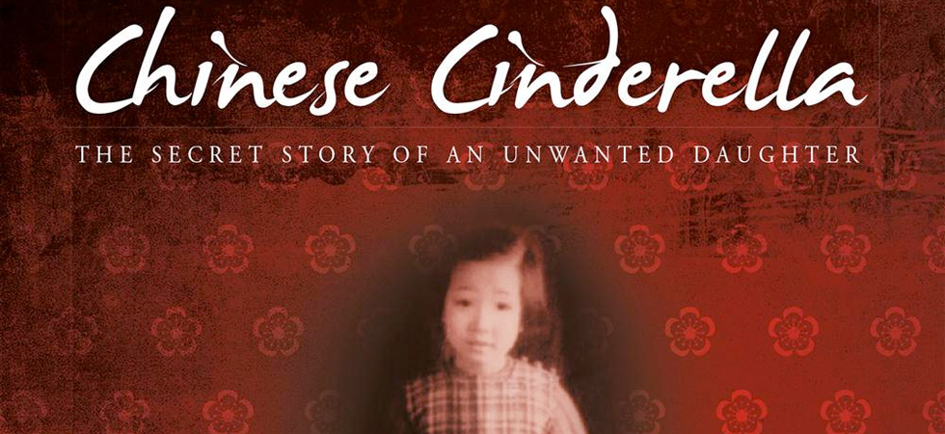

Workbook Questions

Learning Intentions: students practice using comprehension strategies such as retrieving directly stated information, making inferences, visualising, predicting, connecting, and summarising. These strategies help students interpret and evaluate the ideas in longer texts.

Instructions: As you read through the novel, answer the following short questions.

Cover & Predictions
- What can you predict about this story by looking at the cover? Consider the colours, images and symbols that have been included.
- What clues about the story do you get from the title and subtitle? (HINT: what is the fairy tale ‘Cinderella’ about?)
- Using the contents page of the novel, list all the cities in China where Adeline lived.

Author’s Note
- Explain why “a person can learn to read and write Chinese without knowing how to speak one word”?
- What TWO things does the author say that she would like the reader to gain from reading Chinese Cinderella?

Preface
- What are the ‘essential things which have not changed’ that Chinese parents think are important for their children? (PDF pg. 13, book pg. ix) There are five things:

- The author says that “in Chinese families, a child is called by many names” (PDF pg. 15-17, book pg. xi-xiii). List four of the different names that Adeline has:

- Is this book a biography or an autobiography? What’s the difference?
- Do you think every person's life story is worth telling in the form of a biography or autobiography? Why or why not?
- Imagine you were to write an autobiography about your life one day. What events or experiences do you think would be most interesting to readers, and why?
- Would it make a difference if your story was written by someone else instead of you? What things might change?

Chapter 1. Top of the Class
- What did the narrator receive from kindergarten and why?
- What affectionate term does Aunt Baba call the narrator?
- At the end of the chapter, Big Sister tells Adeline that she is ‘bad luck’.
  - What is the reason Big Sister gives?

Use the internet to find the answers to the next two questions:
  - How important is ‘luck’ in Chinese culture?
  - In the table below, list 2 things that are considered lucky and 2 things that are considered unlucky in Chinese culture (e.g. colours, numbers, items)

Lucky | Unlucky

Chapter 2. A Tianjin Family
- How long after the children’s mother’s death was it before Father remarried?
- How old was Niang when she married Father? What was the age difference between them?
- Describe Niang.
- What does “Niang” mean in Chinese?
- How did Adeline and Aunt Baba become closer?
- List THREE ways that China was affected by losing the Opium War:

Chapter 3. Nai Nai’s Bound Feet
- How did the Chinese tradition of binding feet affect Nai Nai in her old age?
- How is Adeline treated by:
  - Nai Nai?
  - Big Brother?
  - Big Sister?
  - Third Brother?
- What two events made Adeline happy at the dinner table?
- How did Big Sister and the siblings get back at Adeline for getting attention from Father at the dinner table?

Chapter 4. Life in Tianjin
- In what way is Adeline’s life at St. Joseph’s different than at home?
- What is a rickshaw?
- Who is Ah Mao?
- How does Big Sister treat Adeline on the way home from school?
- What does the family do to recognize Adeline’s special award?
- Why did Father disappear?
- Describe three elements of Nai Nai’s Buddhist funeral.

- The oldest woman is the “head of household”. Predict how Nai Nai’s death is going to affect the family.

Chapter 5. Arrival in Shanghai
- “There, in a first-class compartment, we came face to face with Father, sitting by himself. He was dressed in a black suit and black tie. His eyes were red and he had been crying.” (PDF pg. 62, book pg. 24) Why do you think Father was crying?
- Why did Father relocate to Shanghai?
- Who stayed in Tianjin, and why?
- Who is Jackie?
- Identify four of the rules at their new home.
- Big Brother states, “To her, we are not separate people. Here we have become one single unit known as all of you. Seems like this is how it’s going to be from now on.” (PDF pg. 62, book pg. 28) Explain what he means by this. How do you think their life will be different?

Chapter 6. First Day of School
- How did Adeline get to school on the first day?
- When no one picked her up from school, where did Adeline go?
- How did Adeline know her phone number?
- What “gift” did Adeline receive when Father picked her up, and why?
- Copy & paste two sentences from this chapter where you think the author is trying to make the reader feel sorry for her:

- Looking at the examples you selected, what techniques has the author used to try and make the reader feel sympathy for her?

Chapter 7. Family Reunion
- How long has Little Sister been away from her mother?
- Who did Little Sister give all her attention to? Why do you think this is?
- What was the “last straw” as far as Niang was concerned when dealing with Little Sister?
- Why didn’t anyone interfere between Niang and Little Sister?
- How did Niang react to Adeline’s plea for her to stop?
- How do you think Niang will have Adeline “pay for her ignorance”? What do you think she might do to her?

Chapter 8. Tram Fare
- Write a reaction (response) to the chapter. What do you think about the events in this chapter, and why? Support your ideas with clear reasoning. Write minimum 5 complete sentences.

Chapter 9. Chinese New Year
- Write an anonymous letter to Father about the injustices the children suffer.
- How did Niang prevent the children from rebelling against her?
- Big Brother says sister and Niang are “two of a kind” (PDF pg. 115, book pg.57). In what ways are they similar?
- What are the two reasons Adeline was called “Genius” by her classmates?
- What were some hints Adeline’s classmates were given about her family life?
- How does writing stories make Adeline’s life easier?
- Why doesn’t Adeline want anyone to know how bad things are for her at home?

Chapter 10. Shanghai School Days
- Create a table comparing Adeline and Wu- Chun-mei.

 | Family | School | Friends
Adeline
Wu- Chun-mei

- Why did the Americans become favored by the Chinese in 1945?
- What book became Adeline’s favorite?
- How did Adeline’s life change in positive ways while Father was away?
- Explain the event that reminded Adeline that she was still the unwanted sister. Who did she feel most betrayed by?

Chapter 11. PLT
- How did Mrs. Huang know the family?
- Which duckling did Adeline get?
- What did Adeline name her duck? Where did she get the name?
- Why was Second Brother angry?
- What did Aunt Baba advise Adeline to do about the dog bite?
- What did Father decide to do for “entertainment” after dinner that Saturday evening?
- How did Father feel about the resulting situation?

Chapter 12. Big Sister’s Wedding
- Where did Big Sister go with Father and Niang? Why?
- What are the ages of Big Sister and Samuel?
- Compare how Big Sister and Adeline felt about the arranged marriage.
- What did Niang do with the wedding gifts?
- What secret did Aunt Baba, Big Sister, and Adeline share?
- Explain the conversation Adeline overheard in the bathroom at the wedding. How was Adeline betrayed by Big Sister?

Chapter 13. A Birthday Party
- Write a thank you letter to Wu Chun Mei for inviting you to her party. Explain what you enjoyed most and why you did not return.
- What does Adeline wish for as she watches Fourth Brother feed unwanted goodies to Jackie?
- Imagine that Wu Chun Mei’s father found out how Adeline was being treated. Write the script of a telephone conversation between him and Niang where he tries to convince her to let Adeline attend the party.

Chapter 15. Boarding School in Tianjin
- For this chapter, work with a partner. Write five questions about this chapter and give them to your friend. Make them TRICKY! Then answer their five questions about the chapter.

Chapter 16. Hong Kong
- Give a few examples of how the Schillings treat Adeline on the boat trip.
- Why did Adeline dread her arrival in Hong Kong?
- How is the new Yen home different than the previous two?
- What were the two surprises Aunt Reine brought from Tianjin?
- What was the sound in YeYe’s voice? Explain what this means.
- How did Niang prevent Adeline from spending time with the Schillings?
- According to YeYe, why is it important that Adeline learn to read and write Chinese? (PDF pg. 310-311, book pg.170-171)
- What does Ye Ye mean when he says, “though life has to be lived forward, it can only be understood backward”?
- In what way did Victor stand up to Niang?

Chapter 17. Boarding School in Hong Kong
- What did Fourth Brother do to tease Adeline?
- Explain what happened the day before between Fourth Brother and Adeline.
- Explain the example of prejudice against Chinese people at the hotel.
- Where did Adeline end up being taken? What fear did not come true?

Chapter 18. Miserable Sunday
- What year is it now? How old is Adeline?
- Explain why “egg day” is such a big deal at the school.
- What did Adeline do with her egg? Why?
- Compare Monica and Adeline.
- How did Irene and Eleanor feel about Adeline?

Chapter 19. End of Term
- What is serendipity?
- Who were Adeline’s two closest friends?
- What is Adeline’s hope for the future?

Chapter 20. Pneumonia & Chapter 21. Playwriting Competition
- Draw a picture, or create a collage of pictures, to represent Adeline’s thoughts and feelings in these chapters.

Chapter 22. Letter from Aunt Baba
- Reflecting on the events of the novel as well as your knowledge of the story of Cinderella, write a paragraph comparing Adeline and Cinderella. Include at least three examples from the story (include quotes and page numbers).

