Year 10B English Exam – Semester 2 2023

SECTION 1: IRONY & SATIRE
- Define the following and give an example of each:

Name | Definition | Example
Dramatic irony
Situational irony
Verbal irony
Satire
Stereotype
Hyperbole
/12
- What is the function of satire? Give an example of how it could be used for its intended purpose.

______________________________________________________________________________________________________________________________________________________________________________________________________________________________________________________________________________________________________________________________________________________________________________________/3

- In the examples on the next page:

- State which is being used: Dramatic Irony, Situational irony, Verbal Irony, Stereotype, or Satire.
- Explain WHY you think so – i.e. what exactly is ironic about this? What stereotype/s are displayed? How can you tell this is a satire?

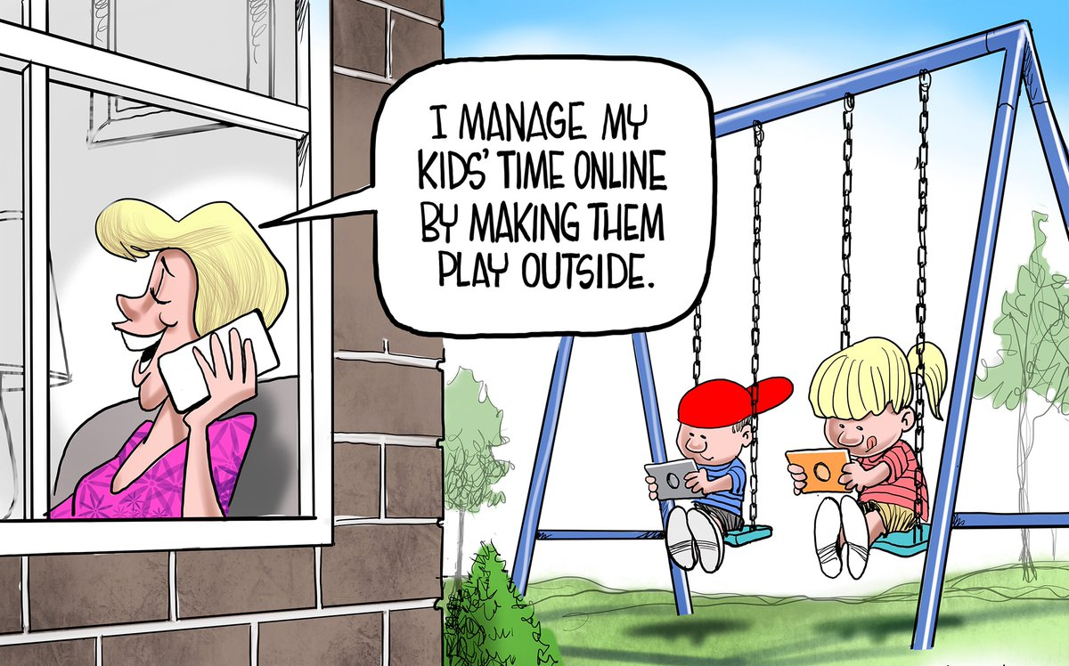
Type: _____________________________
Explanation: ___________________________________________________________________________________________________________________________________________________________________________________________________________________________________________________________________________________________________________________________________________________________________________________________________________________________________________

Type: _________________________________
Explanation: ____________________________________________________________________________________________________________________________________________________________________________________________________
“She is a selfish, hypocritical woman and I have no opinion of her.”

____________________________________________________________________________________________________________________________________________________________________________________________________________________________________________________________________________________________________________________________________________________________________________________________________

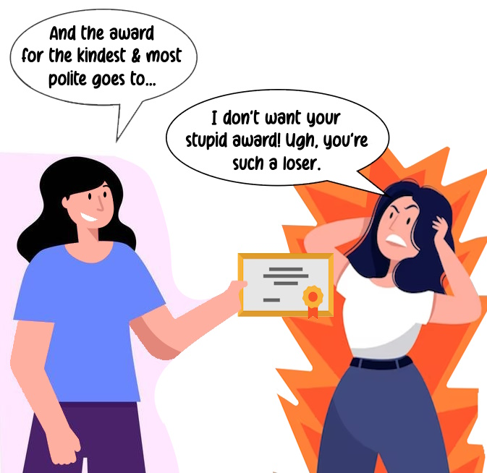
Type: _____________________________
Explanation: ______________________________________________________________________________________________________________________________________________________________________________________________________________________________________________________________________________________________________________________________________________________________________________________________________________________________________________________________________________________

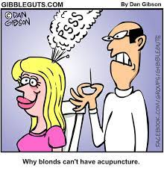

Type: _____________________________
Explanation: ___________________________________________________________________________________________________________________________________________________________________________________________________________________________________________________________________________________________________________________________________________________________________________________________________________________________________________

Mrs Bennet speaking about Mr Bingley, who has refused to marry her daughter Jane:
“Well, my comfort is, I am sure Jane will die of a broken heart, and then he will be sorry for what he has done.”
Type: _____________________________
Explanation: ___________________________________________________________________________________________________________________________________________________________________________________________________________________________________________________________________________________________________________________________________________________________________________________________________________________________________________

____________________________________________________________________________________________________________________________________________________________________________________________________________________________________________________________________________________________________________________________________________________________________________________________________

END OF SECTION ONE TOTAL /30

SECTION 2: OUT OF THE DUST
- Choose one character from Out of the Dust OTHER THAN Billie Jo and create a character web about them using examples from the novel.

/7
- Describe how Billie Jo’s relationship with her father changes over the course of the novel.
________________________________________________________________________________________________________________________________________________________________________________________________________________________________________________________________________________________________________________________________________________________________________________________________________________________________________________________________________________________________________________________________________________________________________________________________________________________________________________________________________________________________________________________________________________________________________________________________________________________________________________________________________________________________________________________________________________________________________________________________________________________________________________________________________________________________________/7
- How does the novel’s style help to make the story more effective? Consider the impact of the author’s decisions in terms of the format (free verse poetry), literary techniques, phrasing, point of view, and overall tone of the novel.
________________________________________________________________________________________________________________________________________________________________________________________________________________________________________________________________________________________________________________________________________________________________________________________________________________________________________________________________________________________________________________________________________________________________________________________________________________________________________________________________________________________________________________________________________________________________________________________________________________________________________________________________________________________________________________________________________________________________________________________________________________________________________________________________________________________________________/8

- Choose one theme from the novel and discuss how this theme is explored, giving examples from the novel.
__________________________________________________________________________________________________________________________________________________________________________________________________________________________________________________________________________________________________________________________________________________________________________________________________________________________________________________________________________________________________________________________________________________________________________________________________________________________________________________________________________________________________________________________________________________________________________________________________________________________________________________________________________________________________________________________________________________________________________________________________________________________________________________________________________________________________________________________________________________________________________________________/8
END OF SECTION TWO TOTAL /30
SECTION 3: INTERTEXTUALITY (MERCHANT OF VENICE)
- What is intertextuality? _________________________________________________________
______________________________________________________________________________________________________________________________________________________________________________________________________________________________________________________________________________________________________________________________________/2
- In the table below, explain the difference between an adaption and a transformation of a text and give an example of each.
 | What does it mean? | Give an example
Adaption
Transformation
/4

- Discuss how the theme of mercy, revenge and justice is developed in Shakespeare’s Merchant of Venice, giving examples from the play.
________________________________________________________________________________________________________________________________________________________________________________________________________________________________________________________________________________________________________________________________________________________________________________________________________________________________________________________________________________________________________________________________________________________________________________________________________________________________________________________________________________________________________________________________________________________________________________________________________________________________________________________________________________________________________________________________________________________________________________________________________________________________________________________________________________________________________/4

- Give an example of how language or dialogue are used to demonstrate characters’ power or lack of power in The Merchant of Venice.
____________________________________________________________________________________________________________________________________________________________________________________________________________________________________________________________________________________________________________________________________________________________________________________________________________________________________________________________________________________________________________________________________________________________________________________________________________________________________________________________________________________________________________________________________________________________________________________________________________
____________________________________________________________________________/4

- In the table below, list 3 symbols in The Merchant of Venice and explain what they represent.
Symbol | What it represents
/6
- On the following page, write a short intertextual narrative that is an adaption OR a transformation of the story of Cinderella. A summary of the plot is provided below:

When Ella’s father dies, her cruel stepmother treats her as a servant, forcing her to dress in rags and cook and clean for her and her daughters. Ella sleeps near the fireplace and is often covered in cinders (soot), so they call her Cinderella. One day, the prince invites everyone in the land to a royal ball. Cinderella’s stepmother & sisters tell her she is not invited and make her help them prepare. After they leave, Cinderella’s Fairy Godmother appears and promises to help her attend the ball. She turns a pumpkin into a golden carriage, mice into horses, and lizards into footmen. She transforms Cinderella's rags into a beautiful gown and gives her a pair of delicate glass slippers. She tells her to enjoy the ball, but warns her that she must return before midnight, when the spell will be broken. At the ball, the entire court is entranced by Cinderella, especially the prince. On the first night, she remembers to leave before midnight. Another ball is held the next evening and again Cinderella attends with her Fairy Godmother’s help. The prince becomes even more infatuated. Cinderella loses track of time and hurries away at the final stroke of midnight, losing one of her glass slippers on the steps of the palace. The prince finds the glass slipper and vows to marry the girl it belongs to. He tries the slipper on all the women in the kingdom. Cinderella’s two stepsisters both try and fail to put on the slipper. Cinderella then tries it on. It fits her perfectly, and she produces the second slipper also. Cinderella marries the prince, and they all live happily ever after.
_____________________________________________________________________________________________________________________________________________________________________________________________________________________________________________________________________________________________________________________________________________________________________________________________________________________________________________________________________________________________________________________________________________________________________________________________________________________________________________________________________________________________________________________________________________________________________________________________________________________________________________________________________________________________________________________________________________________________________________________________________________________________________________________________________________________________________________________________________________________________________________________________________________________________________________________________________________________________________________________________________________________________________________________________________________________________________________________________________________________________________________________________________________________________________________________________________________________________________________________________________________________________________________________________________________________________________________________________________________________________________________________________________________________________________________________________________________________________________________________________________________________________________________________________________________________________________________________________________________________________________________________________________________________________________________________________________________________________________________________________________________________________________________________________________________________________________________________________________________________________________________________________________________________________________________________________________________________________________________________________________________________________________________________________/10

END OF SECTION THREE TOTAL: /30
SECTION 4: PERSUASIVE TEXTS & DEBATES
Find and label the following persuasive devices in the debate speech below: antimetabole, anaphora, alliteration, allusion, connotations, inclusive language, high modality, metonymy, metaphor or simile, rhetorical question.
/10

Ladies and gentlemen, esteemed judges, and fellow debaters. Today, we gather to discuss a topic of utmost importance - the role of technology in shaping our future.
In the age of technology, we are all passengers on a digital ship, sailing through uncharted waters. The course we set today will determine whether this voyage leads us to the shores of prosperity or the depths of destruction. But let me ask you this: should we allow the very tools that have the potential to elevate us to the peak of human achievement become instruments of our own demise? Is it not our duty to harness these forces for the betterment of humanity, rather than their detriment? Our smartphones and devices, these miniature marvels of engineering, have become a modern-day Excalibur, granting us the power to access an unprecedented wealth of information at our fingertips. But what do we do with this power? Do we wield it like wise knights, or do we squander it like reckless jesters? We must choose our path wisely.
My friends, consider Silicon Valley, the heart of technological innovation. The entrepreneurs who reside there are the torchbearers of our collective aspirations. When we debate technology's role, we aren't just debating wires and circuits; we are debating the future of humanity itself. Technology shapes us, and we shape technology. Its power lies in its potential. It can bring nations together, like a bridge connecting distant shores, but it can also create chasms wider than any ocean. The digital divide, which slices societies into haves and have-nots, is a stark reminder that not all are reaping the benefits of technological progress. It is not enough for us to merely accept the status quo. It is not enough for us to be passive spectators in the play of technology. It is not enough for us to accept the narrative that technology's unchecked expansion is inevitable. We must question. We must challenge. We must demand a future that is just, equitable, and sustainable. We must ask ourselves: Are we the architects of our own future, or are we content to be mere passengers on a ship steered by algorithms and profit margins?
In conclusion, let us remember the words of John F. Kennedy: "Change is the law of life. And those who look only to the past or present are certain to miss the future." Let us be the captains of our own destiny, using technology as a tool for progress, equality, and the betterment of humankind. For the future is not set in stone; it is ours to shape, and together, we can ensure it's a future where technology is our ally, not our adversary. Thank you.

2. In a debate, the motion is: “That schools should teach life skills such as cooking, budgeting, and basic home maintenance.”

- Imagine you are on the proposition team. Write down two points that you could argue on this topic.

__________________________________________________________________________________________________________________________________________________________________________________________________________________________________________________________________________________________________________________________________________________________________________________________________________________________________________________________________________________________________________/2

__________________________________________________________________________________________________________________________________________________________________________________________________________________________________________________________________________________________________________________________________________________________________________________________________________________________________________________________________________________________________________/2

- Now imagine you are on the opposition team. Write a rebuttal for the previous two points. (If you can’t think of a good rebuttal, just come up with two new points that you could argue for the opposition)

__________________________________________________________________________________________________________________________________________________________________________________________________________________________________________________________________________________________________________________________________________________________________________________________________________________________________________________________________________________________________________/2

__________________________________________________________________________________________________________________________________________________________________________________________________________________________________________________________________________________________________________________________________________________________________________________________________________________________________________________________________________________________________________/2

3. In the table below, list the order of speakers in a debate and briefly outline what they should cover in their speech.

Who speaks | What they say
1.

2.

3.

4.

5.

6.

/12

END OF SECTION FOUR TOTAL: /30

TOTAL /120

