Year 9 English PRACTICE Exam – Sem 2 2023

SECTION ONE: VOCABULARY & SENTENCES

1. Fractious
A. To hang from above.
B. Irritable or quarrelsome; breaking into fights.
C. Something sent through the air by force.
D. Guess, estimate, throw thoughts or ideas together.

2. Proprietary
A. Doubtful; uncertain.
B. Relating to ownership.
C. Lack of energy or vitality; sluggishness.
D. To gain or receive.

3. Creed, cred
A. To hang or weigh.
B. To do or make.
C. To hurl or throw.
D. To believe.

4. Circumspect
A. A piece of jewellery that hangs from a chain.
B. Downcast, depressed or in low spirits.
C. Hard to control or deal with; unable to be pulled.
D. Cautious; unwilling to take risks.

5. Arbitrary
A. To dry thoroughly; to dehydrate.
B. Random, based on chance rather than plan.
C. Loss of mental function or memory.
D. Rot, break down.

6. Grad, gred, gress
A. Strengthen.
B. Send.
C. Hurl or throw.
D. Walk, step, go.
7. Portage
A. To stop, to prevent someone from doing something.
B. Carrying a boat or its cargo between two bodies of water
C. To grab hold of attention.
D. Behaviour; way of carrying yourself.

8. Ruminate
A. To attack suddenly and violently; to criticize strongly.
B. To officially forbid or put an end to.
C. To meditate or think deeply; to chew over
D. Lucky or favourable; promising success or a good outcome.

9. Spic, spec, spect
A. To look.
B. To believe.
C. Strong.
D. To conquer.

10. Chastening
A. Showing firm determination.
B. Cheerful and full of energy.
C. Correction by punishment or suffering.
D. Suitable or right, perfect for a particular situation or need.

11. Tract
A. Look, see.
B. Seize or hold.
C. Pull or drag.
D. Send.

12. Versatile
A. Something sent through the air by force.
B. Someone who is quiet, reserved, and thoughtful.
C. Able to be used for many different purposes or turned many ways.
D. Bad, harmful. Turning against.

13. Imperious
A. Relevant or pertinent; connected to the subject under consideration.
B. Arrogant, domineering; making demands in a haughty way.
C. A level; a rank of command or authority.
D. A possible result, effect or consequence.

14. Belie
A. Causing harm or damage.
B. To prove false; to contradict.
C. To cause or bring about; to bring into existence; to produce offspring.
D. Warlike or hostile, aggressive, willing to fight.

15. Voc
A. Make or do.
B. Voice, to call.
C. Break or burst.
D. Strong.

16. Seclusion
A. Isolation or separation.
B. Cancer-causing.
C. Hatred or contempt for women and girls.
D. To make evident or certain by showing.
17. Protracted
A. To officially name someone as a candidate for a position or an election.
B. A rebel; someone who doesn’t conform to the usual in ideas or behaviour.
C. Lasting a long time; dragged out.
D. Helping to shape or develop; having a strong influence.

18. Vers, vert
A. To call, voice
B. To believe.
C. To seize or take hold of.
D. To turn.

19. Goad
A. Causing harm or damage.
B. To provoke or annoy; to drive with a sharp stick.
C. Difference; lack of similarity or equality.
D. Acting like a dog.

20. Advocate
A. Weak and sluggish, lacking in energy or enthusiasm.
B. A person who speaks for or on behalf of someone, giving public support or recommendation.
C. To call on someone, or to quote or appeal to them
D. Ambiguous, two interpretations have equal voice or meaning

21. Form
A. Conquer.
B. Turn.
C. Shape.
D. Break or burst.
22. Monologue
A. A long speech or dialogue by one person.
B. Having something added which makes it stronger.
C. Courage when in pain or bad times.
D. Irritable and quarrelsome, breaking into fights.

23. Egress
A. Going out or leaving a place.
B. A person who speaks for or on behalf of someone, giving public support or recommendation.
C. Ambiguous, two interpretations have equal voice or meaning.
D. To clear from accusation.

24. Pos, pon, posit
A. To put or place.
B. Down, away from, remove.
C. Word, idea, reason.
D. Break.

25. Recourse
A. Causing sleep.
B. Isolation or separation; the state of being away from others in a sheltered or private place.
C. A muddy swamp; a situation characterised by no progress or activity.
D. A source of help; a way of dealing with a difficult situation.

26. Nihilism
A. A go-between; someone who settles disputes by acting as an impartial third party and helping both sides communicate.
B. Suitable or right, perfect for a particular situation or need.
C. The belief that nothing matters and life is pointless.
D. Massive or impressive; made from a single large block of stone.

27. Fract, frag
A. To hurl or throw.
B. To break.
C. To hang or weigh.
D. To pull or drag.

28. Coalesce
A. A level; a rank of command or authority.
B. To imitate or copy, trying to do just as well or better.
C. To merge together, unite, or form into one.
D. Outstandingly bad; shocking; offensive.

29. Proposition
A. A small piece that’s broken off or separated from something.
B. The breaking of a rule or law.
C. Irritable and quarrelsome, breaking into fights.
D. To put forward an idea.

30. Log
A. Voice, to call.
B. Break or burst.
C. Name.
D. Word, idea, reason.
/30

1. Read the following sentences and annotate them as follows:

- Circle the verbs
- Underline the subjects
- Put a square around any coordinating conjunctions
- Put a squiggly line under any subordinating conjunctions
- After each sentence, write what type of sentence it is.

NOTE: In compound or complex sentences, make sure you identify BOTH subjects and BOTH verbs.

- It wasn’t me who knocked on your door.
Type of sentence: _________________________________
- A man may die, nations will rise and fall, yet ideas live on.
Type of sentence: __________________________________
- The human brain never stops working until you stand up and try and speak in public.
Type of sentence: _________________________________
- You had better take her to the hospital before she gets worse.
Type of sentence: ___________________________________
- Nobody wants to listen to that boring lecture about horticulture.
Type of sentence: __________________________________
- The girls and boys were dancing at the party.
Type of sentence: __________________________________
/12
2. Write a simple sentence:

3. Write a compound sentence:

4. Write a complex sentence:
/3

SECTION TWO: PARODY

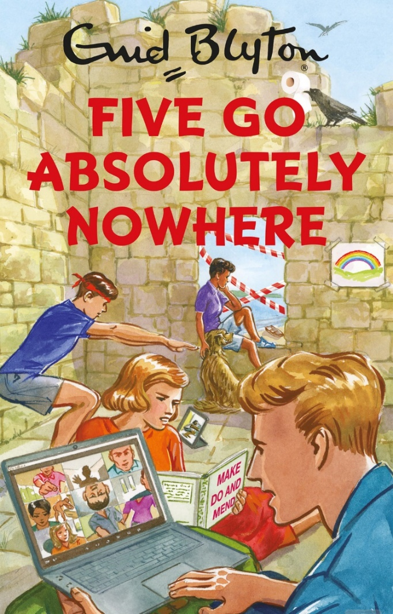
1. What is a parody? How is it different from general comedy?_______________________
____________________________________________________________________________________________________________________________________________________________________________________________________________________________/2

2. Explain what is being parodied in the image on the left. HINT: There is more than one thing.
__________________________________________________________________________________________________________________________________________________/2

3. In the table below, list three of the key features of a parody and briefly explain what effect they are intended to have on the audience.

Feature | Effect on audience
a)

b)

c)

/6
SECTION THREE: CHINESE CINDERELLA – STYLE & CULTURE

1. Give a basic outline of the plot of Chinese Cinderella.
________________________________________________________________________________________________________________________________________________________________________________________________
________________________________________________________________________________________________________________________________
_______________________________________________________________________________________________________________________________________________________________________________________________________________________________________________________________/4

2. List three of the main themes in Chinese Cinderella.

/3

3. An autobiography is subjective. Explain what this means and how it influences the descriptions of characters and events in the novel.
__________________________________________________________________________________

__________________________________________________________________________________

__________________________________________________________________________________

__________________________________________________________________________________

__________________________________________________________________________________

__________________________________________________________________________________

__________________________________________________________________________________

__________________________________________________________________________________
/3

4. Explain the importance or effect of the following components in a novel.

Component | Importance or Effect
Themes
Character
Setting
Writing style
/12

5. Describe some differences between Chinese and Western culture that can be seen in Chinese Cinderella.
________________________________________________________________________________________________________________________________________________________________________________________________
________________________________________________________________________________________________________________________________
________________________________________________________________
________________________________________________________________
_______________________________________________________________________________________________________________________________/5

6. Why is it valuable for us to study other cultures? On what basis should we judge other cultures? Consider personal and spiritual perspectives.
________________________________________________________________________________________________________________________________________________________________________________________________
________________________________________________________________________________________________________________________________________________________________________________________________________________________________________________________________________________________________________________________________
________________________________________________________________________________________________________________________________
________________________________________________________________________________________________________________________________
_______________________________________________________________________________________________________________________________________________________________________________________________/6
SECTION FIVE: INFORMATIVE TEXTS

1. List three things you could look for to decide whether an internet source is reliable.

- _________________________________________________________________________________________________________________________________________________________________________________
- _________________________________________________________________________________________________________________________________________________________________________________
- _______________________________________________________________________________________________________________________________________________________________________________/6

2. The following sentences contain mistakes in academic language. Re-write them in formal language appropriate for an essay.
- It’s stuff like this that makes technology super dangerous and like really unsafe for kids to use. They shouldn’t be sitting around staring at screens all day, it’s just bad for them.

_______________________________________________________________________________

_______________________________________________________________________________

_____________________________________________________________________________/2
- I believe that you can see from the evidence I have listed that the nutrients in leafy greens boost brain activity. This proves my point that healthy food improves mental health.

_______________________________________________________________________________

_______________________________________________________________________________

_____________________________________________________________________________ /2

3. Rephrase the following sentences, making them sound more academic by nominalising.

- We lost the files so we couldn’t find the evidence we needed.

_______________________________________________________________________________

_____________________________________________________________________________/2
- Doctors assessed the patient and found two malignant tumours. They diagnosed her with lung cancer which means they will need to operate.

_______________________________________________________________________________

_______________________________________________________________________________

_____________________________________________________________________________/2

4. What is the difference between a paraphrase and a summary?

________________________________________________________________________________________________________________________________________________________________________________________________
/1
5. Read the paragraph below and paraphrase it in the lines below.

Wombats usually spend their days tucked away in their underground homes. However, they do sometimes come out to sunbathe and warm up, especially when the weather is very cold. They spend their nights foraging for food, or digging new tunnels, entrances, or exits for their ever-expanding burrows. They are herbivores, so most of their time is spent grazing on native grasses. When threatened, a wombat will escape to the nearest burrow, where it can defend itself by crushing a predator’s head with its rump against the roof or wall of the burrow. In the open, an adult wombat can usually hold its own against a single dog but can be overcome by a pair or a pack of dogs.
________________________________________________________________________________________________________________________________________________________________________________________________
_______________________________________________________________________________________________________________________________________________________________________________________________________________________________________________________________________________________________________________________________________________________________________________________________________________________________________________________________/5
6. Read the information below and summarise it on the lines beneath.

Elite-level performances can leave us awestruck. Some might call athletes like Simone Biles and Michael Phelps ‘naturals’ who possess a gift that ‘can’t be taught’. But the idea that humans can be born with inbuilt talent is a pernicious myth. Believing that abilities are limited by genetic predisposition only results in ‘I can’t’ or ‘I’m not’ statements. In nearly all cases, the key to extraordinary performance is simply thousands and thousands of hours of hard, focused work.
This is not to deny the existence of genetic traits or characteristics. Humans are born with a set of physical and mental attributes, some of which may make them more prone to certain strengths or weaknesses. However, this does not mean that we are at the mercy of our genes. Our environment has just as much influence on our lives as our genetic background – in fact, probably much more, although it’s difficult to measure. The role of innate characteristics in shaping extraordinary performance is not that they endow certain individuals with instant ability. Instead, they make a difference in the early stages of skill development, and they influence how much and how well people practice – which is ultimately what makes the difference.
One reason why people believe in the myth of natural talent is the apparent existence of prodigies like Mozart, Picasso, or Tiger Woods. But investigating the stories of these people shows that they did not develop their extraordinary abilities without intense, extended practice. Mozart began training before the age of four, and his first serious compositions were written when he was fifteen, after more than ten years of practice under his father, a famous music teacher who pushed him hard.
To examine the idea, scientists conducted a wide range of studies on the effect of training with skills that are often considered ‘innate’ such as memory or pitch recognition. One found that after an average of 250 hours of practice, college students were able to increase the number of random digits they could recall from 7 to nearly 80. In another study, children were trained in “perfect pitch” – the ability to name a note without hearing another tone for reference. This has long been considered an inborn trait, but by the end of the study, the children had all mastered it. Far from being ‘gifts’ bestowed upon only a lucky few, these are abilities that anyone can develop with the right exposure and training.

Word definitions:
Pernicious = harmful
Elite = expert, best/highest level
Bestowed = given to
Prodigies = people who show amazing skill with little or no training
Predisposition = already existing skill
Prone = likely to have
Endow = give
Innate = inborn
Ultimately = in the end

Summary:
________________________________________________________________________________________________________________________________________________________________________________________________
________________________________________________________________
________________________________________________________________
________________________________________________________________________________________________________________________________
________________________________________________________________________________/5
7. Imagine that you are using the two online articles below as sources in an informative text. Use the table on the next page to help you cite these sources correctly in your bibliography and in-text referencing.
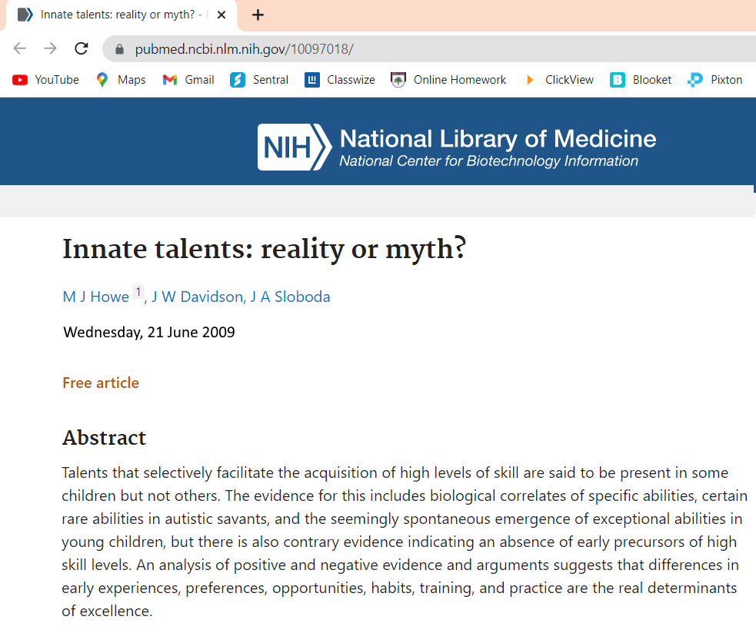

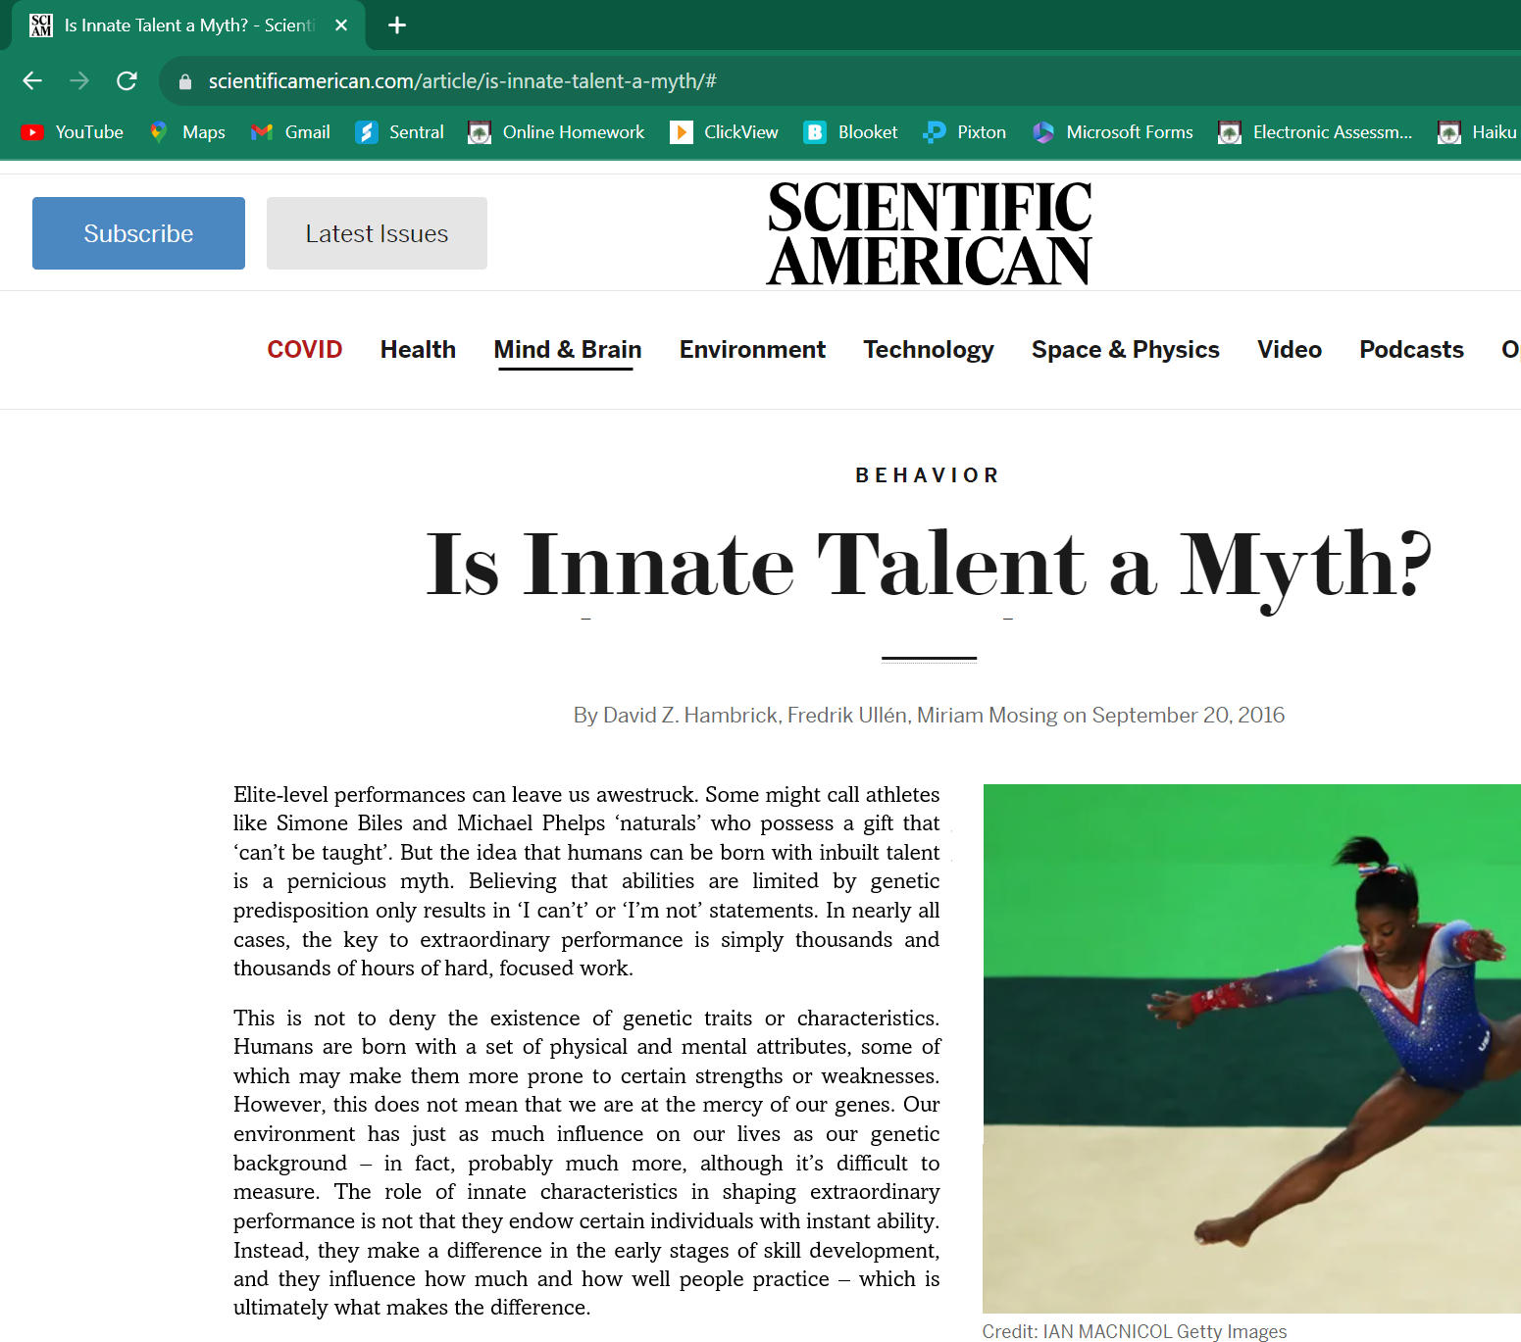
Source 1:
viewed 10 May 2022
Source 2:
viewed 9 July 2022
Type of resource | Info needed | Example
Website (with author) | Author’s last name (comma) first initial (NO comma) Year (comma) Title of webpage in italics (comma) URL (comma) date accessed | Crenshaw, M 2019, Shoe Science, http://famoushoesoftheworld.com, accessed 4 September 2019
Website (no author) | Organisation or company name (NO comma) Year (comma) Title of webpage in italics (comma) URL (comma) date accessed | World Health Organization 2021, WHO recommendations for routine immunization, http://www.who.inmmunization/en, accessed 1 May 2021

In-text referencing (add the correct reference in the blanks)

Humans are born with genetic traits from their ancestors, but “the idea that humans can possess innate talents is a pernicious myth” ______________________________________________. Scientific research including the study of the genetic backgrounds and early lives of many highly skilled individuals proves that “differences in early experiences, preferences, opportunities, habits, training and practice are the real determinants of excellence” _______________________________
__________________________________________________________________________. /2

Bibliography:

________________________________________________________________________________________________________________________________________________________________________________________________
________________________________________________________________________________________________________________________________________________________________________________________________
________________________________________________________________
________________________________________________________________
/6
SECTION SEVEN: PERSUASIVE WRITING

1. For the following six persuasive techniques, give a definition and an example.

Technique | Meaning | Example
Anaphora

Antimetabole

Hypophora

Metonymy

Tripling/Rule of Three

Extended metaphor

/12

2. Read the persuasive speech below and label 5 persuasive techniques that have been used. /5
Are screens harming our children? In the age of technology, we are all passengers on a digital ship, sailing through uncharted waters. The course we set today will determine whether this voyage leads us to the shores of prosperity or the depths of destruction. But let me ask you this, should we allow the very tools that have the potential to elevate us to the peak of human achievement become instruments of our own demise? Is it not our duty to harness these forces for the betterment of humanity, rather than their detriment? Our smartphones and devices, these miniature marvels of engineering, grant us the power to access an unprecedented wealth of information at our fingertips. But what do we do with this power? Do we wield it like wise knights, or do we squander it like reckless jesters? We must choose our path wisely.
My friends, consider Silicon Valley, the heart of technological innovation. The entrepreneurs who reside there are the torchbearers of our collective aspirations. When we debate technology's role, we aren't just debating wires and circuits; we are debating the future of humanity itself. Technology shapes us, and we shape technology. Its power lies in its potential. It can bring nations together, like a bridge connecting distant shores, but it can also create chasms wider than any ocean. The digital divide, which slices societies into haves and have-nots, is a stark reminder that not all are reaping the benefits of technological progress. It is not enough for us to merely accept the status quo. It is not enough for us to be passive spectators in the play of technology. It is not enough for us to accept the narrative that technology's unchecked expansion is inevitable. We must question. We must challenge. We must demand a future that is just, equitable, and sustainable. We must ask ourselves: Are we the architects of our own future, or are we content to be mere passengers on a ship steered by algorithms and profit margins?
Technology has left an indelible mark on our society, and not for the better. Family dinners have been replaced by screens and the laughter of children has been substituted with the eerie glow of smartphones. The tears shed in virtual isolation, the broken connections with our loved ones, and the overwhelming loneliness that often accompanies this digital age - these are the scars etched into the very fabric of our society. We see our children's eyes glazed over with the constant allure of virtual worlds and our elders left behind in an ever-accelerating race for technological advancement. It's time to question: Has technology brought us closer together or driven us further apart? The answer is crystal clear. In our pursuit of progress, we've forsaken the precious bonds that make us human. We must reevaluate the path we're on, for the sake of our humanity and the future of our society.
In conclusion, let us remember the words of John F. Kennedy: "Change is the law of life. And those who look only to the past or present are certain to miss the future." Let us be the captains of our own destiny, using technology as a tool for progress, equality, and the betterment of humankind. For the future is not set in stone; it is ours to shape, and together, we can ensure it's a future where technology is our ally, not our adversary.
Thank you.

3. Choose four persuasive techniques and explain what effect they have on the audience.

Persuasive Technique | Effect on audience
1.

2.

3.

4.

/4

4. In the table below, list three types of hooks and give an example of each.

Hook | Example
1.

2.

3.

/6

5. What is modality? How is it used in persuasive writing?
________________________________________________________________________________________________________________________________________________________________________________________________
________________________________________________________________________________________________________________________________
/2
6. In the following list:
- circle 3 words with HIGH modality
- underline 3 words with LOW modality

must
may
would
unquestionably
potentially
has to
obviously
should
doubtful
never
totally
can
in all cases
apparently
impossible
could
/6

7. Explain the difference between a subjective and an objective claim. Which is more persuasive?
________________________________________________________________________________________________________________________________
________________________________________________________________
_______________________________________________________________/2

8. Explain the difference between connotation and denotation.
________________________________________________________________________________________________________________________________
_______________________________________________________________/2

9. Read the following pairs of words and decide whether they have mostly positive or negative connotations. Put a “P” next to the word with POSITIVE connotations and “N” next to the word with NEGATIVE connotations. (The first one has been done for you as an example)

1. slim__P___
2. dirt cheap _____
3. old _____
4. use _____
5. chatterbox_____
6. determined _____
7. cunning _____
scrawny __N___
affordable _____
vintage _____
exploit _____
talkative_____
stubborn _____
clever _____

/6
10. Why are the connotations of words helpful in persuasive writing?
________________________________________________________________________________________________________________________________________________________________________________________________
_______________________________________________________________________________________________________________________________/2

11. In the table below, list the order of speakers in a debate and briefly outline what they should cover in their speech.

Who speaks | What they say
1.

2.

3.

4.

5.

6.

/12

TOTAL MARKS: /180

