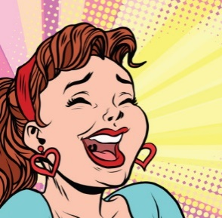
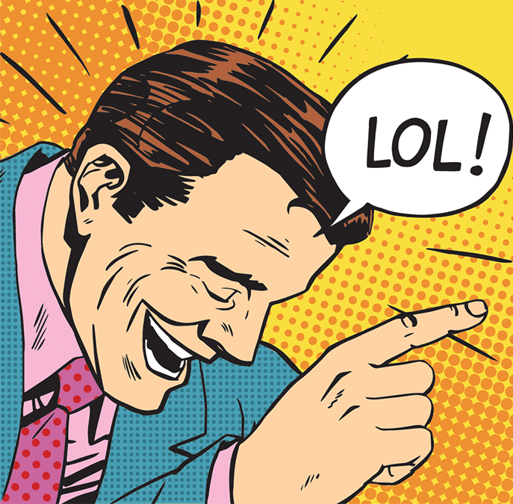
Parody

What is a parody?
A parody is a creative work that copies or imitates something else in order to mock (tease, poke fun at) the original. Parodies can imitate creative works like books, songs, poems or films, or well-known events. They can be found in art, literature, music, animation, internet videos, gaming, and film. A parody is also called a pastiche, a spoof, a lampoon, a satire, a take-off, or a send-up amongst many other names. Parodies normally mock something that is well-known or famous. The joke works best when audience recognises the original.

The main purpose of a parody is to make fun of something, but parodies can also be used to criticize or make a point about the original, in a subtle way. By exaggerating some of the flaws, plot holes, or weak characters in a story, it could point out that it’s not very well written or that the author is self-important and pompous. A parody can draw attention to the fact that the original work demonstrates ideas, behaviours or attitudes that are wrong and need to change.

Parody vs Comedy
Not all comedy is parody, but the two are linked and share a lot of similarities. In order to be a parody, it must be an imitation of something specific. To check whether it’s a comedy or a parody, see if you can recognise an original story, incident, artwork, or film style that is being mocked or mimicked.

Features of a parody
Imitation - the original story should be clearly recognisable. The parody should have a similar plot, similar or the same characters, similar style or wording, some key phrases the same, and a title that is similar or swapped.
- Example: Three Little Wolves and the Big Bad Pig (instead of Three Little Pigs & the Big Bad Wolf)
- Effect on audience: the person listening can recognise the original and knows what is being parodied.

Exaggeration – choosing a feature from the original and making it much MORE (e.g. bigger, louder, more frequent) to the point where it’s unrealistic or ridiculous.
- Example: someone playing piano so fast that their fingers are a blur and smoke starts rising from the keys.
- Effect on audience: Draws audience’s attention to the feature. Adds humour and is memorable. Can be used to show that the original is a bit ridiculous.

Humour – one of the main points of a parody is to entertain and make people laugh!
- Example: Johnny English is about to kiss the girl in his fancy spy car when he accidentally pushes a button which ejects her through the roof.
- Effect on audience: Silliness and jokes keep the audience entertained & make the parody memorable.

Moral or lesson – many parodies are intended to make a point, to show people that certain ideas or behaviours are silly or wrong and need to be changed.
- Example: in the parody Babakiueria, a group of Aboriginal people in military uniforms sail along the river and arrive at a park where some white people are having a BBQ and playing cricket. The leader approaches a white man and asks: ‘what do you call this place’? He replies ‘er… this is the barbecue area’. The leader plants an Aboriginal flag, saying: ‘Babakiueria. Nice native name. I like it.’
- Effect on audience: Using humour and entertainment can be a more subtle and effective way to change people’s minds. Telling them outright they’re wrong often makes them defensive and unwilling to listen. Parody draws them in first by being entertaining, then lets them see for themselves, in a fun way, why it’s wrong.

Caricatures – characters that are exaggerated to create a silly or funny effect. Can exaggerate their physical appearance, behaviour, or personality traits.
- Example: caricatures of Donald Trump often show him with bright orange skin and a huge trailing blonde comb-over.
- Effect on audience: the caricature is intended to draw attention to certain features in a character’s appearance. It can also highlight their mannerisms or characteristic gestures. This helps the reader picture them vividly and remember them.

Wordplay and puns – playing with the double meanings of words or phrases. Deliberately using mixed metaphors, incorrect spelling, or homophones in a funny way.
- Example: “Rindercella slopped her dripper” instead of “Cinderella dropped her slipper.”
- Effect on audience: wordplay is intended to make the audience laugh. It can also be clever or memorable.

Plot twist – a surprise ending, or a development that the audience did not expect.
- Example: the supposed ‘hero’ turns out to be the villain. The reader knows something that the characters themselves don’t. New information right at the end shows that the mystery isn’t solved after all.
- Effect on audience: Subverts expectations – does the opposite of what the reader expects.

