Weekly Vocab – Sarah Burney

Week 1 words:

- Irksome
- Beseech
- Primeval
- Capitulate
- Glean
- Depreciate
- Pathos
- Obfuscate
- Redundant
- Inference

Definitions in own words

- Really annoying or boring
- To beg
- So old it’s before history
- To give in
- To gather something in small amounts, bit by bit
- To get less valuable or worth less money over time
- Words that make you feel something
- Making it unclear or hard to understand on purpose
- Not useful anymore
- An educated guess

Pictures or symbols

- Irksome
- Beseech
- Primeval
- Capitulate
- Glean
- Depreciate
- Pathos
- Obfuscate
- Redundant 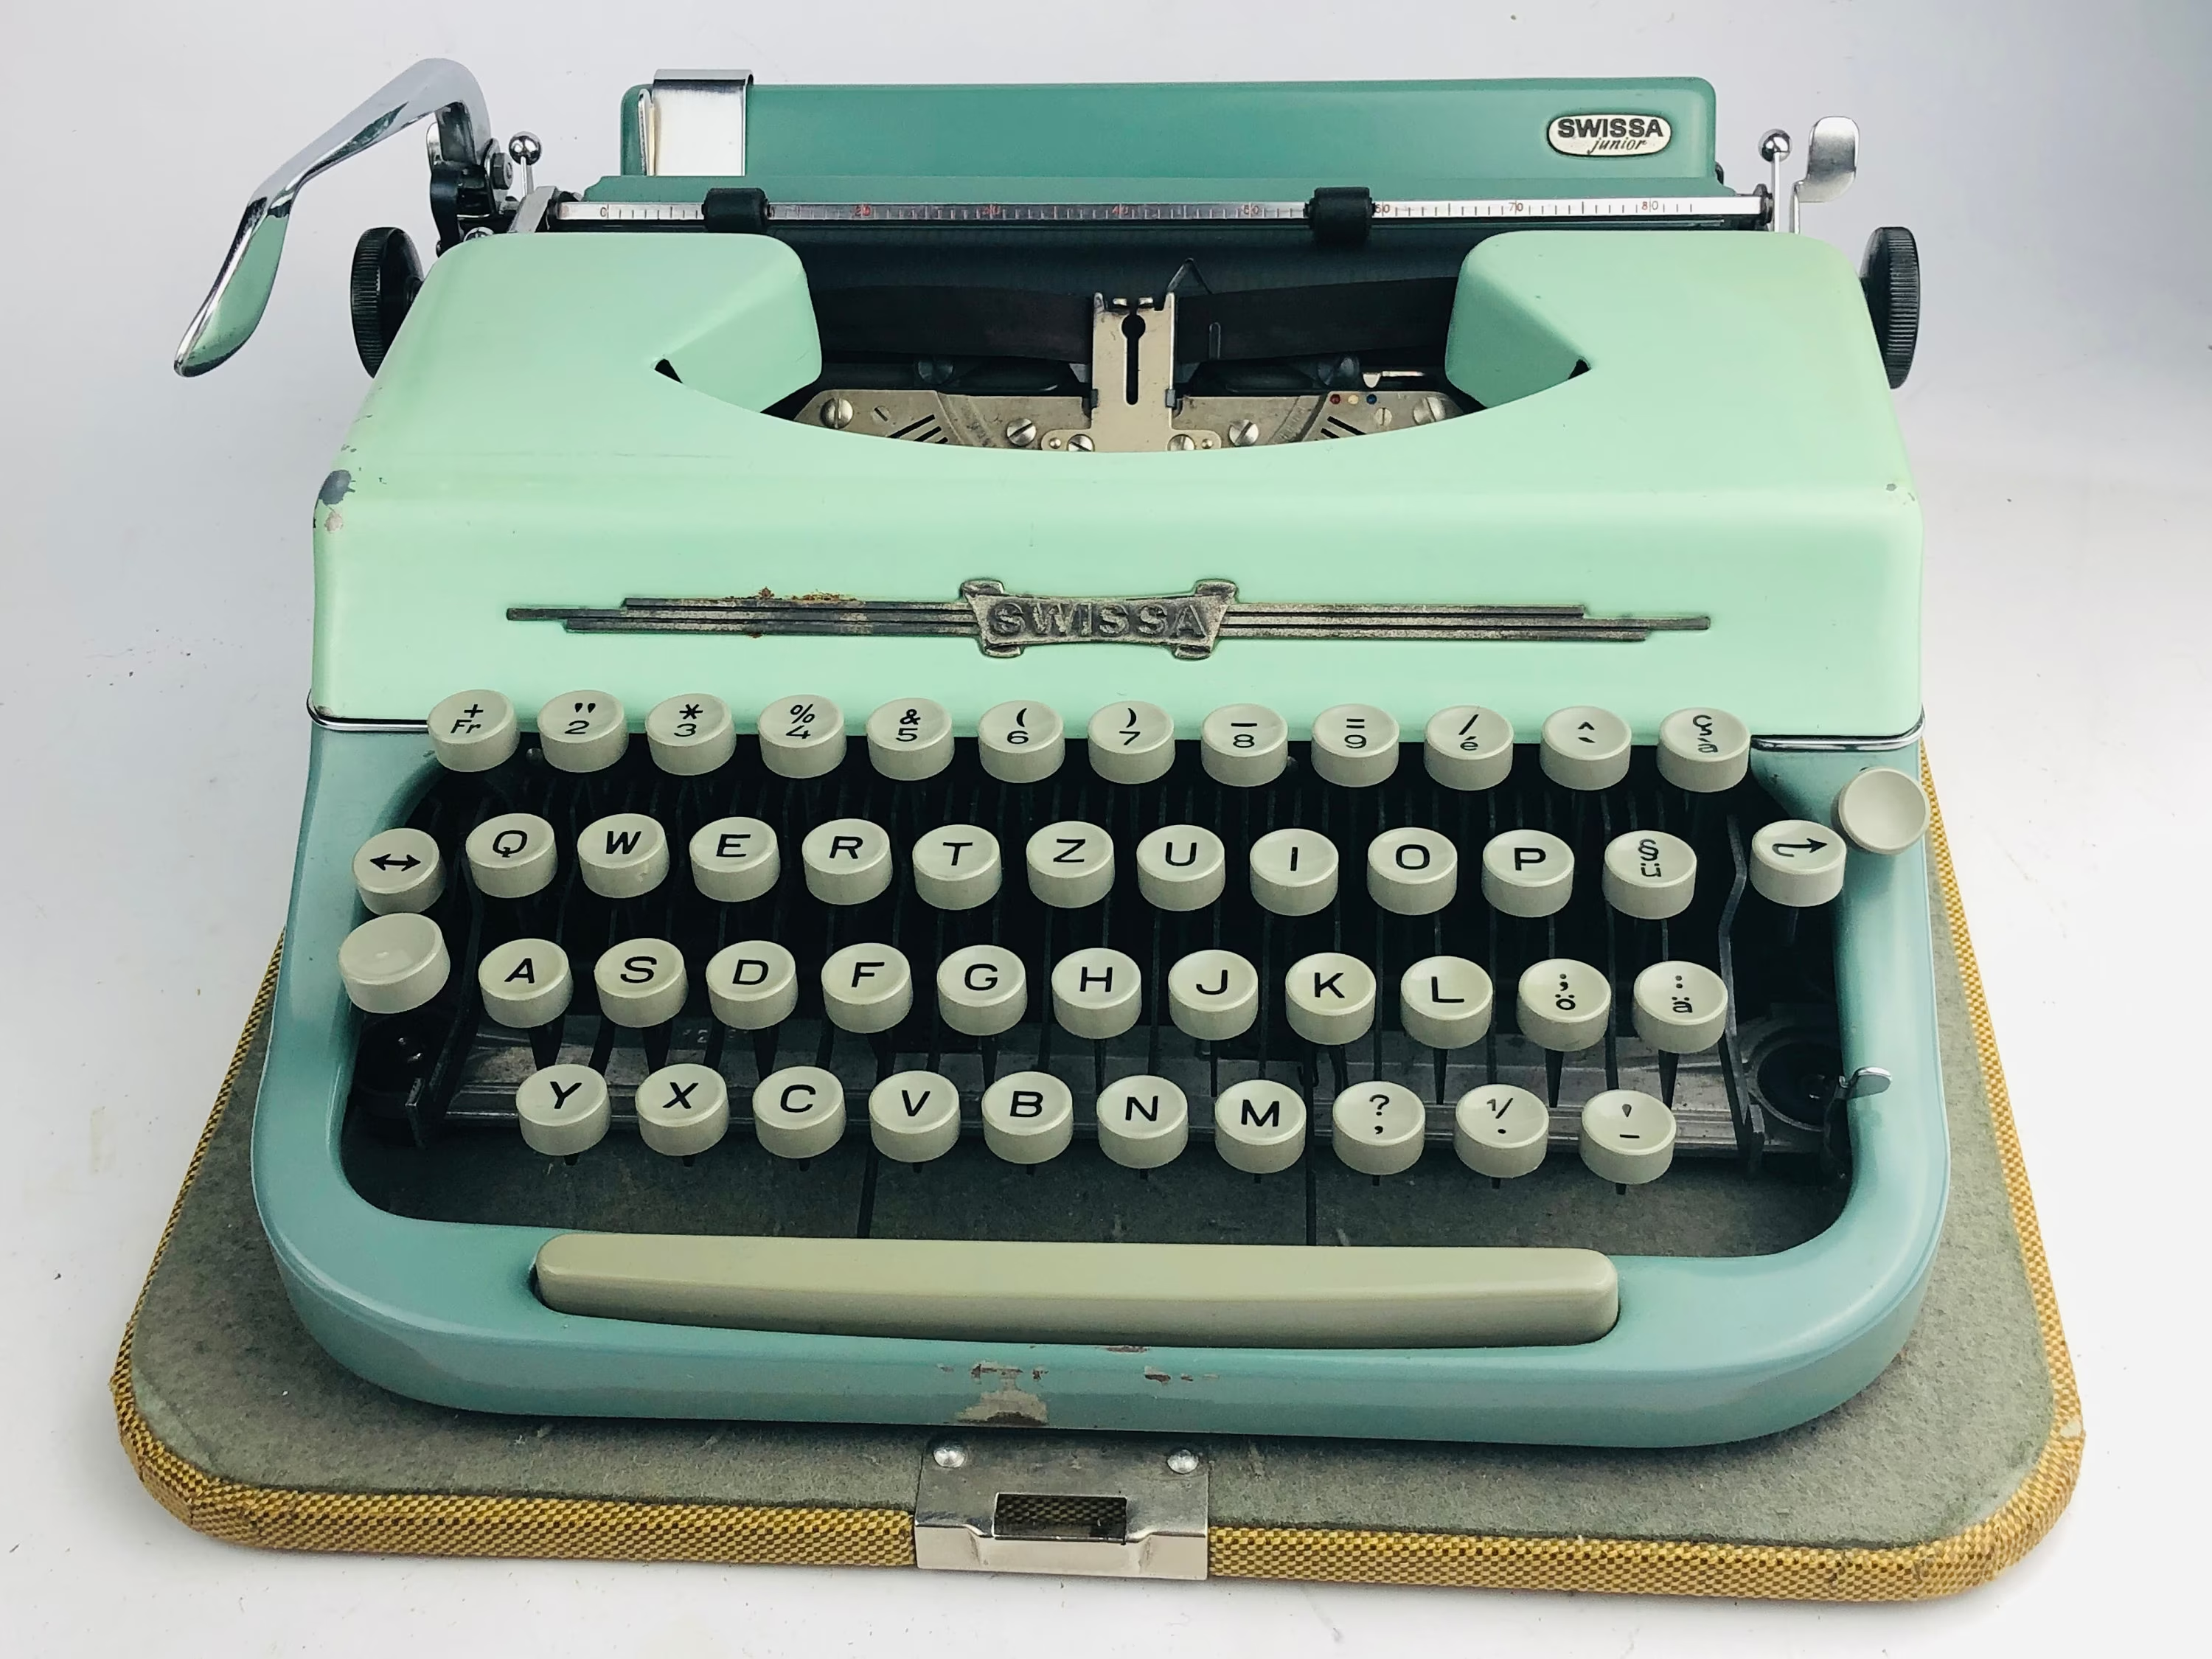
- Inference

Activities
- Sentence: “Kevin found having school photos taken very irksome.”
- Example from life: I had to beseech my dad for driving lessons when I turned 16.
- Synonym & Antonym: ‘Ancient’ is a synonym of primeval. ‘Recent’ is an antonym.
- Etymology: Capitulate comes from medieval Latin capitulare ‘draw up under headings’ which is a reference to a formal agreement of surrender.
- Rhymes: Glean rhymes with mean
- Prefixes/Suffixes: De = lessen or remove, because depreciate means get less valuable
- Analogy: Pathos is like cutting onions cos it can make you cry.
- Connect: Obfuscate is related to irksome because it’s very annoying when something is unclear or hard to understand.
- Haiku: Poor old typewriters
No one needs them anymore
They are redundant
- Change part of speech: Inference is a noun. Infer is the verb form.

Share:
- I shared my haiku with my neighbour.
- They shared their picture for ‘primeval’. It was a picture of a dinosaur.

