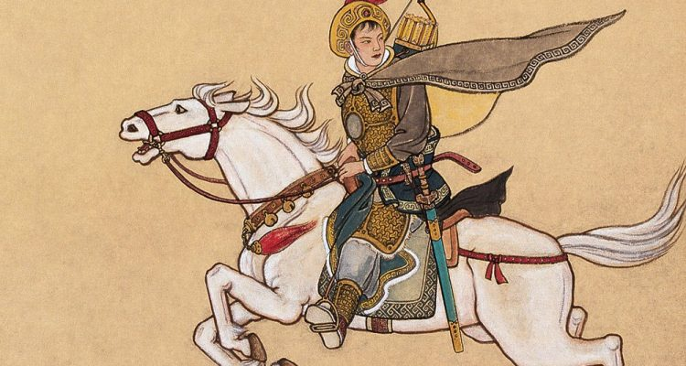
Introduction
The Ballad of Mulan is the oldest known version of Mulan’s story. It was probably composed around 400AD (the final years of Ancient Rome in Europe) and most likely began as a folk tale or a song passed down verbally. The first written version that we know of was anonymous and not dated. Some scholars believe it may have been based on a true story, while others argue that this is unlikely. But the ballad went on to inspire countless retellings in Chinese culture for centuries.

The Ballad of Mulan
Tsiek tsiek and again tsiek tsiek,
Mulan weaves, facing the door.
You don't hear the shuttle's sound,
You only hear Daughter's sighs.
They ask Daughter who's in her heart,
They ask Daughter who's on her mind.
"No one is on Daughter's heart,
No one is on Daughter's mind.
Last night I saw the draft posters,
The Khan (emperor) is calling many troops,
The army list is in twelve scrolls,
On every scroll there's Father's name.
Father has no grown-up son,
Mulan has no elder brother.
I want to buy a saddle and horse,
And serve in the army in Father's place."

In the East Market she buys a spirited horse,
In the West Market she buys a saddle,
In the South Market she buys a bridle,
In the North Market she buys a long whip.
At dawn she takes leave of Father and Mother,
In the evening camps on the Yellow River's bank.
She doesn't hear the sound of Father and Mother calling,
She only hears the Yellow River's flowing water cry tsien tsien.

At dawn she takes leave of the Yellow River,
In the evening she arrives at Black Mountain.
She doesn't hear the sound of Father and Mother calling,
She only hears Mount Yen's nomad horses cry tsiu tsiu.

She goes ten thousand miles on the business of war,
She crosses passes and mountains like flying.
Northern gusts carry the rattle of army pots,
Chilly light shines on iron armour.
Generals die in a hundred battles,
Strong soldiers return after ten years.

On her return she sees the Son of Heaven,
The Son of Heaven sits in the Splendid Hall.
He gives out promotions in twelve ranks
And prizes of a hundred thousand and more.
The Khan asks her what she desires.
"Mulan has no use for a minister's post.
I wish to ride a swift mount
To take me back to my home."

When Father and Mother hear Daughter is coming
They go outside the wall to meet her, leaning on each other.
When Elder Sister hears Younger Sister is coming
She fixes her rouge, facing the door.
When Little Brother hears Elder Sister is coming
He whets the knife, quick quick, for pig and sheep.
"I open the door to my east chamber,
I sit on my couch in the west room,
I take off my wartime gown
And put on my old-time clothes."
Facing the window she fixes her cloudlike hair,
Hanging up a mirror she dabs on yellow flower powder
She goes out the door and sees her comrades.
Her comrades are all amazed and perplexed.
Traveling together for twelve years
They didn't know Mulan was a girl.

"The he-hare's feet go hop and skip,
The she-hare's eyes are muddled and fuddled.
Two hares running side by side close to the ground,
How can they tell if I am he or she?"

Activities

In a word document:

- Write a summary of the poem in your own words.
- List at least 2 similarities and 2 differences between the original ballad and the two film versions that we watched.
- Which film version do you think was more faithful to the original ballad? Give reasons for your answer.
- Which version is your favourite? Why?
- Share your document with me before you go.

