Set 4: Advertisements & Infographic

Text 1: Television advertisement
Watch the advertisement found here: https://www.youtube.com/watch?v=xmYT0__TK20

Questions for Text 1:
- What is the purpose of the ad?
- Who is the target audience for this ad?
- Why does the shot freeze in the middle of the ad?
- Why is the dialogue important to reflect the main message of the ad?
- There is a close up of an instrument inside one of the cars. Why is this included?
- What are the reactions of the 2 drivers?
- The action reverts to normal speed once they are back in their cars. What is the effect of this?
- What impact does the ad’s ending have on the audience?

Text 2: Print advertisement
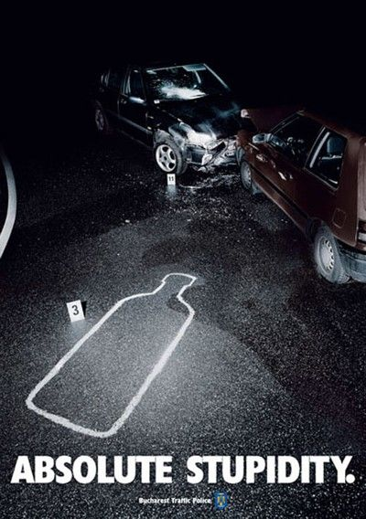

Questions for Text 2:
- What is the purpose of the ad?
- What event is portrayed in the ad?
- Why is the outline marked on the road? What is it referring to?
- How does the ‘body copy’ (text on the page) attract the reader’s attention?

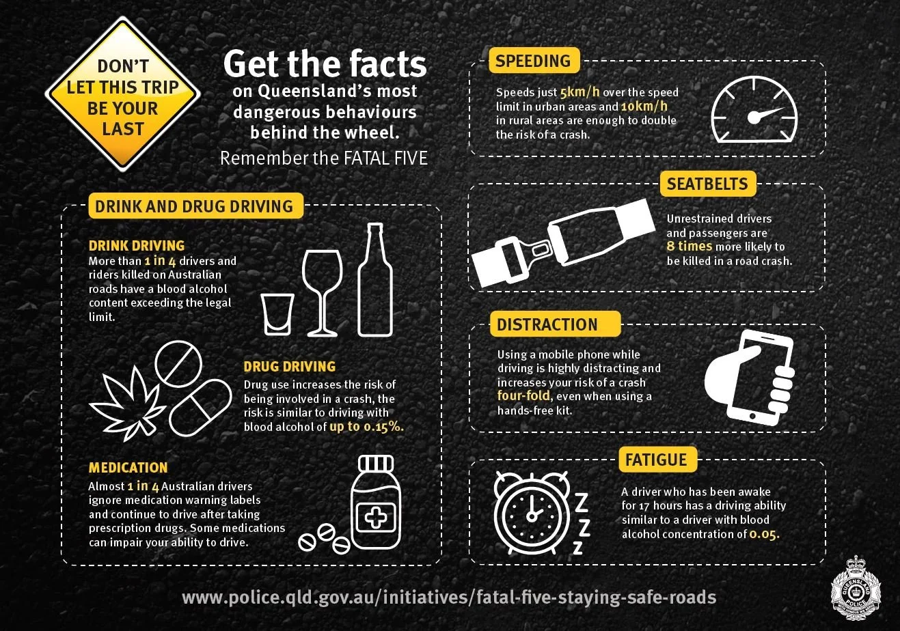
Text 3: Road Safety Infographic

Questions for Text 3:
- What is the purpose of this infographic?
- Who is the target audience for this information? Where do you think it was designed to be displayed?
- How do the icons/images in this infographic add to the message?
- What impact do the facts and statistics listed have on the audience?

Set 4: Questions for Evaluation
- All three of these texts highlight dangerous behaviour on the roads. How have the authors used visual, cinematic and language features to present their ideas, evaluate the experience (directly or indirectly), and engage or challenge the audience?
- Compare the perspective of the two texts. How have the authors used written or visual elements to show their point of view? Are they trying to influence/persuade the audience? How do they want the readers/viewers to feel or act?
- EVALUATE the three texts. Which is more effective at getting the message across, and why? Use persuasive & evaluative language to justify your answer.

