The Three Prejudiced Pigs and the

Wrongfully Accused Wolf

Hi, I’m Harold Lupus. I’m an extremely polite and affable guy and even a little timid by nature, if truth be told, but I’ve been the victim of cruel prejudice all my life. The unfortunate problem is that I’m a wolf. Many of the other creatures in the community look askance at me when I’m just innocently walking down the street. They are afraid just of what I look like, even though they don’t know me. It’s so unfair. I’m the gentlest soul, honestly, but I have these big scary looking teeth. Of course, we wolves have had a great deal of bad press over the years. People will believe anything about us.

I’m going to tell you about the most distressing few months of my life, and it was the result of this evil and stupid prejudice. It all started when I moved into a new town called Swinton. There seemed to be a high proportion of pigs living in the area, which I was initially pleased about as they are intelligent and friendly folk – or so I thought! After quietly settling in for a few pleasant days, I decided to go and meet the neighbours. I learned that the three houses opposite me were occupied by three brothers, all pigs. I started there.

I had noticed as I was moving my furniture in that two of the three houses were quite crudely constructed from some very strange building materials – straw and sticks!? It struck me as odd, but I told myself it would be impolite to comment on it. The curtains of all three houses were always drawn, and at first, I assumed the brothers were away on holiday. Then I noticed a little nose peeking around the curtains on the straw house. Well, perhaps they were a little shy, I thought. What I didn’t realise was that they had harshly pre-judged me, before even meeting me.

I approached the straw house and knocked on the door in a frank and friendly way. The pig opened the door a crack and peeked out nervously. As soon as he saw me, he disrespectfully slammed the door in my face. I heard the lock snap shut and bolts being drawn. I was surprised and hurt. I called out: “little pig, little pig, let me come in!” but he rudely replied, “not by the hair of my chinny chin chin!” I mastered my injured feelings and continued to be reasonable. I shouted out, “There’s no need to huff and puff – we’re neighbours. I’ve bought a house in town!”

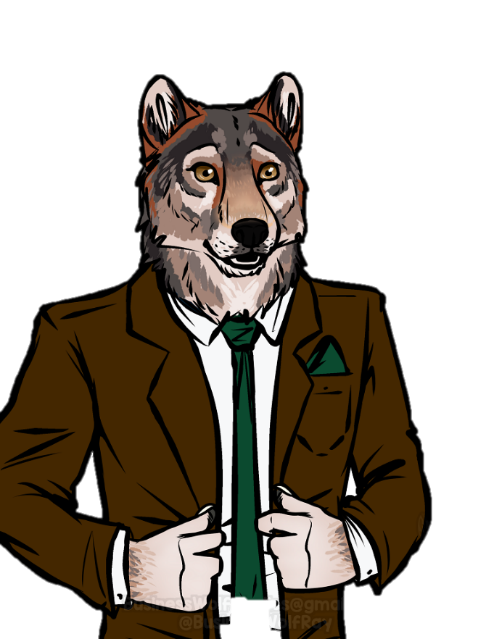As there was no reply I moved on to the next house, hopeful of better treatment from his brother in the stick house. But it was the same dismal experience. This brother didn’t even open his door! I was beginning to feel very discouraged. I wondered if it had been a mistake to move into this neighbourhood. The third house didn’t seem worth trying now, so I turned and began walking back towards my house. But at that moment, something unexpected happened. A slight earthquake shook the ground. It was only minor, probably about 5 on the Richter scale: just enough to rattle some crockery. But the two ridiculous ‘houses’ nearest to me, made from straw and sticks, had not exactly been constructed with earthquake resistance in mind. They collapsed like dominoes.

I rushed over to help the pigs, who were buried. I dug through the rubble of the straw house only to find that tragically, a huge TV screen had fallen on the first brother and broken his neck. I was horrified at this distressing scene. I had never seen death up close before, and it truly shocked me. I hurriedly recovered my presence of mind and ran to the ominous stick pile. The poor pig in this house was harder to recover as he was completely buried. When I eventually found him, he too was in grave trouble. Some of the heavier beams had fallen on him and he had several serious blunt-force traumas to his head. He was bleeding heavily. I tried to stem the flow, knowing from my first aid training that he could die from loss of blood in an incredibly short time. It was then that the third pig finally managed to open his front door. I am not sure why he took so long to respond – he certainly seemed in no rush to help his brothers! I called out to him in distress, but astonishingly, his reaction was to run back inside his house and grab his shotgun. Within moments he was standing over me, threatening me, aiming the gun at my head. He screamed, “get your hands up, you filthy wolf!”

I reluctantly withdrew pressure from the second pig’s wounds. Already he was growing deathly pale. Calmly, I tried to point out to the gun-wielding maniac that I was trying to save his brother’s life, but he just continued yelling at me and waving the shotgun. As I watched, the second brother stopped breathing. Sympathetic tears filled my eyes. It was tragic to see life just slipping away in front of my eyes, knowing I was powerless to stop it. Realising what had happened, the third pig seemed to grow even more enraged. He wouldn’t listen to my quiet words of sympathy at his double loss. He poked me cruelly in the kidney with his shotgun and ordered me to quick march into the centre of town to the police station, where he handed me over to the police.

I spent the rest of the day patiently giving statements, explaining what had happened over and over. I was happy to do so, of course; it was my civic duty as a witness. From the evidence rooms, I could hear the third pig ranting and raving. I hoped he would eventually calm down and see sense, but unfortunately, he did the opposite. He went straight to the tabloids and told *his* version of the story. Predictably, everyone believed him because I was a ‘Big Bad Wolf’, and the victims were ‘little pigs’. You would not believe the details he invented. He said that I had shouted threateningly, “I’ll huff and I’ll puff and I’ll blow your house down” through his window that morning. As if I could blow a house down with my breath! He then claimed he had found me attempting to EAT his brother. I couldn’t believe it. What an utterly disgusting accusation, when I had only been trying to stop him from bleeding to death! In the end he became so fanciful he said he had heard me on his roof, trying to get down his chimney. It’s an absolute disgrace that papers are allowed to publish such nonsense.

It took three months for the police to investigate the case and rush it through court. I was exonerated when the post-mortem on the two brothers clearly ruled their deaths as accidental. Seismic data also confirmed the brief earthquake as the likely cause of the collapse of the two houses. But I will never forget the hate on so many faces of people who didn’t even know what I was really like. Prejudice is a terribly destructive thing. I should know.

