Satire Questions

For each of the cartoons below, answer the following three questions:

1. What are the issue/s under consideration?
2. What behaviour does the cartoonist think needs to change?
3. How does this comic use satire (irony, stereotypes, ridicule, humour)?

Stereotype Questions

1. Why do stereotypes exist?
2. What stereotypes do you think other cultures have of Australia or Australians?
   * Are any of these stereotypes true, to some extent?
3. List some of the negative or harmful effects of stereotypes.
4. What two ways can stereotypes be used in satire to effect positive social change?
5. What stereotypes are used in the cartoon below? What is the author of the cartoon trying to point out about these stereotypes?

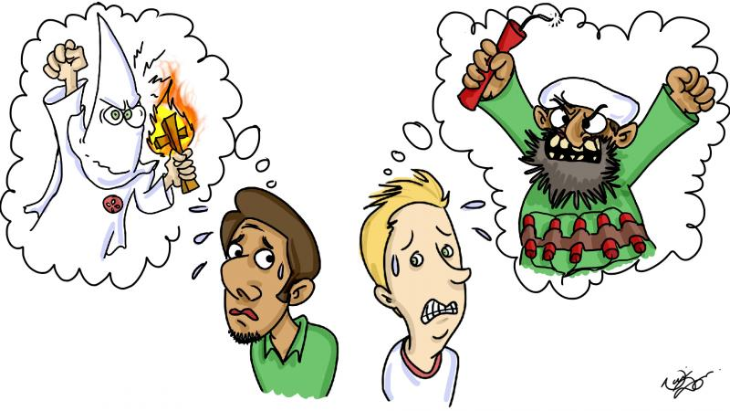

1. Do you think using stereotypes in satire:
   * Is an effective way to challenge people’s beliefs, and will make them see that the stereotype is ridiculous?

**OR**

* + Will not work to change people’s minds, because seeing a depiction of the exaggerated stereotype will strengthen their existing belief that this is “true”?

Which do you think is more likely? Give reasons for your answer.