Self Sacrifice Study Activity
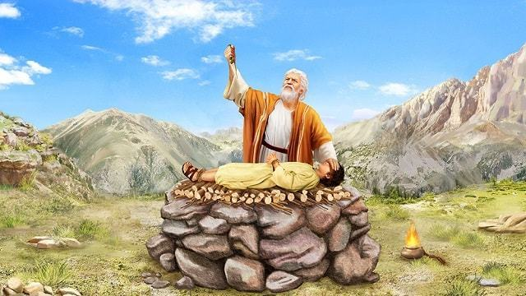
‘To deny oneself for the benefit of others’

Your task over the next couple of weeks will be to conduct a personal study on the subject of self-sacrifice based on the model of the Widows two mites.
Self sacrifice doesn’t replace obedience, but it does cost something. It needs to be an everyday occurance, and can simply be a broken heart that acknowledges God through thanksgiving. Sacrifice pleases God, and has been best modelled by the Lord Jesus Christ.
Step 1 - Choose a Bible character from the list below (if you choose another – seek approval before you start).
Step 2 - Follow the components of Bible study on the reverse side of this page.
Step 3 – Make the connection between your character, their act of self sacrifice, and the ultimate example of self sacrifice as seen in the Lord Jesus Christ.
Step 4 – Identify a way in which your study outcomes will be presented – ensuring that it teaches the concept of self sacrifice to others.
Ideas for presentation include – a podcast, short presentation, study notes, web page, Sunday school lesson plan, meditation, an entry in a Christadelphian magazine, a letter to a friend, play, etc.

Character | Act of self sacrifice (Heb 11)
Abel | A more excellent sacrifice
Enoch | He pleased God
Noah | Prepared an ark to the saving of his house
Abraham | Went out, not knowing whither he went
Sarah | Judged him faithful who had promised
Isaac | Blessed Jacob and Esau concerning things to come
Jacob | Blessed both the sons of Joseph
Joseph | Gave commandment concerning his bones
Moses | Refused to be called the son of Pharaoh’s daughter
Rahab | Received the spies with peace
Gideon, Barak, Samson, Samuel, David, Jonathan, Kings of Judah, Prophets, Simeon, Mary, Joseph, Disciples, Barnabus, Paul, Silas, Cornelius, etc.
What are the components of
Bible study?

Context
- Read the section including verses before and after
- What is the context of the story? – create and answer your own questions about the story.

Difficult words
- Use a Bible dictionary to decipher any difficult words and find out their meanings.
- Does this help to explain the story better?
- Has the word been translated differently anywhere else in the Bible?

Bible Translations
- Read the verses relating to your story in several other Bible translations.
- Which one was better or clearer and why?
- Which one explained the story in a different way?

Cross references (Bible echo’s)
- Look in the Bible margin and look for similarities for stories or ‘Bible echo’s’
- Which cross-references made you think about the story differently?
- List cross-references that don’t seem to be relevant. Suggest ways they might be related.

Commentaries
- Read several other Bible commentaries to see what other people think about the subject
- What different opinions do the commentators have about the main lesson of the story?
- Which opinion(s) do you agree/disagree with?

Things to remember
- Some dictionaries, translations, cross-references or opinions may be biased and/or incorrect.
- It’s important to always use the Bible to interpret itself. If an opinion conflicts with your understanding of other Bible teaching then you need to be particularly careful.
- Some questions may take a long time to answer. Don’t give up!

