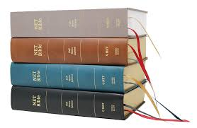

**Writing a How To Guide for Reading the Bible**

* Do an introduction on why it is an advantage to read the Bible effectively. The information document will help you here.
* Include a routine for Bible reading such as is included in the information document.
* Include the list of techniques and resources we have discussed. Make sure you write clear instructions of how to use these things. Use lots of headings and subheadings to keep it organised.
* Use quotes
* 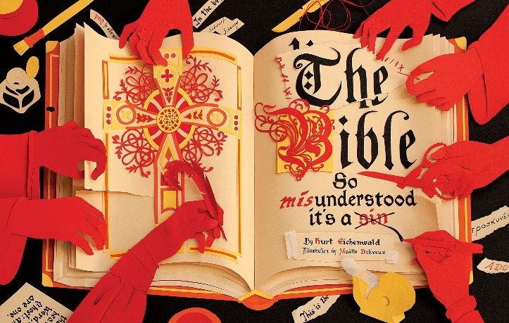Use pictures, colours and formatting to make it attractive