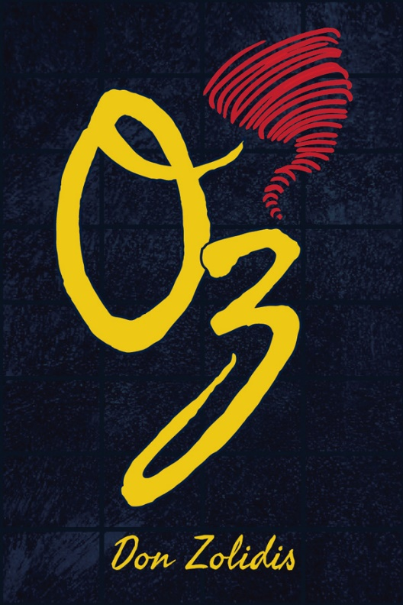
Year 9/10 Drama
Review of a Live Performance
Oz by Don Zolidis performed by the Brooklyn High School Drama Society
Your task: Write a 400-600 word review of a live performance.
Things to include:
- The title and playwright
- How the play used an element of drama to help tell the story
- How the play utilized an off-stage role to help tell the story
- Your opinion on the performance and performers

Play synopsis
Reeling from her sister's death, Beth suddenly finds herself journeying through a world suspiciously resembling the film The Wizard of Oz. But with the yellow brick road sold to foreign investors after a financial meltdown, the Scarecrow revelling in his ignorant bliss, the Cowardly Lion acting like a paranoid sociopath, and the Tin Man embracing his emotional numbness, Beth wonders what role she plays in this classic story gone awry. A hilarious and heart-wrenching exploration of grief and perseverance on the road to acceptance.
In a formal review use formal language where possible.
Use your knowledge from previous units of work as reference points for the elements of Drama and the off-stage roles. Helpful hint- don’t write about the ones we didn’t see anything about eg (front of house)
Due Date: Monday week 7- by email

