Year 9/10 Drama Production Assessment Tasks
Congratulations on such an amazing production! You all worked so hard and it really showed.
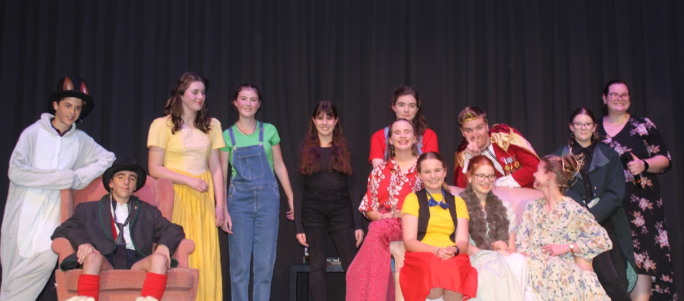

Cinderella and the Substitute Fairy Godmother- 40%
What you need to hand up:
- 10% - 300 word reflection on the Rehearsal/Production/Performance process
  - What you learnt about yourself and your classmates
  - How effectively you contributed to the show
  - What could have been improved on
  - Make sure to include specific examples from the rehearsal process and performances

- Group work reflection sheet- BE HONEST
This will be combined with your marks from the 2 performances (30%)

Cinderella and the Substitute Fairy Godmother Review- 10%
Write a 500-700 word review of the group production focused on:
- The main theme(s) of the play
- How your characters helped to portray the theme
- How you developed your character(s)- include details like voice, physicality, costuming, props etc
- Make sure to use the playwrights name and specific examples from the script to illustrate your point
- How successful overall you were and what you would do differently next time.
Due Date: Monday week 7 by email

