Year 8 Music MuseScore
Composing and Arranging

What you will be marked on:
- Copy Cat Hot Cross piece- in pairs or individual
- Melody Writing Task- individual
- Reflection on work- individual 400 words
Guide
Copy Cat Hot Cross Buns Assignment

- Press new score
- In woodwind, add a flute
- In Keyboards, add a piano
- In Strings Plucked, add a guitar
- Change tempo to 100
- Change bar length (measure)s to 8
- Fill in the title and your names
- Press Done
- Follow along with Aunty Kirsty as you learn the basics of MuseScore

Checklist of skills
- Opening a new score
- Saving Score onto onedrive
- Basic note input, 2 methods- mouse and keyboard
- Multiple notes at once, shift key short cut
- Adding Lyrics
- Adding dynamics
- Printing score only

Melody Writing Assignment
- Follow a similar process to the first assignment and create a new MuseScore file with 3 instruments. One must be piano, one must be either flute or violin and the last may be either drums or guitar.
- You can title your piece whatever you like, but please include your names.
- Save your file.
- Write the ONE of the following chord progressions into your part- choose which one you like most

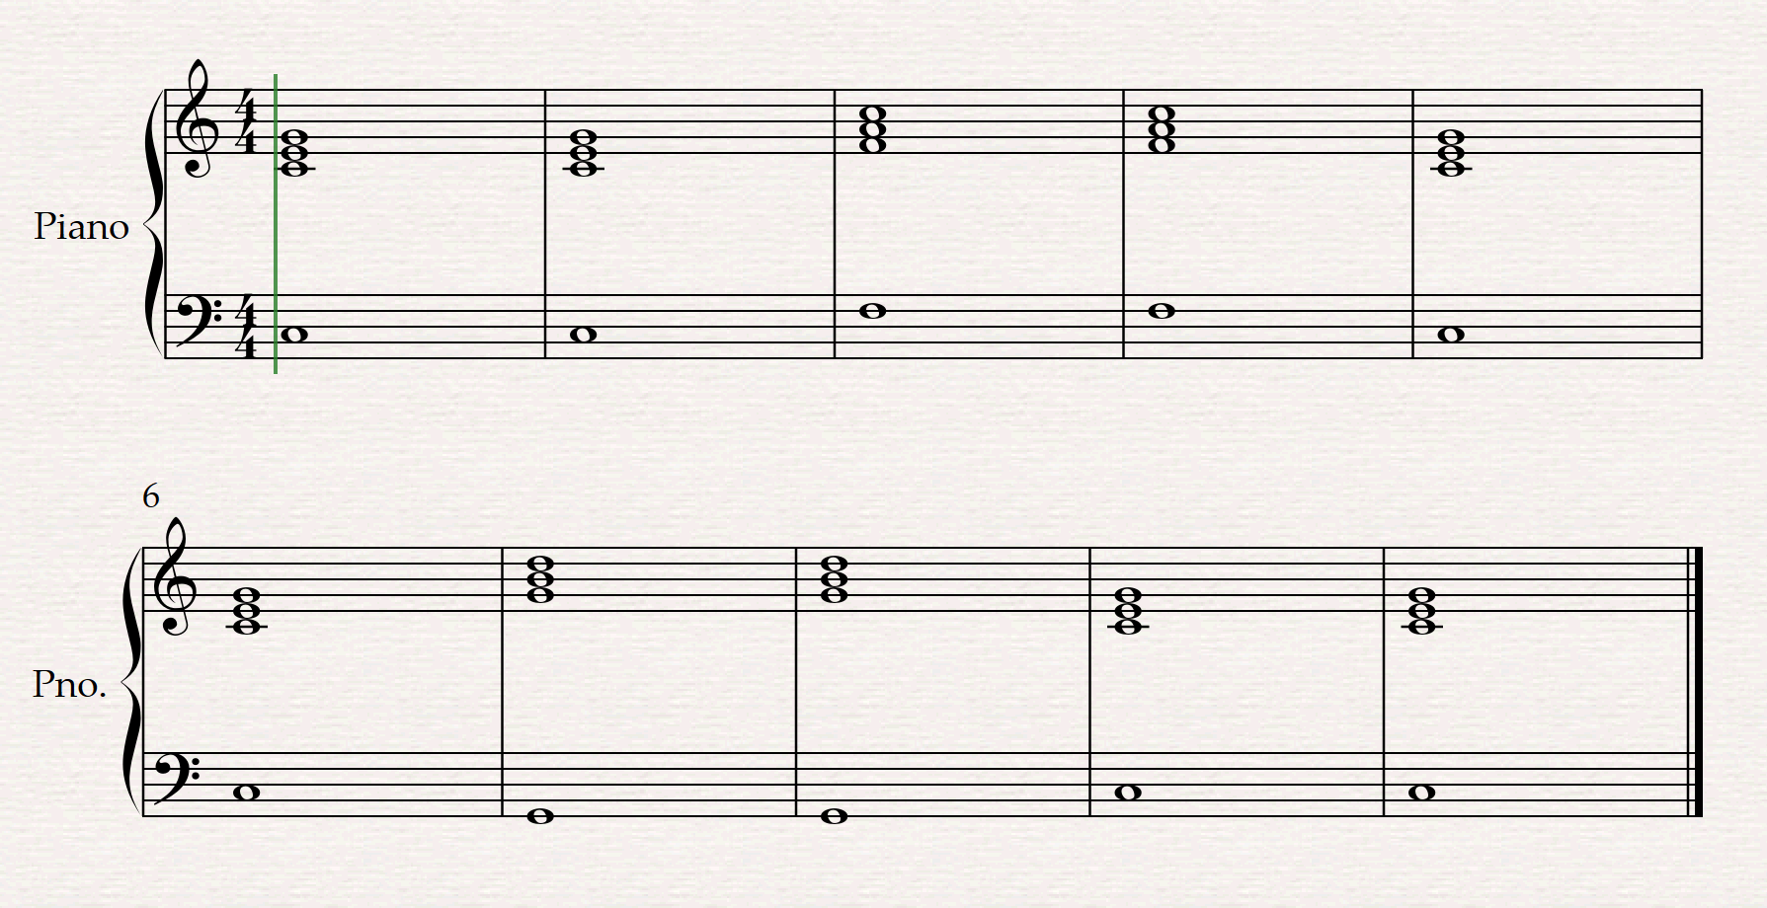
- basic 1,4,5

B) Basic 12 Bar blues

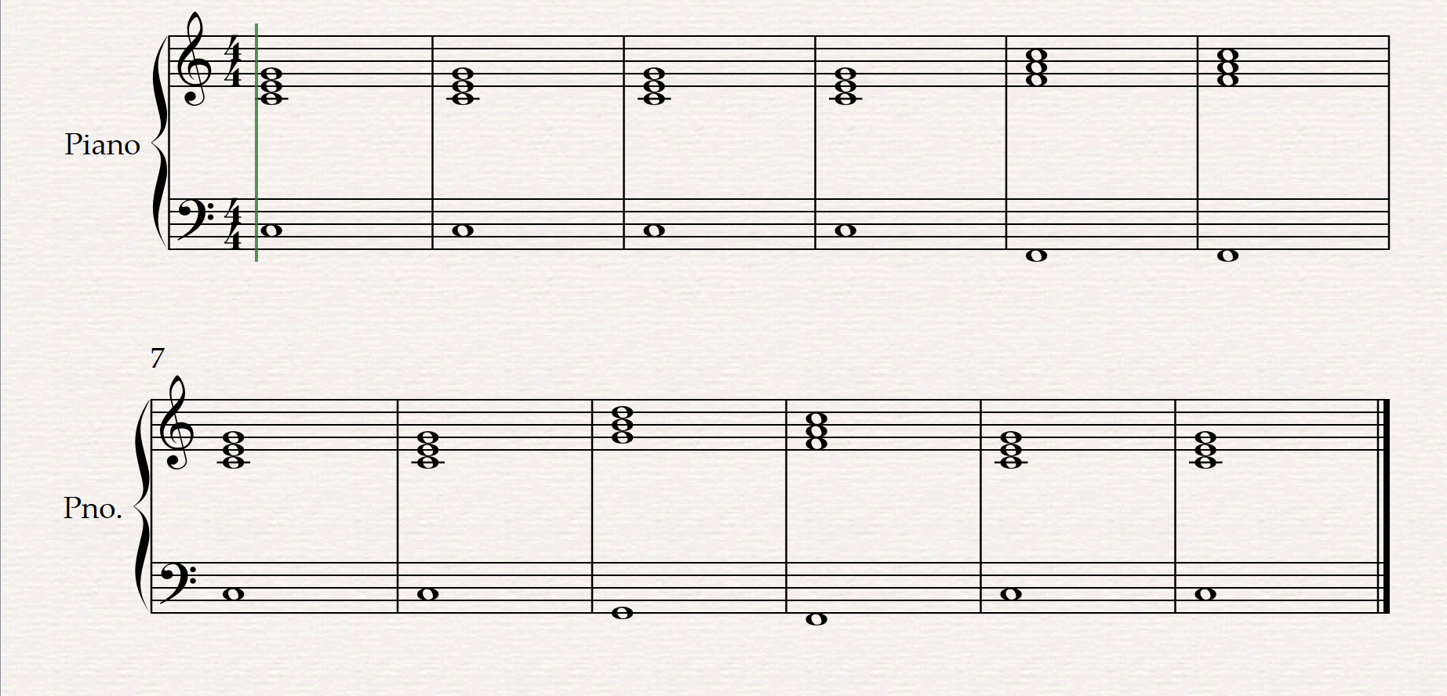

C) 1,4,7,3,6,2,5,1

- Using the given chords as the structure, write a melody on your treble stave that uses the following
  - Crotchets, quavers, minims and at least 3 rests of different types
  - The first note of each bar needs to be one of the notes that are in the piano part
  - Includes call/response or repetition
  - Finishes on a C
  - Doesn’t have too many big jumps or really fast notes that would make it really hard to sing/play

- Optional extension, you can change the rhythms of your piano part, using the same notes but with a fun rhythm

Reflection
Write a 400 word reflection on your experience using MuseScore. You need to use the PEEL paragraph structure. You reflection should include:
- A short introduction, explaining what you completed
- A paragraph explaining what you learnt in the copy cat assignment
- A paragraph explaining what you improved on in the melody writing task and what you thought about your melody you created
- A conclusion including what you took from the experience overall, what you would do differently next time and what you would’ve liked more support/teaching about from me

Rubric
 | WA | AE | E | BE | WB
Copy Cat Arrangement | Completed copy cat arrangement without help, focused and worked excellently as part of a team. | Completed copy cat arrangement with minimal help, mostly on task and teamwork was good. | Mostly completed Copy Cat arrangement with help, generally on task and worked well as a team. | Partially completed copy cat arrangement. Often off task and poor teamwork skills. | Copy Cat arrangement not submitted for marking.
Melody Writing task | Highly effective manipulation of the elements of music to write a melody. Multiple compositional devices used intentionally and effectively, extension in piano part. | Well considered manipulation of the elements of music to write a melody. Well considered use of at least one compositional device. | Competent manipulation of the elements of music to write a melody. Competent use of a compositional device. | Mostly completed use of some elements of music to write a melody. Limited use of a compositional device. | Melody task not submitted for marking.
Reflection | Well- considered reflection on their learning, with specific reference to their creative choices and how successful their choices were. | Considered reflection on their learning, including specific reference to their creative choices. | Competent reflection on their learning, including general reference to their creative choices | Limited reflection on an aspect of their learning, with limited reference to their creative choices. | Very basic reflection on the assignment and learning.

