Irish Traditional Folk Song

# She Moved through the Fair

# Listening Skills

## A

-Listen to Sinead O’ Connor sing this song.

<https://www.youtube.com/watch?v=Tjh1hFg42AQ>

Q1 What instruments do you hear?

Q2 Are there repeated notes at the end of phrases?

Q3 Is the rhythm strict?

Q4 Describe the tempo of the performance.

Q5 How does the performance create the atmosphere of the lyrics?

## B

Listen to Tir Eolas perform the same song

<https://www.youtube.com/watch?v=GYkozYc6wfs>

Q1 What family of instruments play the drone at the start of the piece?

Q2 Which instrument is being plucked in the introduction?

Q3 Compare the tempo of this recording to recording A

Q4 What percussion instrument is played at the end of the first verse?

Q5 Describe two differences between the first and second verse.

## C

Listen to Celtic Woman perform the song <https://www.youtube.com/watch?v=6Tvnn4XzxJY>

Q1 What Irish traditional instrument is heard at the beginning?

Q2 What is heard immediately after this instrument that is different to recordings A and B?

Q3 Is the rhythm strict or free?

Q4 This is a modern performance. Name one feature that makes this clear.

Q5 The last line of the second verse and the third verses features _________________ .

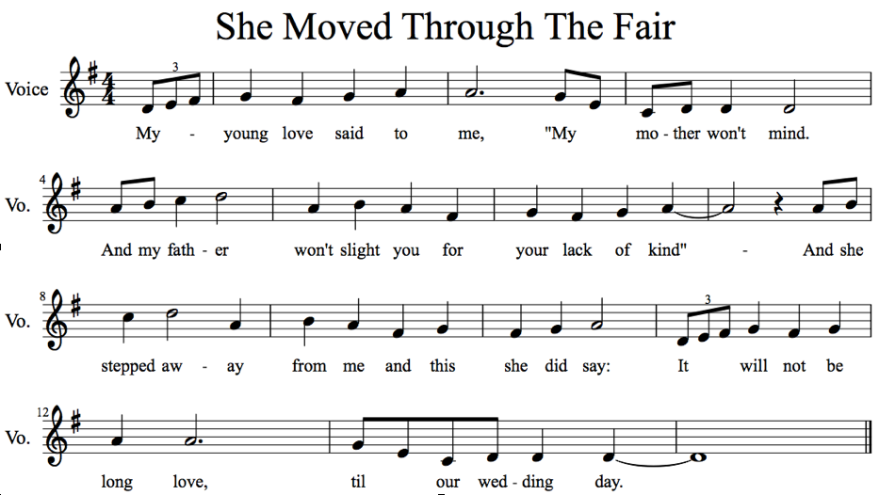

# Music Theory

Q1 What key is the music written in?

Q2 Explain the time signature marked

Q3 What melodic technique is used at the end of the 3rd and 13th bar?

Q4 How many phrases are in the piece?

Q5 What is the form of the piece?

Q6 Explain the rhythm used on the first word “my”

Q7 This piece features an upbeat. What is another word for this?

Q8 Explain the rest used in bar 7

Q9 Syncopation is not a feature of Irish music. Why does it appear in the notated piece above?

Q10 What is the range of the piece?