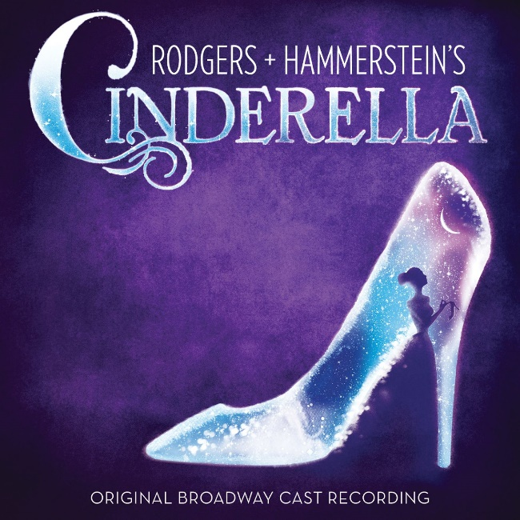Year 8 Drama

Review of a Live Performance

**Cinderella**

Rogers and Hammerstein

**Your task: Write a 400 word review of a live performance.**

Things to include:

* The title
* At least one theme of the play and how it contributed to the story
* Your opinion of the show

In a formal review use formal language where possible.

**Due Date: week 7 in lesson**

|  |  |  |  |  |
| --- | --- | --- | --- | --- |
| WA | AE | E | BE | WB |
| Highly creative and well-reasoned opinions with evidence to support. Well written with correct grammar and editing. | Creative and reasoned opinions with some supporting evidence. Generally correct grammar and editing | Reasoned opinions with some evidence to support. A few grammatical errors. | Limited or not supporting evidence to back up ideas. Lack of editing. | Assignment not completed. |