Greek Theatre Group Assignment

**Your Task:** Decorate your mask in the style of a Greek Theatre Mask and create a short performance using two or more Greek Theatre techniques.

**Due Date:** Term 3, Week 4 Tuesday

**Requirements:**

Your mask needs to show an emotion of your choosing as clearly as possible, choose your decoration and modifications to the mask to highlight and express your emotion.

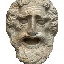In groups of 4 or 5 create a short performance using at least 2 of the following Greek Theatre techniques.

* 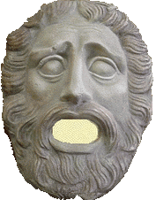Canon
* Unison
* Stichomythia
* Locomotor Movement
* Gestural Movement
* Chorus
* Exaggeration
* Repetition

|  |  |  |  |  |  |
| --- | --- | --- | --- | --- | --- |
|  | WA | AE | E | BE | WB |
| **Mask** | Completed mask design, highly creative and well designed mask with accurate and extended references to Greek Theatre | Completed mask design showing evidence of creativity and design, accurately referencing Greek Theatre | Completed Mask design, referencing Greek Theatre | Partially completed mask, design is unclear | Unfinished or missing mask. |
| **Performance** | Group Performance accurately demonstrated 5+ techniques, was highly rehearsed, demonstrated excellent mask use and was completely memorised. | Group Performance accurately demonstrated 3-4 techniques and showed evidence of rehearsal and excellent mask use. | Group performance demonstrated 2 different techniques and was generally coherent and rehearsed. | Group performance was limited in technique and poorly rehearsed. | Group performance was unprepared and lacked technique. |