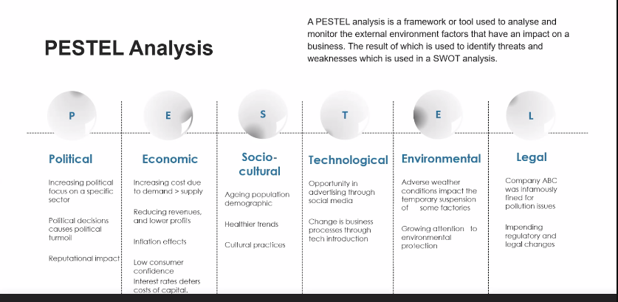

Political
Economic
Socio-Cultural
Technological
Environmental
Legal

