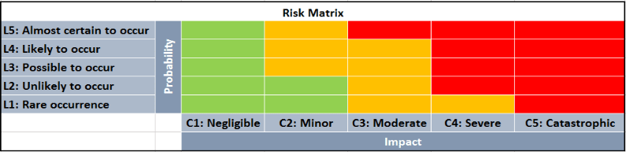
RISK MANAGEMENT REGISTER

RISK ASSESSMENT FOR ___________________
DATE _______________

Risk no. | Risk title: Name of risk | Description of Event: There is a risk that… | Cause of the Event : Because of… | Effect of the Event... With the result that: | Risk Category e.g. (PESTLE) | Probability | Impact | Risk Rating (High/ Medium/ Low) | Risk Response / Contingency plan
example | Supply of goods/materials | Suppliers may not deliver materials to site timeously | Selected goods and materials need to be sourced from overseas vendors/suppliers | Goods/materials may arrive late to site resulting in schedule delays and cost overruns | Economic | L3 | C4 | High | Locate suppliers within Queensland to ensure materials arrive on time so that construction avoiding schedule delays

