0



Definition

Characteristics

Examples

Elasticity diagram

Perfect knowledge for both producers and consumers.

All prices, resources and technologies are known.

* Large number of buyers and sellers
* Identical (homogenous) products
* No buyers or sellers can influence market.
* Price taker
* No barriers to entry
* Fruit and vegetable growers
* Lawn mowing services
* Cleaning services



Perfect Competition



Definition

Characteristics

Examples

Elasticity diagram

This is a market structure in which many firms sell products that are similar but not identical.

* Large number of small sellers
* Product differentiation
* No significant barriers to entry
* Some control over price
  + Non-price competition
* Coffee shops
* Restaurants
* Hairdresser
* Bakery



Monopolistic competition

-



Definition

Characteristics

Examples

Elasticity diagram

A market structure dominated by a few large firms which supply most of the market.

* Few firms in the market
* Product differentiation
* Non-price competition
* High barriers to entry
* Airlines
* Mobile phones
* Sport clothing
* Grocery stores



Oligopoly

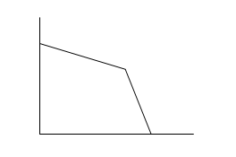



Definition

Characteristics

Examples

Elasticity diagram

A market structure in which there is only one seller of a product that has no close substitutes and high barriers to entry.

* Only one seller supplies the whole market.
* Price maker
* Unique product / service
* Australia Post
* The only doctor in a small country town.
* The only KFC in a small country town.



Monopoly

