Find the hidden item…

How many faces do you count?

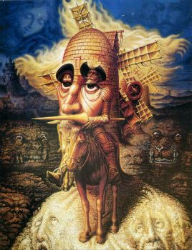

**Market Structures**

4 different types of market structures

Characteristics of each type



Price

Choice

Barriers to entry

Quality

* Price takers – no influence on price
* Low profit margin
* Homogenous (identical) product
* Variety of choice
* Large choice of sellers
* Large choice of buyers
* Buyers cannot distinguish between the quality of products by the look, feel, size or colour.
* No barriers to entry – freedom of entry and exit.



Perfect Competition



Price

Choice

Barriers to entry

Quality

* Price makers – set own prices
* Firms compete with pricing
* Lowering prices for higher qty sales
* Raise prices – based on quality
* Similar products (not identical)
* Variety of choice
* Large choice of sellers
* Large choice of buyers
* Distinguish quality through marketing, branding different quality levels
* Relatively low – freedom of entry and exit



Monopolistic Competition



Price

Choice

Barriers to entry

Quality

* Price maker / price setter
* Predatory pricing
* Price wars
* Product differentiation
* Interdependence of firms
* Reward schemes / loyalty programs
* Innovation / improvements to gain more customers
* High cost to entry / high set up costs
* Established rivals with market share.
* Legal requirements
* Access to key resources



Oligopoly



Price

Choice

Barriers to entry

Quality

* Price maker – set whatever price they want because they are the only supplier within the market.
* Unique product
* No close substitutes / limited choice for customers.
* Sometimes low quality products, no substitutes available
* No incentive to innovate
* High barriers to entry
* High start-up costs
* Legal requirements
* Access to key resources



Monopoly



Perfect Competition

Monopolistic Comp

Monopoly

Oligopoly

* Low profitability – so many other producers selling exactly the same thing.
* Slightly easier to make profit – products are slightly different, maybe even better, so you can charge more.
* Slightly easier to make profit – customers are normally loyal to brands. If one raises prices, the other may lower prices and take away customers.
* Very easy to make high amounts of profit – because this one is the only seller, so they can charge whatever price they want.



Profitability

**Market Structures Match Game**

**SUMMARY / reflection**

3 Recall

2 Interesting

1 Question