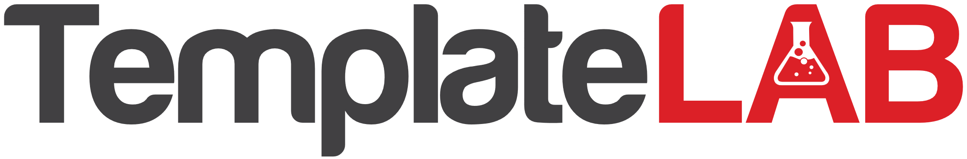
Costs
Fixed Costs
Examples

Any expense that a business incurs during the manufacturing or production process for its goods and services.
Expenses that remain the same no matter how much a business produces.
These costs are completely independent of a business’s specific activities.
- Rent
- Property tax / council rates
- Insurance
- Depreciation

COSTS

Costs
Variable Costs
Examples

Any expense that a business incurs during the manufacturing or production process for its goods and services.
Expenses that change depending on how much a business produces and sells.
Variable costs increase as production rises and decreases as production falls.

- Labour / wages
- Utilities / electricity
- Raw materials
- Commissions

COSTS

Pricing strategy
Brainstorm
Examples
Research
A method to determine how much to charge for a product or service.
How much will it cost to make one unit? Determine a price to cover that and still make a profit.
- How much does a similar product or service sell for?
- How big is the market?
- Which pricing strategy would be best?
- Cost-plus pricing
- Manufacturer suggested retail prices
- Competitive pricing
- Premium pricing
- Value pricing

Pricing
Examples

- Retailers
- Manufacturers
- Fee for service
- Freemium provider
- Direct sales
- Franchise
- Subscription
- Bundling
- Razor and blades
- Marketplace
- Pay as you go

Business Models

LIST THE…
CASH INFLOWS: | CASH OUTFLOWS:
Revenue streams:  - Direct sales  - Value add ons  - Licensing & media  - Subscriptions | Expenses:  - Labour / wages  - Commission  - Advertising  - Deliver / freight  - Insurance  - Legal fees (trademark etc)  - Office / printing  - Rent  - Phone / internet  - Utilities / electricity
Initial start up loan | Interest payable on loan from bank
Owner savings
Gift / crowd sourcing

If you have a positive balance (cash in hand), then you have sufficient funds to meet our commitments.
If you have a negative balance (no cash in hand), you’re in trouble and will need to source additional funds (bank overdraft).

