| - | Finding and Solving Problems | Contextual Application | Analysis and Evaluation |
| --- | --- | --- | --- |
| A | Insightful identification and exploration of problems and/or needs using a customer-focused approach.  Highly creative generation of innovative and viable solutions to problems and/or needs using a customer-focused approach. **A+** | Perceptive and highly effective contextual application of decision-making and project management tools and strategies.  Astute creation and application of business intelligence to iteratively develop business models and plans **A+**  Perceptive contextual application of communication and/or collaborative skills. **A+** | Discerning evaluation of business models and plans.  Critical analysis and evaluation of opportunities and challenges for business in the digital age.  Insightful analysis and evaluation of social, economic, environmental, and/or ethical impacts of global and local business. |
| B | Well-considered identification and exploration of problems and/or needs using a customer-focused approach.  Creative generation of viable solutions with some innovation to problems and/or needs using a customer-focused approach. | Well-considered and effective contextual application of decision-making and project management tools and strategies.  Purposeful creation and application of business intelligence to iteratively develop business models and plans.  Mostly perceptive contextual application of communication and/or collaborative skills. | Well-considered evaluation of business models and plans.  Mostly critical analysis and evaluation of opportunities and challenges for business in the digital age.  Well-considered analysis and evaluation of social, economic, environmental, and/or ethical impacts of global and local business. |
| C | Considered identification and exploration of problems and/or needs using a customer-focused approach.  Mostly creative generation of viable solutions to problems and/or needs using a customer-focused approach. | Considered contextual application of decision-making and project management tools and strategies.  Competent creation and application of business intelligence to iteratively develop business models and plans.  Effective contextual application of communication and/or collaborative skills. | Considered evaluation of business models and plans.  Some critical analysis and evaluation of opportunities and challenges for business in the digital age.  Considered analysis and evaluation of social, economic, environmental, and/or ethical impacts of global and local business. |
| D | Some identification and exploration of problems and/or needs using a customer-focused approach.  Some generation of solutions to problems and/or needs using a customer-focused approach. | Some application of decision-making and project management tools and strategies.  Some creation and application of business intelligence to iteratively develop business models and plans.  Some contextual application of communication and/or collaborative skills. | Some analysis and description of business models and plans.  Some analysis and description of opportunities and challenges for business in the digital age.  Some analysis and description of social, economic, environmental, and/or ethical impacts of global and local business. |
| E | Attempted identification and exploration of problems and/or needs using a customer-focused approach.  Attempted generation of solutions to problems and/or needs using a customer-focused approach. | Attempted application of decision-making and project management tools and strategies.  Attempted creation and application of business intelligence to iteratively develop business models and plans.  Attempted application of communication and/or collaborative skills. | Attempted description of business models and plans.  Description of opportunities and challenges for business in the digital age.  Description of social, economic, environmental, and/or ethical impacts of global and local business. |

SunStick Business Report

Stage 2 Business Innovation: Annesley Farren

# Executive Summary

SunStick reminds customers to reapply sunscreen through an accessible and convenient product, ensuring protection from the sun at a competitive price. A razor-and-blade business model creates recurring revenue. Marketing strategies will make SunStick readily accessible throughout Australia through low price and intensive distribution, maximising profit and building a financially sustainable business model.

Contents

Executive Summary 2

Table Of Figures 4

Market Analysis 5

Industry Overview 5

Key Competitors 5

Growth and Trends 6

Target Market 7

Market Segments 7

Market Size 7

Demographics 8

Marketing Strategies 9

Marketing Objectives 10

Promotional Methods 10

Branding 11

Proposed Revenue Model 12

Proposed Pricing Strategies 13

Cash Flow Statement 15

Income Statement 15

Conclusion 16

References 17

Appendices 18

# Table Of Figures

Figure 1: Comparison of SunStick and Key Competitors 5

Figure 2: Number of Sunscreen Products Sold Annually (2016 to 2021) 6

Figure 3: Market Size Analysis 7

Figure 4: Target Market Analysis 7

Figure 5: SunStick logo 11

Figure 6: SunStick bottle 11

Figure 7: Cost Structure Analysis 12

Figure 8: Revenue made by each product per month 13

Figure 9: Revenue made by ear product per month over the first three years 14

Figure 10 Break-Even Analysis 14

Figure 11: Cash Flow Statement 18

Figure 12: Income Statement 19

Figure 13: PESTEL Analysis 20

Figure 14: Value Proposition Canvas 21

# Market Analysis

## Industry Overview

### Key Competitors

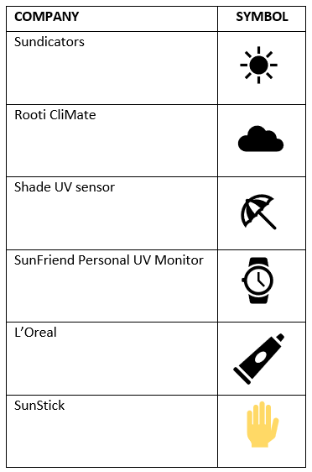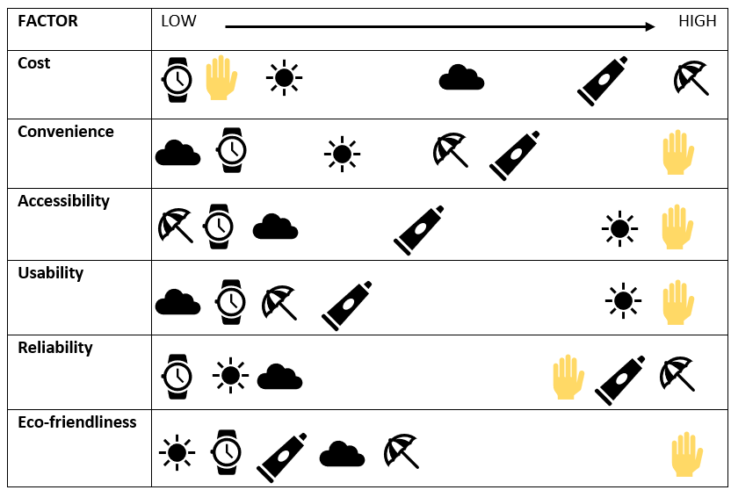SunStick holds competitive advantage over competitors through a business model that addresses customer pains and gains. The table below compares SunStick to its competitors.

5

4

3

2

1

**KEY:**

*Figure 1: Comparison of SunStick and Key Competitors*

**[1][2][3][4][5]**

NOTE: As SunStick uses photosensitive ink rather than an electronic device, it cannot be ranked with reliability than the electronic products

**SunStick’s Key Competitive Advantages:**

* Cost efficiency
* Accessibility
* Usability
* Convenience
* Eco-friendliness
* Reliability

### Growth and Trends

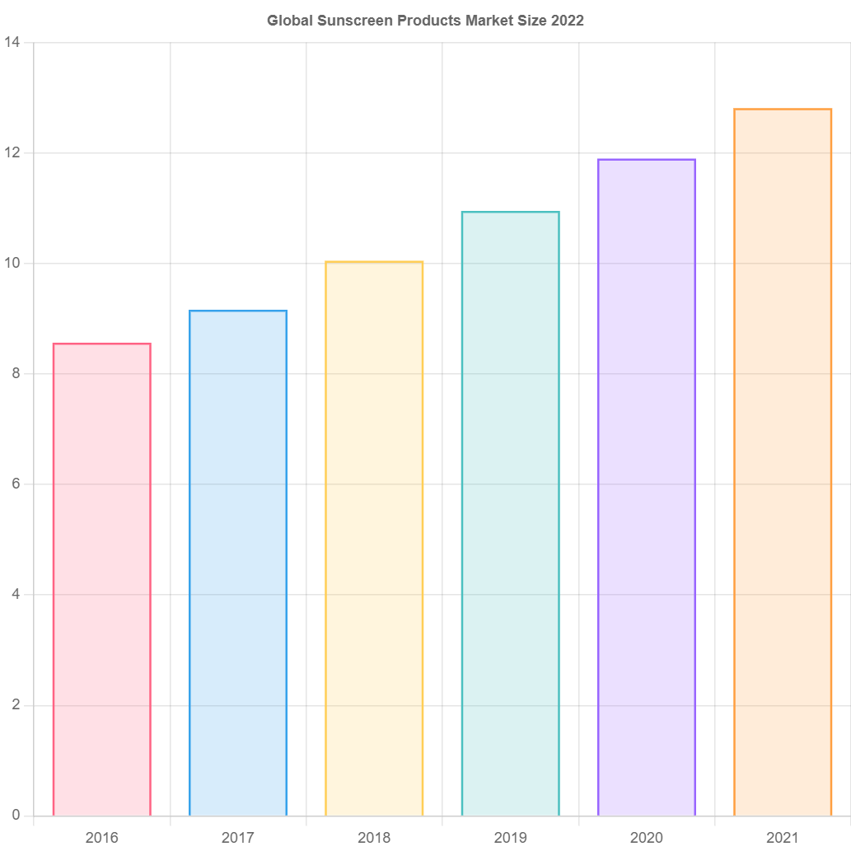The industry in which SunStick operates is experiencing a steady-growth market, which appears sustainable.

Number of products sold (billion)

*Figure 2: Number of Sunscreen Products Sold Annually (2016 to 2021)* [6]

A PESTEL analysis at Appendix 3 helped identify key current trends in the industry. These include:

* Increasing demand for sun care products in the younger generation (age 15-29), particularly athletes and those regularly outdoors, due to increasing awareness regarding sun safety, and a rising spending capacity within this population.
* Increasing preference for eco-friendly and natural sun care products.

SunStick will focus on accommodating these market trends within the product to enhance customer satisfaction, promote the cooperative nature of its brand.

The industry is expected to grow by 5.6% p.a. throughout the next decade, reaching $3 billion annual sales in Australia.[7] An increase in demand for SunStick’s product is expected due to this large growth.

## Target Market

The target market is 15 – 50-year-olds as they are typically educated on sun safety, and regularly use sunscreen. The specific cohorts are young adults (aged 15 to 29) and mothers (aged 30 to 50) who are concerned about their children’s sun-safety.

### Market Segments

Key sunscreen users in Australia:

|  |  |
| --- | --- |
| **Market type:** | **Customers:** |
| Total Addressable Market | $≈$ 14 million sunscreen-users |
| Serviceable Addressable Market | $≈$ 9 million within target market |
| Serviceable Obtainable Market | $≈$ 1 million (considering target market, resource limitation, budget, marketing, and competitors) |

*Figure 3: Market Size Analysis [8]*

### Market Size

*Figure 4: Target Market Analysis*

The chart above realistically estimates the target market size. Market growth is expected due to industry growth.

### Demographics

Targeted marketing and product design is obtained by understanding qualities and characteristics of the target market. Qualities of SunStick’s target market are identified below.

* Aged 15-50
* Australian
* Spend time outdoors – active lifestyle
* Value personal wellbeing
* Environmentally Conscious

The product is intended for mothers to use on their children. To reduce purchase resistance in this demographic, the product has high usability through the simple colour-change signal and high durability through waterproofness, preventing unintentional removal. This also benefits other target markets, such as young adults, as it can be worn for sporting and swimming activities.

Feedback was sought from individuals of all demographics when designing the product to ensure easy usability and convenience for all target markets.

## Marketing Strategies

The 7 P’s use a customer-focused approach to create tactical marketing.

**PRODUCT:**

* Usable
* Reliable
* Cost-efficient
* Clean, organised layout of information on container
* Convenient size for transportation
* Eco-friendly
  + Refillable container
  + Recyclable cardboard refill packets
* Caring brand personality – created through friendly marketing

**PRICING:**

* Market penetration strategy – lower price-point than competitors
* Razor and blade model – expensive initial purchase, ongoing inexpensive purchases

**PLACE:**

* Operating base (production & distribution) – Adelaide
* Intensive distribution
  + Products available in supermarkets, chemists and online with Australia-wide shipping

**PROMOTION:**

* Mass-marketing strategy
  + Website
  + Collaboration with Cancer Council
  + Sample stall in Glenelg for potential consumers to trial the sensor
  + Distribute wristbands with sun-activated ink to Australian schools

**PEOPLE:**

* Efficient employees
* Friendly customer-service

**PROCESS:**

* Easy usability – visually guided procedure, simple colour-coded signals to follow

**PHYSICAL EVIDENCE:**

* Sample stall
* Promotional wristbands
* In-store products

### Promotional Plan

MARKETING OBJECTIVES:

* Profit-maximisation, increased sales
  + Through low-price, mass-marketing strategies and intensive distribution
  + Product readily available Australia-wide.
* Market-share Leadership
  + Cost-competitive, attracting and retaining customers
  + Bottle can only be refilled with SunStick sunscreen – custom-nozzle required

ADVERTISING:

* E-Marketing
  + low-cost
  + large audience catchment (including target market)
  + spreads brand-awareness
* Word-of-mouth
  + creates a positive business image
  + customers verify its worth
* Sample distribution
  + allows potential customers to trial the product, proving that it works
  + distribution of samples at Glenelg, and UV sensitive wristbands though Cancer Council SunSmart Schools program, reaching all of the target market.
* Brand Collaboration
  + Cancer Council, a well-known and trusted brand with a similar brand personality and target market, introduces SunStick to potential customers and provides brand credibility
  + SunStick will produce the product, Cancer Council will sell.

PUBLIC RELATIONS:

* Ensure balance between purpose and profit – SunStick’s priority on customer health promotes positive customer relations, building trust and loyalty
* Customers inclined to choose SunStick based on their perception that the brand respects the environment

TESTING AND EVALUATING:

Promotions will be tested on market segments before launch to highlight issues, optimising customer response rate and cost effectiveness.

# Branding

SunStick conveys a friendly branding to customers, portrayed through the logo and packaging designs.

The logo design represents the purpose and identity of SunStick:

* The icon represents the sun, which SunStick provides protection from
* Earthy colours convey the brands’ ecological values, and are representative of a sunset, creating a connection with the outdoors
* Bright colours and playful styling represent the relationship between SunStick and customers

Environmentally-friendly product packaging is consistent with the branding, lending credibility.

*Figure 5: SunStick logo*

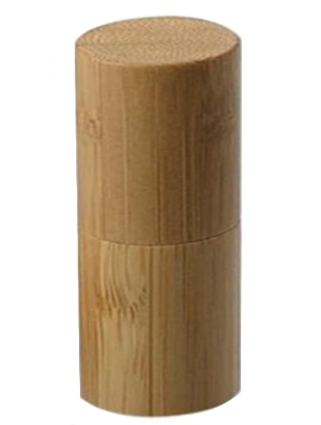

*Figure 6: SunStick bottle*

# Proposed Revenue Model

SunStick uses a razor-and-blade model to generate reliable, recurring income by avoiding competition, attracting customers, and guaranteeing customer loyalty.

Customers purchase a wooden bottle containing UV sensor and sunscreen. They are able to purchase carboard refill packages to restock the container. The benefits of these purchases are:

* Low-cost appeals to money-conscious customers
* Refillable container appeals to environmentally conscious customers
* Competitive advantage as SunStick refills are required to refill the bottle

The relatively low cost of the original purchase is covered by customer loyalty and continual refill purchases.

Individuals within the target market were interviewed, expressing their willingness to buy refills.

The table below identifies the approximate monthly and annual profit SunStick anticipates. The recurring revenue model allows for a predictable estimate of the revenue stream, given customers purchase the expected number of refills. The need for this business model was shown through the value proposition canvas at Appendix 4 since a consistent revenue stream is required to optimise overall business profits.

|  |  |  |  |  |  |  |  |  |  |
| --- | --- | --- | --- | --- | --- | --- | --- | --- | --- |
| **Product** | **Description** | **Price Per Product** | **Cost of production Per Product** | **Monthly Revenue at Initial Purchase Per Customer** | **Monthly Profit** | **Monthly Revenue After Initial Purchase Per Customer** | **Monthly Profit** | **Yearly Profit Per Customer – includes initial purchase + 6 refills** | **Yearly Profit Per 10,000 customers** |
| SunStick Bottle: | Includes 350g Cancer Council Mineral SPF 50+ sunscreen, 150g sensor, and refillable wooden tube | $40 | $12.00 | $40.00 | $28.00 | $0.00 | $0.00 | $28.00 | $280 000 |
| Sunscreen Refill: | 350g Cancer Council Mineral SPF 50+ sunscreen | $20 | $6.00 | $0.00 | $0.00 | $20.00 | $14.00 | $84 | $840 000 |
| Sensor Refill: | 150g SunStick UV Sensor | $15 | $4.00 | $0.00 | $0.00 | $15.00 | $11.00 | $66 | $660 000 |

*Figure 7: Cost Structure Analysis*

# Proposed Pricing Strategies

The pricing strategies SunStick utilises are competition-based.

Market research was performed, compiling the competitor’s prices and features to price SunStick accordingly.

SunStick products are significantly cheaper than the majority of competitors, attracting budget-conscious customers. One competitor, SunFriend, had low prices, at which SunStick could not effectively operate at. SunStick, however, holds a competitive advantage over SunFriend due to being more wearable, made of organic and eco-friendly materials, and waterproof at any depth, all of which appeals to the target market. Another competitor, Sundicator, had similar pricing to SunStick, however SunStick holds competitive advantage through convenience, reusability, and eco-friendliness. For these reasons, customers will likely choose SunStick over competitors, choosing to pay a small price premium for a superior product.

By using a competition-based pricing strategy, SunStick attracts customers with a lower price-point than competitors.

*Figure 8: Revenue Made By Each Product*

*Figure 9: Revenue Made By Ear Product Per Month Over The First Three Years*

YEAR 1

Breakeven Point – 750 products (assuming an average of all product types)

*Figure 10: Break Even Analysis*

## Cash Flow Statement

The cash-flow statement at Appendix 1 shows the financial growth of SunStick over the first year of trading. Key observations include:

* Initial funding of $40,000 contributed by the business owner to produce and patent products
* Net cash sales increase over warm months, and decrease in cooler months[9] as seasonal factors influence sales volumes
* Fixed costs of patents, marketing, and website development total less than the total revenue

## Income Statement

The income statement at Appendix 2 shows the predicted number of sales and revenue over the first 3 years of trading. Key observations include:

* The number of customers rapidly increases
* The initial purchase of the bottle produces the most revenue, therefore new customers will be beneficial
* Wage expenses increase in years 2-3 as more part-time employees are required to support the increase in customers
* Patent and facility expenses recur annually
* Marketing intensity reduces as awareness drives word-of mouth promotion, meaning a high initial marketing spend that tapers off over time

# Conclusion

SunStick provides its customers with an affordable and convenient product that keeps them safe, and which generates recurring revenue through a razor and blade business model. Through the ongoing purchase of refills by customers, SunStick will break even at 750 products sold, as an average of all product types. Profits will be maximised through low price and intensive distribution, making SunStick products readily accessible throughout Australia.

Word Count: 1,200

# References

*Australian Bureau of Statistics*, 2021, ‘Regional population by age and sex’, accessed 12th July 2022, <<https://www.abs.gov.au/statistics/people/population/regional-population-age-and-sex/latest-release>>.

*Cancer Council*, 2017, ‘Almost half of Australians confused about sunscreen’, accessed 27th July 2022, <<https://www.cancer.org.au/media-releases/2017/almost-half-of-australians-confused-about-sunscreen>>.

*KickStarter*, ‘CliMate’, accessed 10th July 2022, <<https://www.kickstarter.com/projects/962920513/climate-create-your-own-friendly-environment>>.

*L’Oreal*, ‘My UV Patch’, accessed 10th July 2022, <<https://www.lorealtechincubator.com/myskintrackuv>, <https://www.lorealtechincubator.com/myuvpatch>>.

*Reports* Express, 2022, ‘Global Sunscreen Products Market Report 2022’, accessed 12th July 2022 <<https://reportsexpress.com/global-sunscreen-products-market-report-2022/>>.

*Shade,* accessed 10th July 2022, <<https://www.wearshade.com/>>.

*Sundicators*, accessed 10th July 2022 <<https://sundicators.com/>>.

*Transparency Market Research*, 2022, ‘Sun Care Market’, accessed 12th July 2022, <<https://www.transparencymarketresearch.com/sun-care-market.html#:~:text=Sunscreen%20products%20are%20widely%20popular%20in%20consumers%20as,the%20adoption%20of%20these%20products%20in%20the%20region>>.

*Cancer Council*, 2015, ‘Do I need to use sunscreen in winter?’, accessed 5th August 2022, <<https://www.skinclinicfremantle.com.au/sunscreen/>>.

*WearableTech*, ‘SunFriend Personal UV Monitor’, accessed 10th July 2022, <<https://wearabletech.io/sunfriend-personal-uv-monitor/>>.

# Appendix 1: Financial projections

*Figure 10: Cash Flow Statement*



# Appendix 2: Income Statement

*Figure 11: Income Statement*



# Appendix 3: PESTEL Analysis

*Figure 13: PESTEL Analysis*

# Appendix 4: Value Proposition Canvas

*Figure 14: Value Proposition Canvas*

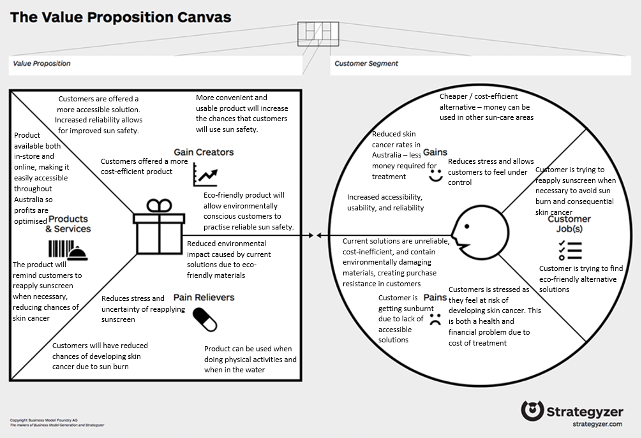

| - | Finding and Solving Problems | Contextual Application | Analysis and Evaluation |
| --- | --- | --- | --- |
| A | Insightful identification and exploration of problems and/or needs using a customer-focused approach.  Highly creative generation of innovative and viable solutions to problems and/or needs using a customer-focused approach. **A+** | Perceptive and highly effective contextual application of decision-making and project management tools and strategies.  Astute creation and application of business intelligence to iteratively develop business models and plans. **A+**  Perceptive contextual application of communication and/or collaborative skills. **A+** | Discerning evaluation of business models and plans.  Critical analysis and evaluation of opportunities and challenges for business in the digital age.  Insightful analysis and evaluation of social, economic, environmental, and/or ethical impacts of global and local business. |
| B | Well-considered identification and exploration of problems and/or needs using a customer-focused approach.  Creative generation of viable solutions with some innovation to problems and/or needs using a customer-focused approach. | Well-considered and effective contextual application of decision-making and project management tools and strategies.  Purposeful creation and application of business intelligence to iteratively develop business models and plans.  Mostly perceptive contextual application of communication and/or collaborative skills. | Well-considered evaluation of business models and plans.  Mostly critical analysis and evaluation of opportunities and challenges for business in the digital age.  Well-considered analysis and evaluation of social, economic, environmental, and/or ethical impacts of global and local business. |
| C | Considered identification and exploration of problems and/or needs using a customer-focused approach.  Mostly creative generation of viable solutions to problems and/or needs using a customer-focused approach. | Considered contextual application of decision-making and project management tools and strategies.  Competent creation and application of business intelligence to iteratively develop business models and plans.  Effective contextual application of communication and/or collaborative skills. | Considered evaluation of business models and plans.  Some critical analysis and evaluation of opportunities and challenges for business in the digital age.  Considered analysis and evaluation of social, economic, environmental, and/or ethical impacts of global and local business. |
| D | Some identification and exploration of problems and/or needs using a customer-focused approach.  Some generation of solutions to problems and/or needs using a customer-focused approach. | Some application of decision-making and project management tools and strategies.  Some creation and application of business intelligence to iteratively develop business models and plans.  Some contextual application of communication and/or collaborative skills. | Some analysis and description of business models and plans.  Some analysis and description of opportunities and challenges for business in the digital age.  Some analysis and description of social, economic, environmental, and/or ethical impacts of global and local business. |
| E | Attempted identification and exploration of problems and/or needs using a customer-focused approach.  Attempted generation of solutions to problems and/or needs using a customer-focused approach. | Attempted application of decision-making and project management tools and strategies.  Attempted creation and application of business intelligence to iteratively develop business models and plans.  Attempted application of communication and/or collaborative skills. | Attempted description of business models and plans.  Description of opportunities and challenges for business in the digital age.  Description of social, economic, environmental, and/or ethical impacts of global and local business. |

1. Sundicators, accessed 10th July 2022 <<https://sundicators.com/>>.
2. *KickStarter*, ‘CliMate’, accessed 10th July 2022, <<https://www.kickstarter.com/projects/962920513/climate-create-your-own-friendly-environment>>.
3. Shade accessed 10th July 2022, <<https://www.wearshade.com/>>.
4. *WearableTech*, ‘SunFriend Personal UV Monitor’, accessed 10th July 2022, <<https://wearabletech.io/sunfriend-personal-uv-monitor/>>.
5. *L’Oreal*, ‘My UV Patch’, accessed 10th July 2022, <<https://www.lorealtechincubator.com/myskintrackuv>, <https://www.lorealtechincubator.com/myuvpatch>>.
6. *Reports* Express, 2022, ‘Global Sunscreen Products Market Report 2022’, accessed 12th July 2022 <<https://reportsexpress.com/global-sunscreen-products-market-report-2022/>>.
7. *Transparency Market Research*, 2022, ‘Sun Care Market’, accessed 12th July 2022, <<https://www.transparencymarketresearch.com/sun-care-market.html#:~:text=Sunscreen%20products%20are%20widely%20popular%20in%20consumers%20as,the%20adoption%20of%20these%20products%20in%20the%20region>>.
8. *Australian Bureau of Statistics*, 2021, ‘Regional population by age and sex’, accessed 12th July 2022, <<https://www.abs.gov.au/statistics/people/population/regional-population-age-and-sex/latest-release>>.
9. *Cancer Council*, 2015, ‘Do I need to use sunscreen in winter?’, accessed 5th August 2022, <<https://www.skinclinicfremantle.com.au/sunscreen/>>.