Task 3
Sophie Luke
SurfSpace Marketing & Financial Strategies
2021

Executive Summary
SurfSpace’s objective is to provide surfers with convenient surfboard storage, solving problems surrounding board transport. Marketing strategies include development of an eco-conscious brand centred around surf culture; exposure through physical lockers; and a unique app. Through utilising two revenue models, pay-per-use, and advertising, SurfSpace can cover costs and expect a reasonable profit. These qualities allow SurfSpace to maintain competitive advantage.

Contents
Executive Summary 1
Table of Figures 3
Market Analysis 4
Growth & Trends 4
Size 4
Target Market 5
Primary Target Market: 6
Secondary Target Market: 6
Competitor Analysis 7
Marketing Strategies 8
Branding 8
Name & Logo 8
Summary – 7 Ps 9
Social Media 10
Finance 11
Revenue Model 11
Pricing Strategy 11
Break Even Analysis 12
Cash Flow Statement 13
Income Statement 13
Conclusion 14
Appendices: 15
Reference List 17
Endnotes 18

Table of Figures
Figure 1: Market Size Analysis 4
Figure 2: Australian Surfing Participation by State 5
Figure 3: Australian Surfing Participation by Age 5
Figure 4: Market Demographics 6
Figure 5: Market Characteristics 6
Figure 6: Competitors UnderGroundSurf & MetroStorage 7
Figure 7: Competitor Analysis 7
Figure 8: Logo 8
Figure 9: Break Even Analysis 12

Market Analysis

Growth & Trends
SurfSpace aims to operate within the surfing industry.
An estimated 2.5 million Australians surf. Globally the surfing market is anticipated to reach US$3.1 Billion by 2026, which is reflected in the current trajectory of Australian surf spending.
SurfSpace aims to exploit these market trends to enhance competitive advantage:
- Sustainability
- Increased women’s participation
- Paddleboards

Size
Market Type: | Customers:
Total Addressable Market | >2.5 million surfers in Australia
Serviceable Available Market | <950,000 surfers in SA, NSW
Service Obtainable Market | <600,000 Surfers in Greater Adelaide, Fleurieu Peninsula and Sydney  (Considering limitations)
Figure 1: Market Size Analysis
SurfSpace’s market is expected to increase as business expands and more lockers are installed.

Target Market
SurfSpace’s target market are surfers; an estimated 72% are passionate about sustainability. Considering this trait, to reduce purchase resistance, SurfSpace will utilise eco-friendly materials.
SurfSpace’s focus location is urban areas, with travel to beaches required. One presumption is public transport may be utilised, increasing inconvenience, and thus SurfSpace’s appeal.
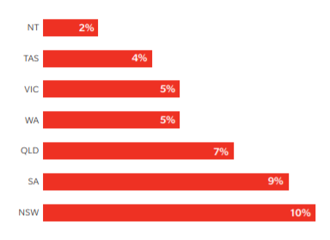
Focus states will include NSW, which has the greatest surfing participation at 10%, followed by SA, 9%.
Figure 2: Australian Surfing Participation by State

SurfSpace’s primary target age is 18 to early 30s, which has the highest surfing participation at 33%; age 50+ surfers accounts for 30%, therefore this will be SurfSpace’s secondary focus.

Figure 3: Australian Surfing Participation by Age

Despite identification of target markets, due to the versatility of its service and enhanced exposure, SurfSpace will reach a variety of customers within the surfing industry.

Primary Target Market:
Age: | Location: | Gender: | Income Level: | Education Level: | Societal Status:
18-early 30s | SA, QLD, NSW  Predominantly inland urban areas.  Travel to beach required. | Any | 70,000+/- | High-school Graduate | Middle-class
Figure 4: Market Demographics
Personality: | Values: | Interests: | Lifestyles: | Wants:
Passionate, energetic, laidback, social | Sustainability, security (for surfboard) | Surfing | Surfing, wellness, active | Extended surf time  Surfing preparation to involve less effort
Figure 5: Market Characteristics
Key traits are access to beaches and a surfing hobby, ensuring SurfSpace is valid. Due to prominent surf culture, targeted and tactical promotion will attract this market.
This market is more likely to interact with social media.

Secondary Target Market:
- Age 50+
- Long-boarders (heavy boards)
- Surf at same spots regularly
- Greater income
- Greater desire for surfing preparation to involve less effort
This market is more likely to utilise SurfSpace for long-term storage.

Competitor Analysis
Competitors
Business: | UnderGroundSurf | MetroStorage
Summary | Surf shop in Noosa Heads.  Provides a short & long-term surf storage option.  2-minute walk to beach | Online storage service.  Offer surf storage at Bondi.  7-minute drive & 36-minute walk to beach.
Cost | Day: $10  Week: $35  Month: $150 | Month: $100
Advantages | - Short & long-term storage  - Distance | - Short & long-term storage
Disadvantages | - Single location  - Secondary service | - Single location  - Distance  - Secondary service  - Irrelevant brand
Due to SurfSpace’s unique service, few competitors can be identified. Competitor analysis was conducted with aid of SWOT analysis (figure 7).
Figure 6: Competitors UnderGroundSurf & MetroStorage

Figure 7: Competitor Analysis

SurfSpace’s competitive advantage includes:
- Specificity of Service
  - Surf storage is primary focus, enhancing targeted marketing and brand
- Accessibility & Convenience
  - Beachside location
  - App ensures rapid booking
  - Location variety
  - Booking flexible according to customer needs
- Customer relationships
  - App account creation ensures services are reutilised
  - Community developed through social media
- Enhanced Exposure & Market
  - Location variety increases exposure
  - Targeted marketing appeals to target markets
Therefore, minimal threat from competitors, localised to specific locations, is overridden.

Marketing Strategies

Branding
SurfSpace aims to develop a brand that identifies with the target market.
Eco-conscious
- Target market is environmentally aware SurfSpace will focus on sustainability.
  - Done through utilising eco-friendly materials in lockers and solar energy, and contributing to environmental charities
Surf Culture
- To appeal to target markets, SurfSpace aims to take advantage of the prominent surf culture, including the: community, lifestyle and language.
  - As surf culture is centred around surfing, SurfSpace’s main philosophies will be ‘ensuring surfing is easy’ and ‘increasing surfing time’.
  - Achieved through social media.

Name & Logo
- Captures SurfSpace’s purpose and develops its brand
- Posted on lockers for promotion
Figure 8: Logo

Summary – 7 Ps
Product
- Unique and convenient
- Flexible according to customer needs
- Automatic locking system – security ensured
- High quality
- App
  - Creation of account – develops customer relationships
  - Increased convenience
Pricing
- Based off competitor’s pricing
- Customers choose rates – hourly, daily, weekly, monthly
  - Save on long-term
Place
- Product: Surf beaches particularly urban
  - Beachside – increased exposure to target market
    - Surf-lifesaving clubs potential site for lockers
  - E.g., Bondi, Byron Bay, Middleton, Goolwa
    - Target South Australia (base) & NSW first – convenience, many surf-beaches
- Base of Operations: Victor Harbour
Promotion
- Product – bright colours & logo attract attention
  - Increases addressable market
- Social media – free posts & paid ads
  - Branding based on surf culture – identifies with target market
  - Targeted approach
  - Low cost
- Emails to app users
- App notifications
  - loyalty rewards
People
- Surfers
Process
- App for booking
- Customers’ control
Physical Evidence
- App

Social Media
Objectives:
- Develops brand through targeted posts
- Engage with surfing communities
- Builds customer relationships
- Targeted paid advertising
- Promote SurfSpace
Platforms to utilise:
- Instagram
- Facebook
Social media offers low-cost, targeted ads for a large reach, and is simple to use.

Finance

Revenue Model
SurfSpace has two revenue models to reduce break-even point and increase profits.
Primary Revenue Model
SurfSpace will utilise pay-per-use model, where customers pay for the service when required, increasing service flexibility, according to customer needs.
Customers select from hourly, daily, weekly, and monthly rates.
Secondary Revenue Model
A secondary revenue model is advertising, specifically for surf brands. This will allow space on lockers to be utilised to reduce overall locker costs.
Additionally, this will develop brand, allowing SurfSpace to identify as eco-conscious, localistic, and centred around surf culture.

Pricing Strategy
When developing a pricing strategy, these factors were considered:
- Competitor’s Pricing – provides model for price customers are willing to pay; ensures competitive advantage
- Costs – ensures profit is achieved
Competitor’s pricing was the main basis for SurfSpace’s pricing strategy. However, due to high costs, prices had to be raised above average to ensure reasonable profit-margins and viable prices. SurfSpace is still ensured competitive advantage.
Locker Hire
Rates | Cost
Hourly | $5
Daily | $30
Weekly | $65
Monthly | $200

Ads
$200 per ad, per month

The viability of this pricing strategy can be seen in the income and cash flow statement (appendix 1 & 2).

Break Even Analysis
Average cost of sale: $75
Majority of SurfSpace’s costs are fixed. A large quantity of sales is required to break-even, however revenue rapidly outweighs costs once it has been achieved.
Figure 9: Break Even Analysis

Cash Flow Statement
(See appendix 1)
The cash flow statement demonstrates SurfSpace’s anticipated revenue and costs.
- To cover initial costs, a $50,000 loan will be taken, with $4,500 repaid per month.
- 70 lockers installed at 5 locations
- As shown, revenue is predicted to decline from Autumn, dropping 80% in winter. To ensure sufficient cash in-flow, cost reductions during these months and high revenue during summer and spring is required.
- Sales grow in Spring as beachgoers increase.
- December is predicted to receive highest revenue due to increased exposure from initial summer months.

Income Statement
(See appendix 2)
SurfSpace aims to start small. Years 2 and 3 will see expansions, with more lockers installed, increasing costs, whilst increasing profit margins.
SurfSpace is predicted to make significant profit.

Conclusion
Overall, SurfSpace aims to provide customers with convenient surfboard storage through a pay-per-use revenue model, increasing the flexibility of the service according to customer needs. SurfSpace’s secondary revenue model, advertising, and pricing strategy ensures achievable break-even point with high profit-margins, ensuring SurfSpace’s success.
Word Count: 1,194

Appendices:
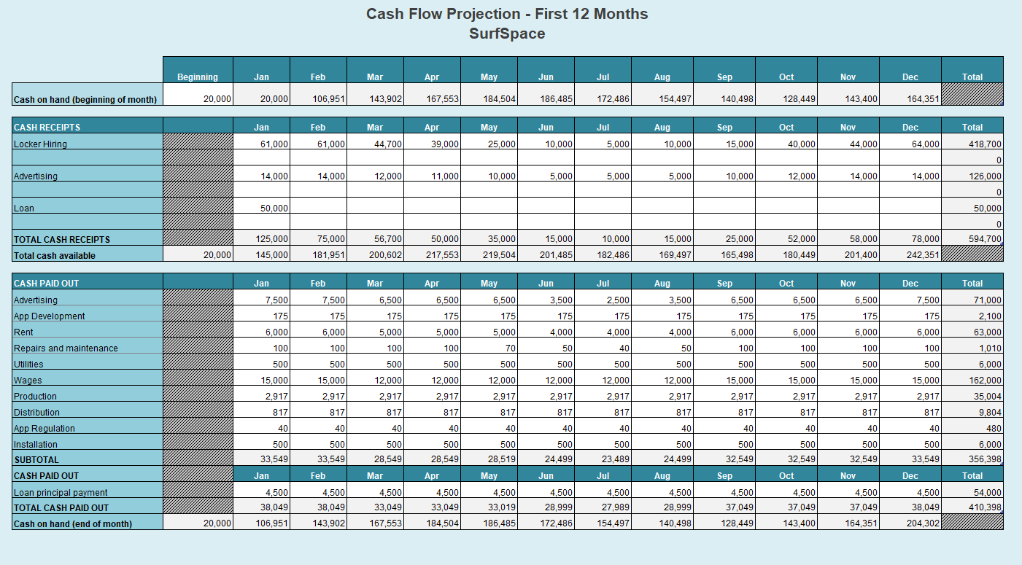
- Cash Flow Statement

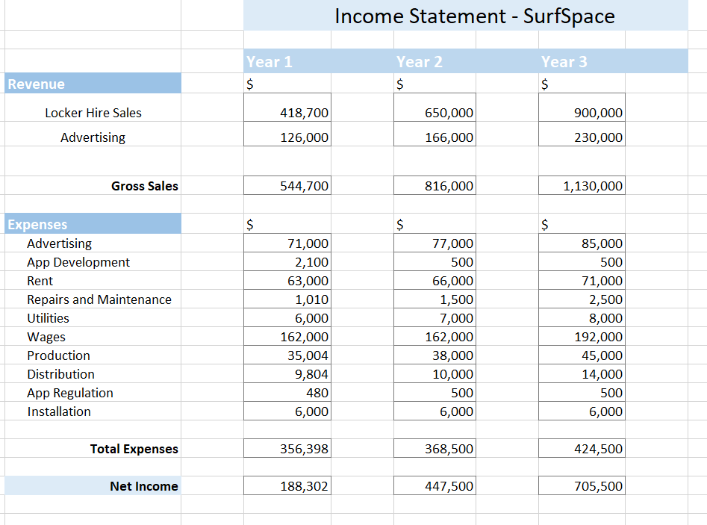
- Income Statement

Reference List
Fair Harbour. (2021, January 23). Top 5 Surf Trends to Watch in 2021. Retrieved from Fair Harbour: https://www.fairharborclothing.com/blogs/news/top-5-surf-trends-to-watch-in-2021
Furness, J., Hing, W., Walsh, J., Abbott, A., Sheppard, J. M., & Climstein, M. (2015, 2 2). Acute Injuries in Recreational and Competitive Surfers: Incidence, Severity, Location, Type, and Mechanism. The American Journal of Sports Medicine, 20, 1-9. Retrieved from file:///C:/Users/7LukeS/Downloads/AmericanjournalofSportsMedicine2015.pdf
Gaille, B. (2018, February 20). 22 Surfing Industry Statistics and Trends. Retrieved from BrandonGaille Small Business & Marketing Advice: https://brandongaille.com/22-surfing-industry-statistics-trends/
Gemba White. (2019, July 24). Playing the Long Game. Retrieved from The Gemba Group: http://thegembagroup.com/wp-content/uploads/2019/07/Gemba_White-Paper_Sport-and-Sustainability_V1.0_240719.pdf
Global Industry Analysts, Inc. (2021, June 1). Global Surfing Market to Reach $3.1 Billion by 2026. Retrieved from CISION PR Newswire: https://www.prnewswire.com/news-releases/global-surfing-market-to-reach-3-1-billion-by-2026--301302242.html#:~:text=Amid%20the%20COVID%2D19%20crisis,2.6%25%20over%20the%20analysis%20period.
Roy Morgan. (2015, April 23). Surf’s up! (For young women and 50+ folks, at least). Retrieved from Roy Morgan: http://www.roymorgan.com/findings/6202-surfs-up-for-young-women-fifty-plus-201504222329
Surf Life Saving Australia. (2019). National Coastal Safety Report 2019. Retrieved from SLSA National Coastal Safety Report 2019: https://www.surflifesaving.com.au/sites/site.test/files/SLSA%20National%20Coastal%20Safety%20Report%202019%20%282%29.pdf
Surfing Australia. (2021, July 27). Why partner with surfing? Retrieved from Surfing Australia: https://surfingaustralia.com/partnerships/

Endnotes

Furness, J., Hing, W., Walsh, J., Abbott, A., Sheppard, J. M., & Climstein, M. (2015, 2 2). Acute Injuries in Recreational and Competitive Surfers: Incidence, Severity, Location, Type, and Mechanism. The American Journal of Sports Medicine, 20, 1-9. Retrieved from file:///C:/Users/7LukeS/Downloads/AmericanjournalofSportsMedicine2015.pdf
Global Industry Analysts, Inc. (2021, 6 1). Global Surfing Market to Reach $3.1 Billion by 2026. Retrieved from CISION PR Newswire: https://www.prnewswire.com/news-releases/global-surfing-market-to-reach-3-1-billion-by-2026--301302242.html#:~:text=Amid%20the%20COVID%2D19%20crisis,2.6%25%20over%20the%20analysis%20period.
Fair Harbour. (2021, 1 23). Top 5 Surf Trends to Watch in 2021. Retrieved from Fair Harbour: https://www.fairharborclothing.com/blogs/news/top-5-surf-trends-to-watch-in-2021
Gaille, B. (2018, 2 20). 22 Surfing Industry Statistics and Trends. Retrieved from BrandonGaille Small Business & Marketing Advice: https://brandongaille.com/22-surfing-industry-statistics-trends/
Furness, J., Hing, W., Walsh, J., Abbott, A., Sheppard, J. M., & Climstein, M. (2015, 2 2). Acute Injuries in Recreational and Competitive Surfers: Incidence, Severity, Location, Type, and Mechanism. The American Journal of Sports Medicine, 20, 1-9. Retrieved from file:///C:/Users/7LukeS/Downloads/AmericanjournalofSportsMedicine2015.pdf
Surf Life Saving Australia. (2019). National Coastal Safety Report 2019. Retrieved from SLSA National Coastal Safety Report 2019: https://www.surflifesaving.com.au/sites/site.test/files/SLSA%20National%20Coastal%20Safety%20Report%202019%20%282%29.pdf
Gemba White. (2019, July 24). Playing the Long Game. Retrieved from The Gemba Group: http://thegembagroup.com/wp-content/uploads/2019/07/Gemba_White-Paper_Sport-and-Sustainability_V1.0_240719.pdf
Surf Life Saving Australia. (2019). National Coastal Safety Report 2019. Retrieved from SLSA National Coastal Safety Report 2019: https://www.surflifesaving.com.au/sites/site.test/files/SLSA%20National%20Coastal%20Safety%20Report%202019%20%282%29.pdf
Surf Life Saving Australia. (2019). National Coastal Safety Report 2019. Retrieved from SLSA National Coastal Safety Report 2019: https://www.surflifesaving.com.au/sites/site.test/files/SLSA%20National%20Coastal%20Safety%20Report%202019%20%282%29.pdf
Roy Morgan. (2015, April 23). Surf’s up! (For young women and 50+ folks, at least). Retrieved from Roy Morgan: http://www.roymorgan.com/findings/6202-surfs-up-for-young-women-fifty-plus-201504222329

