RapidReceipts Business Report
Stage 2 business innovation
India Farren
2021

Executive Summary
RapidReceipts allows customers to store financial documents on an accessible and easy-to-use app to prevent the corruption of the documents. Using a ‘freemium’ business model allows customers to build trust and familiarity with RapidReceipts before purchasing a subscription. Marketing strategies aim to exploit the steady growth of the market RapidReceipts operates within, to build a financially sustainable business model.

Contents
Executive Summary 1
Table of Figures 3
Market Analysis 4
Industry Overview 4
Key Competitors 4
Growth and Trends 5
Target Market 6
Market Size 6
Demographics 6
Marketing Strategies (120) 7
Branding 8
Proposed Revenue Model 9
Proposed Pricing Strategies 10
Cash-Flow Statement 12
Income Statement 12
Conclusion 13
Bibliography 15
Appendices 16

Table of Figures
Figure 1: Comparison of RapidReceipts and Key Competitors 4
Figure 2: Number of App Downloads from Google Play Store and iOS Apple Store by Quarter (2015-2020) 5
Figure 3: Market Size Analysis 6
Figure 5: Market Psychographics 6
Figure 4: Market Demographics 6
Figure 6: 7 Ps of Marketing 7
Figure 7: Logo 8
Figure 8: Cost Structure Analysis 9
Figure 9: Revenue Made for Each Subscription (per month) 11
Figure 10: Break Even Analysis 11
Figure 11: Cash Flow Statement 15
Figure 12: Income Statement 15

Market Analysis

Industry Overview

Key Competitors
RapidReceipts holds competitive advantage through the execution of the business model to address customers pains and gains by utilising organised, convenient digital storage of receipts and warranty cards. The table below compares RapidReceipts to its competitors.
Factor | Low |  | High
Cost
Convenience
Accessibility & usability
Ability to scan & store receipts
Ability to store warranty cards
Figure 1: Comparison of RapidReceipts and Key Competitors
Company | Symbol
RapidReceipts
QuickBooks
Expensify
Bench
ReceiptBank
KodakAlaris
Key (reference these companies)
RapidReceipts Competitive Advantages Include…
- Low cost of monthly subscriptions
- High convenience
- Highly accessible and usable app
- Ability to store and scan receipts
- Ability to store warranty cards

Growth and Trends
The industry in which RapidReceipts operates in is experiencing steady growth which is expected to continue, suggesting a sustainable market.
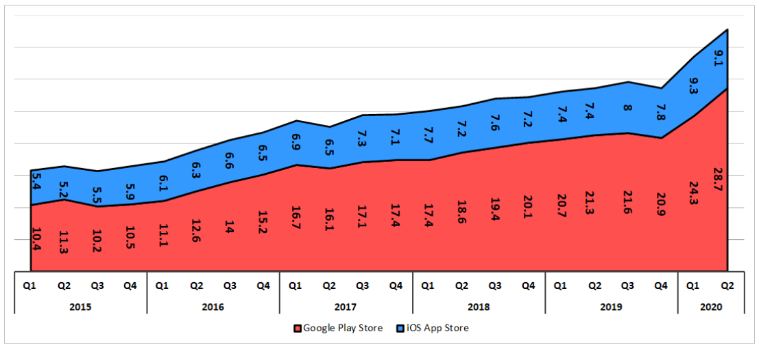
(SensorTower, 2020)
Figure 2: Number of App Downloads from Google Play Store and iOS Apple Store by Quarter (2015-2020)
A PESTEL analysis was used to identify key current trends in the industry. These include:
- Increasing familiarity and technological advances with QR codes
- Advances in technology increasing storage on devices
- Increasing accuracy of Optical Character Recognition technology used to digitise receipts scanned onto apps
Increasing demand for document management services is another major trend; expected to increase by 4.8% each year for 5 years, reaching $628 million. An increase in demand for RapidReceipts product is expected due to this large growth as customers wish for digital storage of documents.
RapidReceipts provides customers with an appealing quality product, therefore obtaining competitive advantage through the exploitation of market growth and trends.

Target Market
The target market includes 18–50-year-old smartphone users who make their own significant purchases. At this age, individuals typically are employed and are financially stable enough to purchase a subscription.

Market Size
Identifying the market size allows the estimation of profits and development of a marketing strategy that addresses the unique needs of customers.
Market Type: | Number of Customers:
Total Addressable Market | ≈18 million smartphone users in Australia
Serviceable Addressable Market | ≈10 million users within target market
Serviceable Obtainable Market | Approximately 1 million (some will use competitor’s products)
Figure 3: Market Size Analysis
The above table aims to realistically estimate the potential market size. Growth of the market is expected as Australia’s population and hence number of smartphone users increases.

Demographics
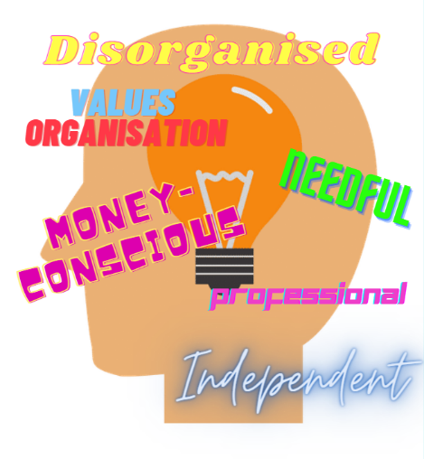
Targeted marketing and product design is obtained by understanding qualities and characteristics of the target market. Qualities and characteristics of RapidReceipts target market are identified below. 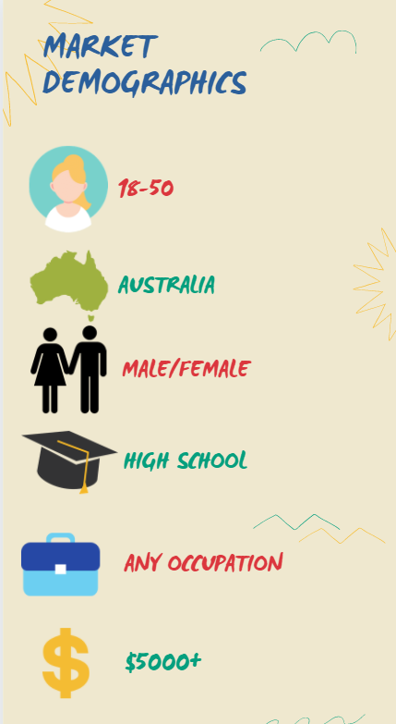
Figure 5: Market Psychographics

Figure 4: Market Demographics
Older customers may struggle to navigate the app and use functions due to low technical literacy. To reduce purchase resistance of this demographic, easily accessible customer support through online chat rooms will be offered to assist usability. Feedback was sought from older individuals when designing the app to ensure it is easily useable.

Marketing Strategies
Figure 6: 7 Ps of Marketing

Branding
RapidReceipts conveys a professional, clean branding to customers, portrayed through the design of the logo and user interface.
The logo design represents the purpose and identity of RapidReceipts:
Figure 7: Logo
- The clean design demonstrates the clean design of the user interface of the app

- The neutral colours represent the professionalism of RapidReceipts

- The icon represents the organised filing of receipts RapidReceipts provides for customers

Proposed Revenue Model
RapidReceipts uses a freemium model to gain access to customers and create a reliable revenue stream.
Customers download the app free-of-charge but have limited access to functions on a bronze subscription. The benefits of this subscription are:
- Appeals to money-conscious customers
- Competitive advantage as the base model is free
- Customers build trust through testing app before purchasing a subscription
- Customers upgrade as they are satisfied with quality and want premium functionality
The purchase of silver and gold subscriptions covers the revenue lost for the bronze subscription whilst creating profit.
Individuals within the target market were interviewed, expressing their willingness to pay this low cost to obtain greater functions of the app.
Bronze Subscription – free of charge:
- Access to personalised QR code for organised storing of receipts

Silver Subscription - $20 monthly:
- Access to personalised QR code for organised storing of receipts
- Warranty cards sent to and stored on profile for easy access of warranty information

Gold Subscription (in addition to silver subscription functionality) - $40 monthly:
- Select receipts to be stored in a separate list for tax returns & share list with others, automatically updating each time a new receipt is added

The table below identifies the approximate monthly and yearly profit that RapidReceipts expects to procure off the revenue stream:
Subscription Type: | Price per unit (monthly): | Cost of Maintenance per unit (monthly): | Cost of Advertising per Unit: | Monthly Revenue: | Monthly Profit/Loss per unit: | Yearly Profit/Loss (per customer): | Yearly Profit/Loss (10,000 customers):
Bronze | $0.00 | $0.83 | $1.05 | $0.00 | -$1.88 | -$22.56 | -$225 600
Silver | $20.00 | $3.12 | $5.91 | $20.00 | $10.97 | $131.64 | $1 316 400
Gold | $40.00 | $7.56 | $9.98 | $40.00 | $22.46 | $269.52 | $2 695 200
Figure 8: Cost Structure Analysis

Proposed Pricing Strategies
The pricing strategies RapidReceipts utilises are freemium and competition based.
Freemium Pricing Strategy:
- Customers trial app with bronze subscription type for free
- Experiencing the app & seeing features persuades customers to upgrade subscription level
- Trust and familiarity is built with customers as they trial before they purchase
Low monthly costs of silver and gold subscriptions mean the customer is enticed to pay to upgrade as prices match the perceived value. Prices start very low, with the bronze subscription being free-of-charge, and increase incrementally as customers gain access to more premium features.
So, although revenue is foregone from the bronze subscription type, providing access is intended to eventually persuade them to purchase a silver or gold subscription, hence making up for the revenue lost.

Competition-based Pricing Strategy:
To decide the price of the 2 paid subscription types, market research was performed, compiling the competitor’s prices and features to price RapidReceipts subscriptions accordingly.
RapidReceipts subscriptions are significantly cheaper than the majority of competitors, attracting money conscious customers to RapidReceipts.
However, one competitor, Expensify, charges customers very low prices; prices at which RapidReceipts could not effectively operate at. The competitive advantage RapidReceipts holds over this competitor is the ability to store warranty cards, as well as the easily accessible and usable app. For these reasons, customers will likely choose RapidReceipts and pay a small cost more per month to receive more premium functions.

By using a combination of pricing strategies, RapidReceipts attracts and induces more customers whilst having costs that are more affordable than competitors.

Break Even Point (800 units sold [assuming an average of all subscription types])
Revenue (average of all subscription types)
Figure 9: Revenue Made for Each Subscription (per month)
Figure 10: Break Even Analysis
Fixed Costs

Cash-Flow Statement
The cash-flow statement, seen in the appendices, shows the financial growth of RapidReceipts over the first 12 months of trading. Key observations from this include:
- Initial funding of $40 000 contributed by the business owner to develop and patent the app
- Steadily increasing net cash sales as more users upgrade subscription level
- Fixed monthly costs of app maintenance, wages and advertising total less than the amount of revenue, hence the business is creating profit

Income Statement
The income statement, located in the appendices, shows the predicted number of sales, and hence revenue, for the first 3 years of business operation. Key observations from this include:
- Rapidly increasing number subscribers (for all subscription types)
- Increase in revenue as more subscriber’s upgrade to silver or gold subscription
- Another employee is added in Year 2 to assist with business operations
- Further investment into advertising in Year 2&3 causing an increase in subscribers
- Patent and app development costs amortised over the first 3 years of business operations
- Total expenses increase in Year 2&3 after further investment into advertising and another employee is added

Conclusion
Therefore, RapidReceipts aims to provide its customers with an affordable, convenient way to store financial documents, achieved through a freemium business model. This ensures that through reliable monthly payments with the renewing of subscriptions, RapidReceipts will be able to break even at 800 units sold, as an average of all subscription types, and maximise profits through the purchase of subscriptions within the app.

Word Count: 1198

Bibliography
Bench, 2021. Bench. [Online]
Available at: https://bench.co/blog/accounting/best-receipt-apps/
[Accessed 20 July 2021].
Expensify, 2021. Expensify. [Online]
Available at: https://www.expensify.com
[Accessed 20 July 2021].
IbisWorld, 2021. Ibis World. [Online]
Available at: https://www.ibisworld.com/au/industry/document-management-services/5517/
[Accessed 27 July 2021].
KodakAlaris, 2021. KodakAlaris. [Online]
Available at: https://www.kodakalaris.com/
[Accessed 20 July 2021].
QuickBooks, 2021. QuickBooks. [Online]
Available at: https://quickbooks.intuit.com/au/
[Accessed 20 July 2021].
ReceiptBank, 2021. ReceiptBank. [Online]
Available at: https://app.receipt-bank.com/login
[Accessed 20 July 2021].
SensorTower, 2020. Number of App Downloads from Google Play Store and iOS App Store by Quarter (2015-2020). [Art] (Business of Apps).

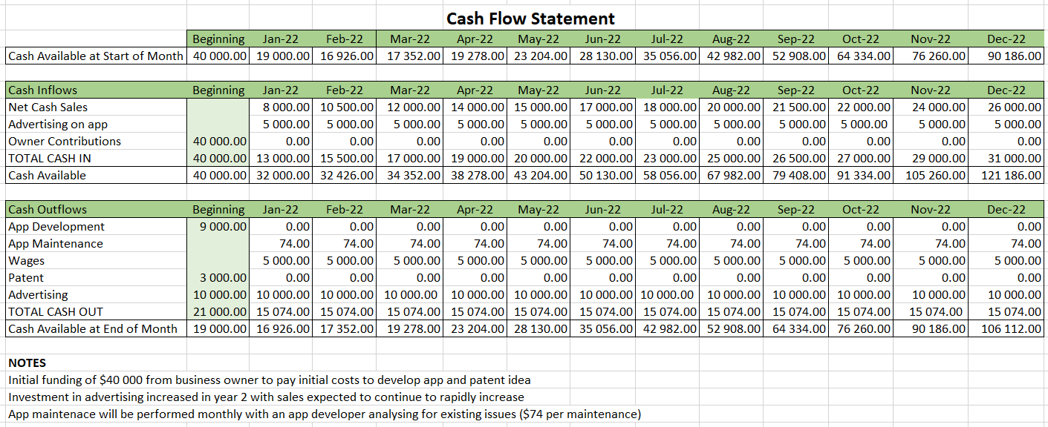
Appendices
Figure 11: Cash Flow Statement
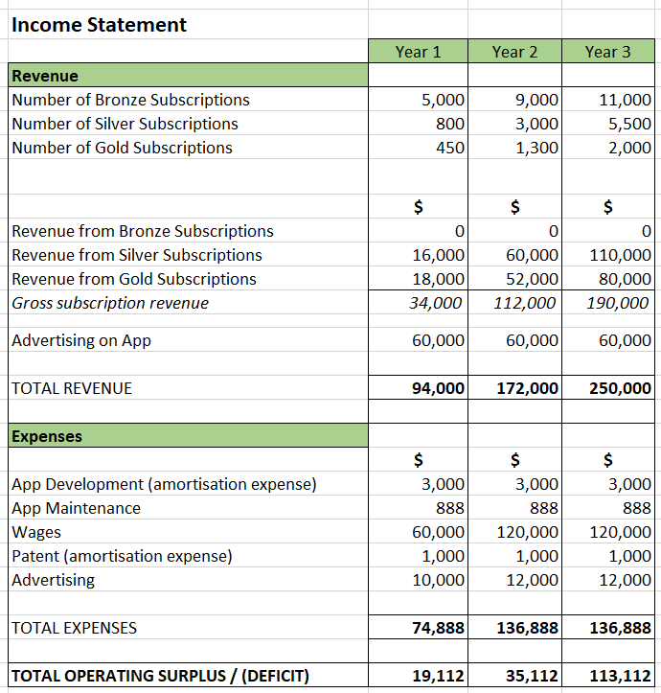
Figure 12: Income Statement

QuickBooks, 2021. QuickBooks. [Online] Available at: https://quickbooks.intuit.com/au/ [Accessed 20 July 2021].
Expensify, 2021. Expensify. [Online] Available at: https://www.expensify.com [Accessed 20 July 2021].
Bench, 2021. Bench. [Online] Available at: https://bench.co/blog/accounting/best-receipt-apps/ [Accessed 20 July 2021].
ReceiptBank, 2021. ReceiptBank. [Online] Available at: https://app.receipt-bank.com/login [Accessed 20 July 2021].
KodakAlaris, 2021. KodakAlaris. [Online] Available at: https://www.kodakalaris.com/ [Accessed 20 July 2021].
SensorTower, 2020. Number of App Downloads from Google Play Store and iOS App Store by Quarter (2015-2020). [Art] (Business of Apps).

