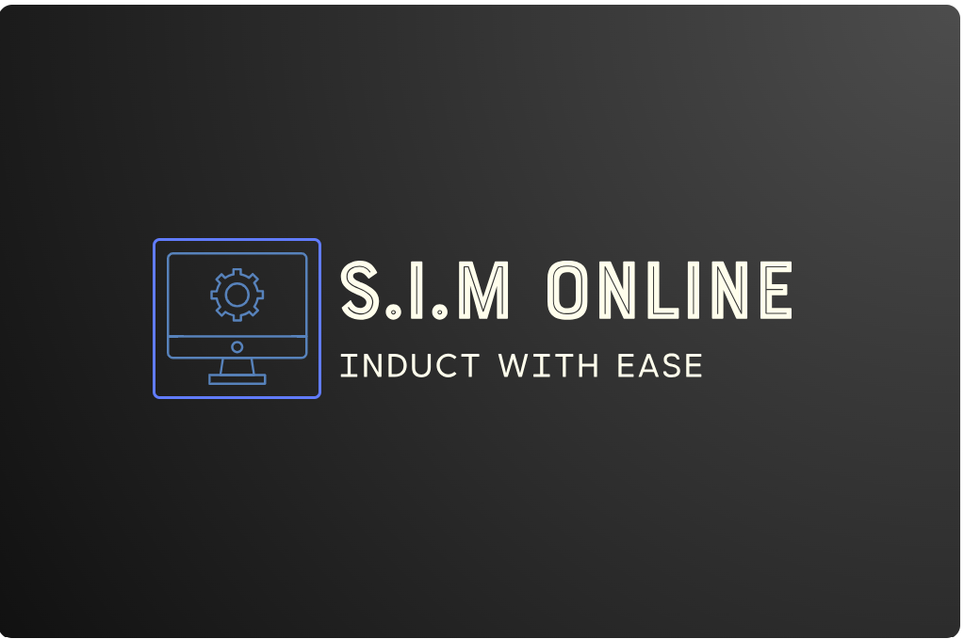

S.I.M Online Business Report
Stage 2 Business Innovation: Ella-Jayne Franco

Executive Summary:
S.I.M Online’s objective is to mainstream school inductions to increase efficiency and combat the rise in cost-of-production for schools. Marketing strategies include loss-leader focusing on free versions converting to paid subscriptions and personal selling by attending expos such as EduTech, cold-calling and e-marketing on apps used by the target market, private schools. This will highlight the specialisation of S.I.M Online and increase customer numbers thus increasing profits ensuring the low costs are covered and Break-Even occurs.
Contents
Executive Summary: 2
Table of Figures: 5
Market: 6
Competitor Analysis: 7
Competitive Advantage of S.I.M Online: 7
Target Market: 8
Marketing Strategies: 9
Promotional Methods: 9
Marketing Objectives: 9
Advertising: 9
Public Relations: 9
Testing and Evaluation: 9
7 P’s 10
Finance: 11
Revenue 11
Different Models 11
Assumptions Underpinning Revenue Model 11
Expenses 12
Cash-Flow-Statement 13
Conclusion: 14
Appendices: 15
Reference List: 17

Table of Figures:
Figure 1: Competitor Analysis 6
Figure 2: Key’s 6
Figure 3: Market Segmentation Graph 7
Figure 4: Market Segmentation Table 7
Figure 5: Market Size Analysis 7
Figure 6: The 7 Ps of Marketing 9
Figure 7: Prices per Package 10
Figure 8: Estimated uptake of each Pack 10
Figure 9: Revenue Made Per Product 11
Figure 10: Break-Even Analysis 11
Figure 11: Cash-Flow-Statement 12
Figure 12: PESTEL 14

Market:
Schools are currently affected by increasing costs and regulatory compliance with staff inductions contributing significantly to this.
The key findings were found in relation to this industry (figure 14):
- School budgets are tight and with inflation and increased regulatory compliance added to this, schools are struggling.
- Due to inductions and an increase in workload, school leaders time availability is decreasing.
S.I.M Online will address these two key pains whilst acknowledging the tight budget in the monthly fees and memberships. The increased efficiency of using S.I.M Online is anticipated to be a cost saving measure for schools overall.
Employment in this industry is not predicted to grow however due to rising pressure on teachers, staff turnover has increased with 45% anticipated to leave the profession within the next 5 years, increasing the inductions schools will need.
Popularity for online inductions has increased since 2020 with many firms moving completely online including their inductions. This has caused significant growth in the industry with increasing support for online inductions and with no induction sites specialising in schools, S.I.M Online can address this unaddressed part of the market.
Trends in the induction industry are:
- Online features
- Personalisation
- Inductions for current staff

Competitor Analysis:
The graph below displays S.I.M Online’s competitive advantage addressing the price flaws in the market and the lack of induction specialisation to the Education industry.
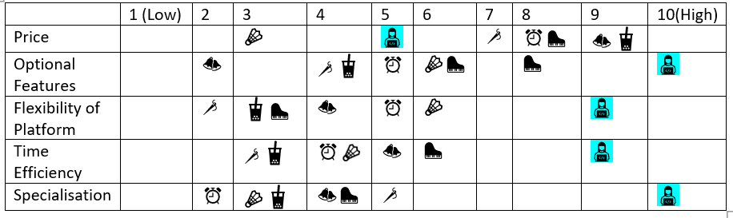
Figure 1: Competitor Analysis
Business | Key
S.I.M Online
Altora
Induct for Work
Link Safe
SignonSite Inductions
hronboarding
Cloud Assess

Competitive Advantage of S.I.M Online:
- Operates at an average price.
- An extremely high number of optional features
- The platform is flexible to any school.
- Extremely time efficient regardless of Pack chosen.
- Specialises in the Education industry.

Figure 2: Key’s
These advantages address the underlying pain customers face and the gains they wish to receive allowing their job to be performed at a higher level of efficiency.

Target Market:
The market segments of the education industry are independent, public and catholic however, S.I.M Online is targeting a niche within the market of high fee-paying private schools in Adelaide as they are estimated to have the highest take up rate.

Figure 3: Market Segmentation Graph
 | Private |  |  | Public
Fees | High | Med | Low | N/A
Budget | High | Tight | Tight | Tight
Take Up Rate | High | Low | Low | Medium
Figure 4: Market Segmentation Table
Market Type | Customer Count (per school)
Total Addressable Market (T.A.M) | 9,614 schools in Australia
Serviceable Available Market: (SAM) | 791 schools in South Australia
Service Obtainable Market: (SOM) | 200 Private schools in South Australia
Target Market (TM) | 40 high budget schools in Adelaide
Figure 5: Market Size Analysis
The graph above realistically represents the target market of high budget private schools which will provide S.I.M Online with a professional brand, increase creditability and lead to the potential roll out in government schools. This scalability in the education industry shows potential scalability to other industries.

Marketing Strategies:
Using the loss leader strategy, the marketing for S.I.M Online is aimed at conversion of free trials to Pack 1, 2 and 3 packages as such S.I.M Online proposes to perform the following.

Promotional Methods:

Marketing Objectives:
- 16 paying customers by the end of the first year.
- Increased sales after promotional events e.g., EduTech.
- Start with high paying private schools as customers to build up professional brand then expand to government schools.
- Achieve approximately 30 enquiries and 20 free trial take ups in the first year.

Advertising:
- Personal Selling via cold calls during
  - February to July
  - Term 4 (small)
  - Term 3 (small)
  - During school holidays due to low time demand on school leaders
- Conferences
  - Advertise S.I.M Online product at EduTech.
    - Costs $1,200 but covered by predicted profit.
- E-marketing
  - Low-cost
  - Specific to target market
    - On apps like Seek.
- Word-of-mouth
  - Create a good, professional representation.
  - Work to deadlines.
  - Create a relationship with customers.

Public Relations:
- S.I.M Online will focus on customer prioritisation making the product and service more appealing to customers.
- The organisation will be strictly professional, so the business is taken seriously, and customers feel they’re getting value for money.

Testing and Evaluation:
The Viral Marketing Test will be used for the conference advertisement and personal sales. Through this S.I.M Online will be able to deduce the amount of publicity and product uptake the events and sales generated determining whether these advertisement as sales methods should continue.

7 P’s
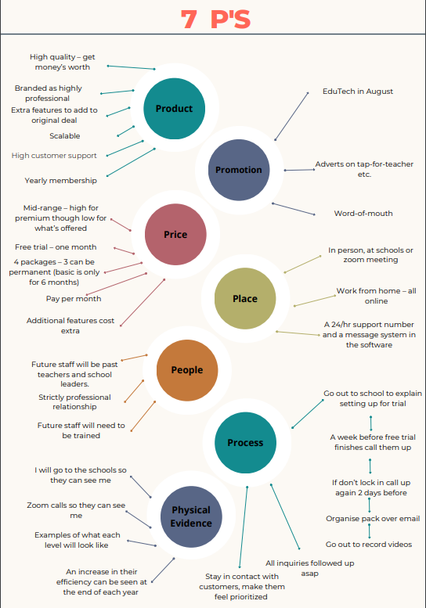
Figure 6: The 7 Ps of Marketing

Finance:

Revenue
S.I.M Online is a Multi-Sided Platform Model through which guaranteed profit will occur through memberships and additional features schools add.

Different Models
S.I.M Online contains a 1-month free trial, 6-month paid trail and then 3 different yearly packages. It is assumed that all customers will try the 1 month then 6 month then decide whether to continue onto a deal following the loss leader strategy.
Below demonstrates the costs for each package including the 6-month paid trial.
Cost Per Package
6-month paid trial | $1000/ $166 per month
Pack 1 | $2000/ $166 per month
Pack 2 | $5000/ $416 per month
Pack 3 | $8000/ $666 per month
Figure 7: Prices per Package

Assumptions Underpinning Revenue Model
S.I.M Online assumes 20 schools will try the 1-month trial in the first year of sales of which 16 will transfer to the 6-month plan from there, 75% are estimated to move to Pack 1 (40%) Pack 2 (15%) or Pack 3 (45%).

Figure 8: Estimated uptake of each Pack
Each of these packs is priced on a non-active part of the market as displayed by the competitor analysis on page 5 appealing to customers want for a reliable price. Profit will also be made through additional features not included in each pack. S.I.M Online will lose profit from the free-one-month trial option however this will be insignificant compared to the profit made from the other Packs and the assumption 75% of free trial customers will upgrade to a Pack.

Figure 9: Revenue Made Per Product

Expenses
A loan of $70,000 will be required for S.I.M Online to begin, being paid off $700 per month increasing once sales increases. It is also assumed that interest in free one-month trials and 6-month paid trials will increase due to advertisement at EduTech. Overall, the cost of production, is $7,900 meaning once 8 basic packs are sold S.I.M Online will break even:

Figure 10: Break-Even Analysis

Cash-Flow-Statement
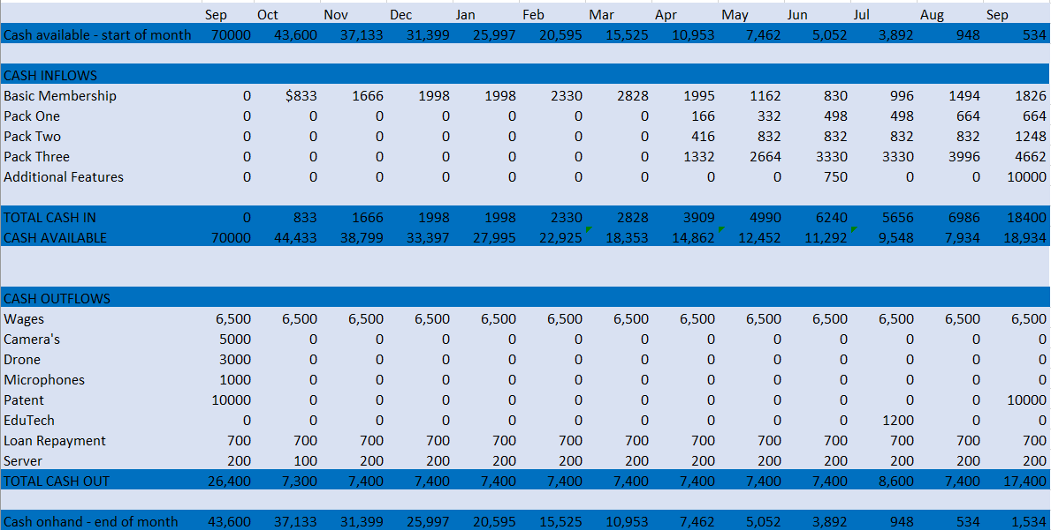
Figure 11: Cash-Flow-Statement

Conclusion:
Overall, S.I.M Online aims to provide customers with an efficient solution to their induction problems. The prices also effectively address an untouched part of the market covering S.I.M Online’s costs whilst providing good profit. The advertisement at EduTech will also boost sales and ensure S.I.M Online breaks-even, ensuring success.
Word Count: 1200

Appendices:
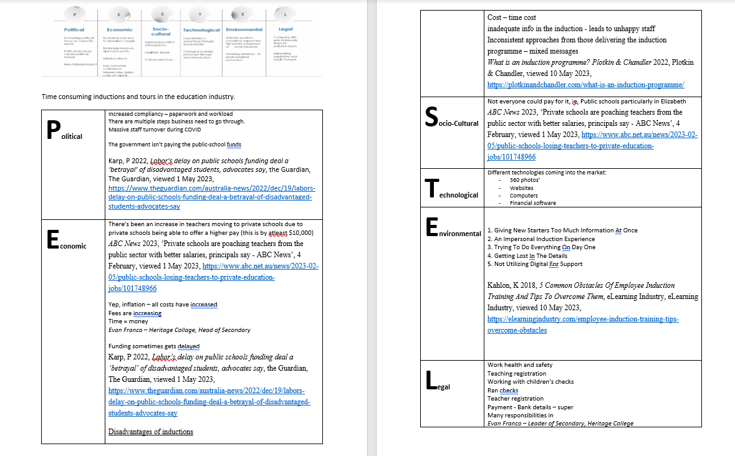
Figure 12: PESTEL

Reference List:
Alveyra, A. (2023, January 5). Top Trends in Employee Onboarding in 2023 to Look Out For. Cursum. https://cursum.com/blog/employee-onboarding/top-trends-in-employee-onboarding-in-2023-to-look-out-for/

Axion SD. (2022). Online Induction System - Contractor Management | Altora. Altora.com.au. https://www.altora.com.au/

Cloud Assess AU. (2021, November 15). Cloud Assess | Pricing and Packages. Cloud Assess AU. https://cloudassess.co/au/packages/

EduTECH 2023. (2023). EduTECH 2023; EduTECH 2023. https://www.terrapinn.com/exhibition/edutech-australia/index.stm

Employee Onboarding Software | HROnboard. (2020, September 14). Employee Onboarding Software | HROnboard. https://hronboard.me/

How to easily manage workplace compliance with LinkSafe. (2023, May 23). LinkSafe. https://linksafe.com.au/

Induct For Work Australia - Online Induction Training Software. (2023, June 9). Online Induction Training Software. https://www.inductforwork.com.au/

Lee, B. Y. (2016, September 10). Doctors Wasting Over Two-Thirds Of Their Time Doing Paperwork. Forbes. https://www.forbes.com/sites/brucelee/2016/09/07/doctors-wasting-over-two-thirds-of-their-time-doing-paperwork/?sh=232858f5d7b4

SignOnSite’s Pricing | Construction Safety Software. (2023). Signonsite.com. https://www.signonsite.com/forms/pricing ‌

The HR Team. (2023, April 3). Employee Onboarding in 2023: Four Game-Changing Trends. The HR Team. https://www.thehrteam.com/blog/employee-onboarding-in-2023-four-game-changing-trends-youll-wish-you-knew-about-sooner/

Wagner, E. (2019). 3 Ways to Test Market Your Product Promotions. I7marketing.com. https://www.i7marketing.com/blog/small-business/3-ways-test-market-product-promotions

Windle, J., Morrison, A., Sellar, S., Squires, R., Kennedy, J., & Murray, C. (2022). Teachers at breaking point Why working in South Australian schools is getting tougher Report to the Australian Education Union South Australian Branch. https://www.unisa.edu.au/contentassets/f84cdb683dbb42a09ae08abc55bd9347/teachers-at-breaking-point-full-report.pdf

9 Employee Onboarding Trends for 2023: Back to Human | Zavvy. (2023). Zavvy.io. https://www.zavvy.io/blog/employee-onboarding-trends

Lee, B. Y. (2016, September 10). Doctors Wasting Over Two-Thirds Of Their Time Doing Paperwork. Forbes. https://www.forbes.com/sites/brucelee/2016/09/07/doctors-wasting-over-two-thirds-of-their-time-doing-paperwork/?sh=232858f5d7b4
Windle, J., Morrison, A., Sellar, S., Squires, R., Kennedy, J., & Murray, C. (2022). Teachers at breaking point Why working in South Australian schools is getting tougher Report to the Australian Education Union South Australian Branch. https://www.unisa.edu.au/contentassets/f84cdb683dbb42a09ae08abc55bd9347/teachers-at-breaking-point-full-report.pdf
9 Employee Onboarding Trends for 2023: Back to Human | Zavvy. (2023). Zavvy.io. https://www.zavvy.io/blog/employee-onboarding-trends
9 Employee Onboarding Trends for 2023: Back to Human | Zavvy. (2023). Zavvy.io. https://www.zavvy.io/blog/employee-onboarding-trends
Alveyra, A. (2023, January 5). Top Trends in Employee Onboarding in 2023 to Look Out For. Cursum. https://cursum.com/blog/employee-onboarding/top-trends-in-employee-onboarding-in-2023-to-look-out-for/
The HR Team. (2023, April 3). Employee Onboarding in 2023: Four Game-Changing Trends. The HR Team. https://www.thehrteam.com/blog/employee-onboarding-in-2023-four-game-changing-trends-youll-wish-you-knew-about-sooner/
Axion SD. (2022). Online Induction System - Contractor Management | Altora. Altora.com.au. https://www.altora.com.au/
Induct For Work Australia - Online Induction Training Software. (2023, June 9). Online Induction Training Software. https://www.inductforwork.com.au/
How to easily manage workplace compliance with LinkSafe. (2023, May 23). LinkSafe. https://linksafe.com.au/
SignOnSite’s Pricing | Construction Safety Software. (2023). Signonsite.com. https://www.signonsite.com/forms/pricing ‌
Employee Onboarding Software | HROnboard. (2020, September 14). Employee Onboarding Software | HROnboard. https://hronboard.me/
Cloud Assess AU. (2021, November 15). Cloud Assess | Pricing and Packages. Cloud Assess AU. https://cloudassess.co/au/packages/
EduTECH 2023. (2023). EduTECH 2023; EduTECH 2023. https://www.terrapinn.com/exhibition/edutech-australia/index.stm
Wagner, E. (2019). 3 Ways to Test Market Your Product Promotions. I7marketing.com. https://www.i7marketing.com/blog/small-business/3-ways-test-market-product-promotions

