Easy Adventure
Carmel Evans
Business Report
Contents
Table of Figures 2
Executive Summary: 4
Market Analysis 5
Market Overview 5
Growth and Trends 5
Target Market 6
Market Segments 6
Demographics 7
Competitor Analysis 8
Proposed Revenue and Pricing Model 9
Income Statement 11
Breakeven Analysis: 12
Marketing Strategies 12
Promotional Plan 13
Influencer Partnerships: 13
Content Marketing: 13
App Store Optimization: 13
Partnerships with Outdoor Brands: 13
Paid Advertising: 13
Performance Measurement: 13
Conclusion 13
Appendices 14
Reference List: 15

Table of Figures
Figure 1: Caravan and Camping Trips in Australia 4
Figure 2: Market Size Analysis 5
Figure 3: Target Market Analysis 5
Figure 4: Market Demographics and Psychographics 6
Figure 5: Competitor Analysis 7
Figure 6: Revenue made per revenue stream over the first year 10
‌Figure 7: Income Statement 10
Figure 8: Break Even Analysis 11
Figure 9: 7P’s of Marketing 11
Figure 10:Projected Cash Flow Statement 13

Executive Summary:
Easy Adventure aims to provide consumers with an easy and straightforward way to plan camping trips and cater for stops with necessities such as water, food and facilities. Easy Adventure is an app collating all camping needs together making them accessible for anyone, any time. The target market includes young adults, parents and retirees from Australia. Revenue is gained by both consumers and business through marketing strategies including promotion through social media, collaboration with other businesses and word-of-mouth.

Market Analysis

Market Overview
Easy Adventure is an app designed to address the difficulty in planning a camping trip. The global camping market is expected to reach $88billion by 2031. In Oceania the current size of the market is $770million and with solid growth rates of 13.45%, is expected to reach $1.27billion by 2027. Due to this growth, an increase in demand for Easy Adventure is expected.

Growth and Trends
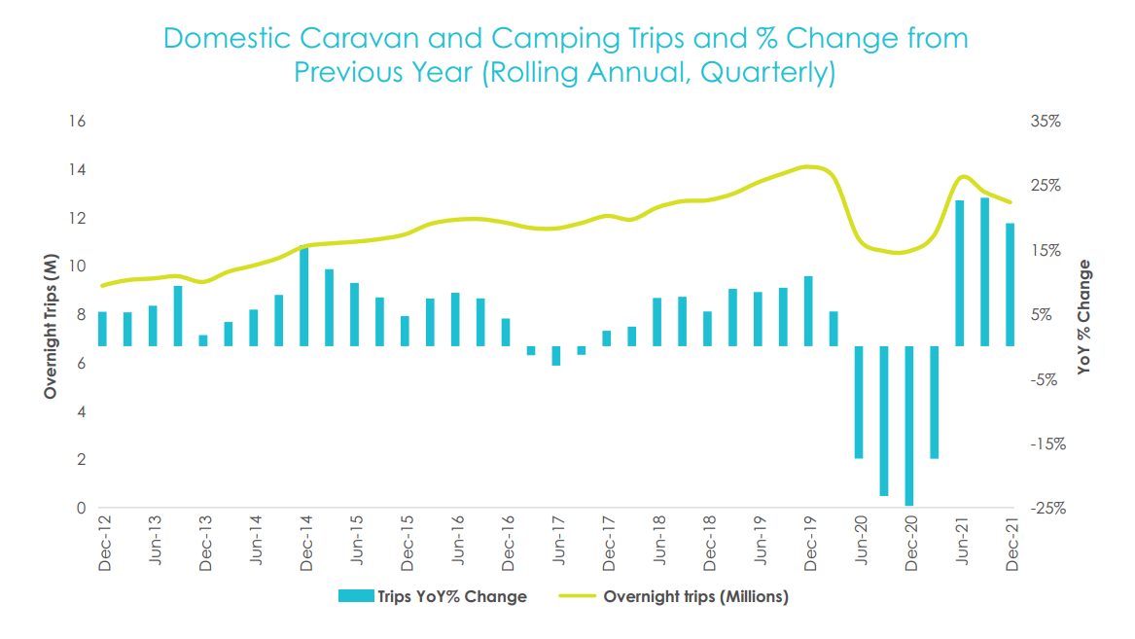
Figure 1: Caravan and Camping Trips in Australia
A PESTLE analysis was used to identify current trends in the industry. These include:
- Technological advances allowing increasing comfort with camping
- Increasing preference for a cheap alternative for holidays
- A growing want for healthy holiday options
- Increasing preference towards local camping
Easy Adventure will focus on accommodating these growing trends especially the technology advances to enhance the demand for the services provided.

Target Market
The target market is 20-70-year-olds who enjoy getting away from life and relaxing at low costs, making camping a good option. Specific cohorts are young adults (20-35) who like to take a break from their working lives, parents with children (aged 36-59) as camping is a cheaper holiday option, and retirees (aged 60-70) who are keen to adventure in a comfortable way through campervans or caravans.

Market Segments
Key campers in Australia that are most likely to use the product.
Market Type: | Customers:
Total Addressable Market | ≈26 million population in Australia
Serviceable Addressable Market | ≈790,000 active campers in Australia
Serviceable Obtainable Market | ≈30,000
Figure 2: Market Size Analysis
The table above is aimed to realistically estimate the target market size. This is expected to grow as Australia’s population and therefore campers increase.
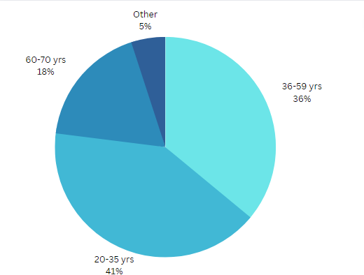

Figure 3: Target Market Analysis

Demographics
Targeted marketing and product design was found by understanding the qualities and characteristics of customers in the target market. The demographics and psychographics of Easy Adventure customers are shown below.
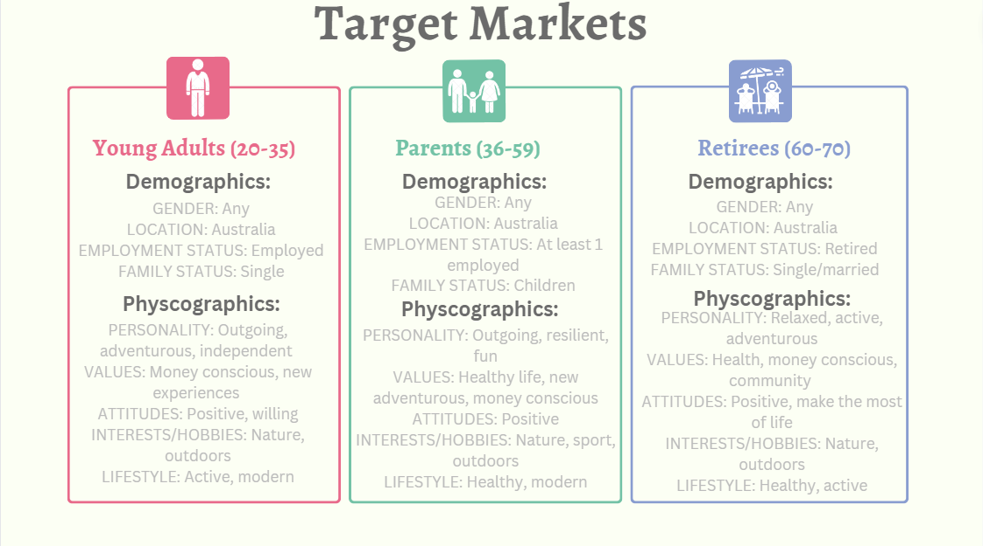

Figure 4: Market Demographics and Psychographics
This product is intended for young adults, parents with children, and retirees that want to relax and explore Australia. All target markets are catered for with the app having customer support for those older that struggle with technology, increasing the market Easy Adventure can operate in.
Feedback was obtained from all target markets to make the product accessible and convenient for all target markets.

Competitor Analysis
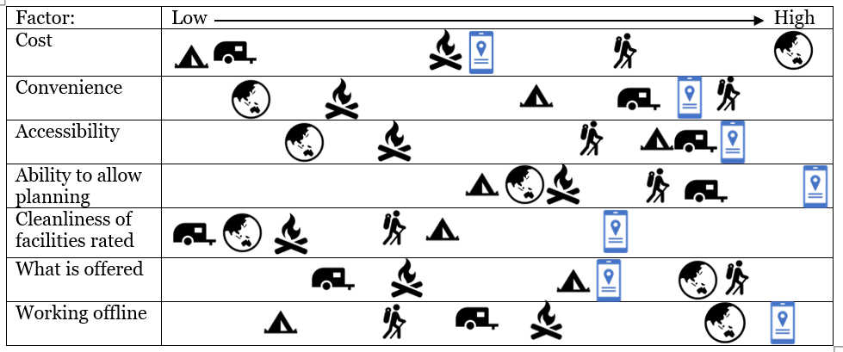
The table below compares Easy Adventures to its competitors. By addressing specific customer pains and gains related to the business model, Easy Adventures holds competitive advantage over competitors.
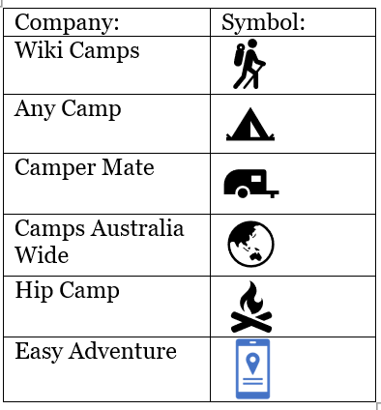
Figure 5: Competitor Analysis

Key Competitive Advantages of Easy Adventure:
- High ability to allow trip planning – Easy Adventure makes it simple to create detailed plans based on real data
- High rating of specific facilities – no other app rates the cleanliness and accessibility of facilities
- Convenience
- Accessibility
- Works effectively offline

Proposed Revenue and Pricing Model
Easy Adventure uses a premium model to gain reliable, recurring income by avoiding competition and attracting customers. It has both Business to Consumer (B2C) and Business to Business (B2B) revenue streams.
Proposed B2C Revenue Streams:
Detailed analysis of the consumer stakeholders identified in the market analysis revealed they are prepared to pay to solve the problems of limited facilities and difficult trip planning in remote areas.
- App Sales
Customers purchase the app and have access to most features including a map, and camping sites and facilities nearby.
- Pricing:
  - $7.00 purchase fee
- Benefits to stakeholders:
  - Low-cost appeals to money conscious customers
  - Customers can build trust with the app before buying a subscription
- Revenue Assumptions
  - Out of the 790,000 active campers in Australia, 30,000 will buy the app being very achievable as it is less than 4%.
- Pricing assumptions
  - The average price of apps is $10 so this is priced at $7 to be lower than the average cost, encouraging purchases.

- Subscription
Customers pay a subscription to have access to caravan parks nearby and access deals with large businesses (e.g., BIG4 Caravan Parks)
- Pricing:
  - $3.00/month
- Benefits to stakeholders:
  - Low cost for high deals attracting customers
  - Competitive advantage as only one subscription for all features
- Revenue Assumptions
  - 40% of purchasers who buy the app will pay for the monthly subscription.
- Pricing assumptions
  - The average price of subscriptions is $10 a month and this is priced at $3 so consumers are willing to pay the small fee.

Proposed B2B Revenue Streams:
Detailed analysis of the business stakeholders identified they are prepared to pay to obtain direct engagement with qualified customers.
- Advertising
Camping stores can advertise on the app for a fee.
- Pricing:
  - $10/per add
- Benefits to stakeholders:
  - They can access real campers (their target market)
- Revenue Assumptions
  - Of the 1284 camping stores in Australia, 10-20 will advertise in any month to have access to campers using the app.
- Pricing assumptions
  - Average price of advertising is $18 so this is priced at $10 to attract businesses.

- Caravan Parks Listing
Caravan parks can pay a one-time listing fee to be featured on the app as an option for customers to stay at.
- Pricing:
  - $25.00 listing fee
- Benefits to stakeholders:
  - Caravan Parks receive more bookings
- Revenue Assumptions
  - There are 1600 caravan parks in Australia, and 20 will list in the first month increasing to 40 by July.
- Pricing assumptions
  - Average listing fee prices are 10% which, taking an average $80 campsite, is $8 a night, so this is priced at $25 a month which allows the consumers to save money.

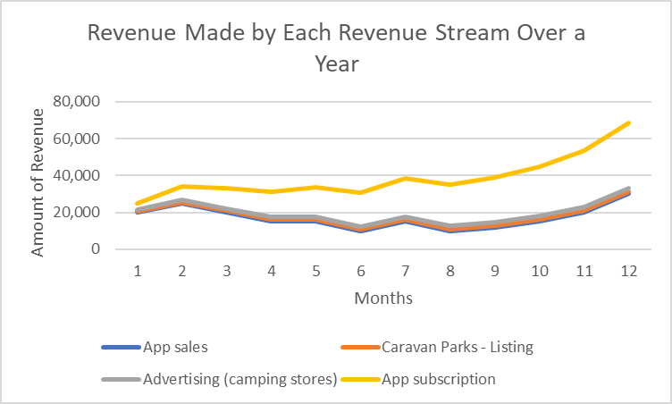

Figure 6: Revenue made per revenue stream over the first year

Income Statement
Based on July (refer to Projected Cashflow Statement in Appendix 1)
‌ 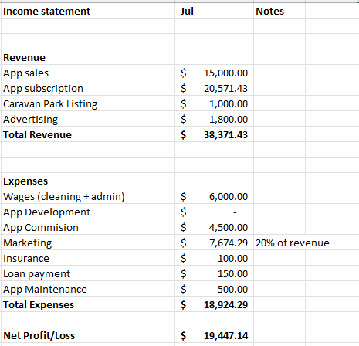
Figure 7: Income Statement

Breakeven Analysis:

Figure 8: Break Even Analysis
The breakeven point is for Easy Adventure is reached when of 2,200 apps with subscriptions are sold. Then all expenses will be paid for, and Easy Adventure will be making profit.

Marketing Strategies

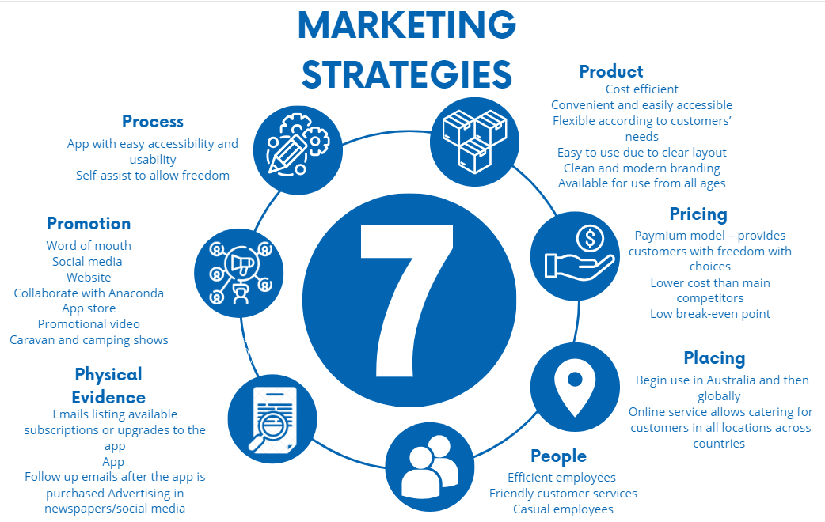Figure 9: 7P’s of Marketing

Promotional Plan
Marketing objectives are to raise awareness and promote Easy Adventure, positioning it as the ultimate camping companion app for avid campers.

Influencer Partnerships:
- Collaborate with campers to promote Easy Adventure on social media platforms, through visually appealing posts and stories of trips planned by Easy Adventure.

Content Marketing:
- Develop products related to camping, featuring Easy Adventure as the best camping app in the industry.

App Store Optimization:
- Optimize the Easy Adventure app to increase downloads on app stores.

Partnerships with Outdoor Brands:
- Create partnerships with camping brands to promote Easy Adventure to their customers.

Paid Advertising:

Run online ads on social media platforms to reach potential customers interested in camping.

Performance Measurement:

The success of promotional efforts will be tested regularly to allow for refinement in the strategies to attain greater sales.

Conclusion
Easy Adventure is committed to providing its customers with an easy way to plan their camping trip while still catering for all their fundamental needs. The accessible and convenient offer of an app entices customers with the low-cost subscription fee being insignificant due to the deals offered. Through using multiple revenue streams including app sales, app subscriptions, advertising and caravan parks listing, Easy Adventure is a viable business with a massive growth potential.

Word Count = 1,199

Appendices
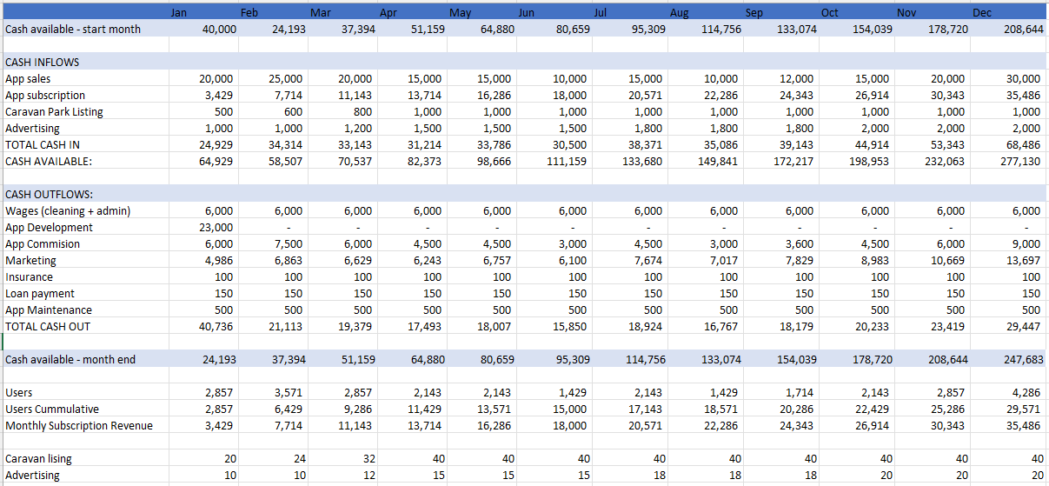
Figure 10:Projected Cash Flow Statement

Reference List:
App Store, 2023, Choosing a Business Model - App Store - Apple Developer 2023, Apple Developer, viewed 31 July 2023, https://developer.apple.com/app-store/business-models/
‌BuildFire, 2023, Mobile App Marketing Costs: How to Plan Your App Marketing Budget 2021, BuildFire, viewed 31 July 2023, https://buildfire.com/app-marketing-budget/
Caravan Stats, 2023, Caravan and Camping State of the Industry 2023 - CaravanStats 2023, CaravanStats, viewed 26 July 2023, https://caravanstats.com.au/research/caravan-and-camping-state-of-the-industry-2023/
Curry, D, 2023, App Pricing Benchmarks (2023) 2023, Business of Apps, viewed 31 July 2023, https://www.businessofapps.com/data/app-pricing/
‌Future Travel, 2023Stayz finally moves to all commission model, just 10% buts gets slammed by property owners – FutureTravel 2021, Futuretravel.com, viewed 31 July 2023, https://futuretravel.com/ttn555-stayz-moves-to-all-commission-model/#:~:text=Now%20owned%20by%20Expedia%2C%20Stayz,Online%20Travel%20Agents%20of%2015%25.
Marcus Lifestyle Team, 2023, Hottest Camping Trends: New Ways To Go Camping 2021, Marcus Lemonis, viewed 24 July 2023, https://www.marcuslemonis.com/lifestyle/camping-trends
McCormick, K 2023, How Much Does Google Ads Cost in 2023? | WordStream, WordStream, viewed 31 July 2023, https://www.wordstream.com/blog/ws/2015/05/21/how-much-does-adwords-cost
Research Dive, 2023, Camping and Caravanning Market Size & Industry Trends: 2031 2023, Researchdive.com, viewed 24 July 2023, https://www.researchdive.com/8626/camping-and-caravanning-market
Schick, S 2014, Report: 40% of app users would be willing to pay a monthly subscription, Fierce Wireless, viewed 31 July 2023, https://www.fiercewireless.com/developer/report-49-app-users-would-be-willing-to-pay-a-monthly-subscription#:~:text=%22With%2037%20percent%20of%20smartphone,)%20of%20growth%20to%20penetrate.%22
Statista, 2023, Average price of Android apps 2023 | Statista 2023, Statista, viewed 31 July 2023, https://www.statista.com/statistics/271109/average-price-android-apps/#:~:text=As%20of%20July%202023%2C%20there,9%20and%2010%20U.S.%20dollars
Statista, 2023, Camping - Australia & Oceania | Statista Market Forecast 2023, Statista, viewed 24 July 2023, https://www.statista.com/outlook/mmo/travel-tourism/camping/australia-oceania
The Bonfire Team 2019, Bonfire - Campground Management Software, Bonfire - Campground Management Software, viewed 26 July 2023, https://www.letsbonfire.com/blog/2019/5/13/2018-camping-statistics-and-how-to-apply-the-findings

‌

Research Dive, 2023, Camping and Caravanning Market Size & Industry Trends: 2031 2023, Researchdive.com, viewed 24 July 2023, https://www.researchdive.com/8626/camping-and-caravanning-market
Statista, 2023, Camping - Australia & Oceania | Statista Market Forecast 2023, Statista, viewed 24 July 2023, https://www.statista.com/outlook/mmo/travel-tourism/camping/australia-oceania
Marcus Lifestyle Team, 2023, Hottest Camping Trends: New Ways To Go Camping 2021, Marcus Lemonis, viewed 24 July 2023, https://www.marcuslemonis.com/lifestyle/camping-trends ‌
Caravan Stats, 2023, Caravan and Camping State of the Industry 2023 - CaravanStats 2023, CaravanStats, viewed 26 July 2023, https://caravanstats.com.au/research/caravan-and-camping-state-of-the-industry-2023/ ‌
The Bonfire Team 2019, Bonfire - Campground Management Software, Bonfire - Campground Management Software, viewed 26 July 2023, https://www.letsbonfire.com/blog/2019/5/13/2018-camping-statistics-and-how-to-apply-the-findings ‌
App Store, 2023, Choosing a Business Model - App Store - Apple Developer 2023, Apple Developer, viewed 31 July 2023, https://developer.apple.com/app-store/business-models/ ‌
Statista, 2023, Average price of Android apps 2023 | Statista 2023, Statista, viewed 31 July 2023, https://www.statista.com/statistics/271109/average-price-android-apps/#:~:text=As%20of%20July%202023%2C%20there,9%20and%2010%20U.S.%20dollars
Schick, S 2014, Report: 40% of app users would be willing to pay a monthly subscription, Fierce Wireless, viewed 31 July 2023, https://www.fiercewireless.com/developer/report-49-app-users-would-be-willing-to-pay-a-monthly-subscription#:~:text=%22With%2037%20percent%20of%20smartphone,)%20of%20growth%20to%20penetrate.%22
Curry, D, 2023, App Pricing Benchmarks (2023) 2023, Business of Apps, viewed 31 July 2023, https://www.businessofapps.com/data/app-pricing/ ‌
McCormick, K 2023, How Much Does Google Ads Cost in 2023? | WordStream, WordStream, viewed 31 July 2023, https://www.wordstream.com/blog/ws/2015/05/21/how-much-does-adwords-cost ‌
Future Travel, 2023Stayz finally moves to all commission model, just 10% buts gets slammed by property owners – FutureTravel 2021, Futuretravel.com, viewed 31 July 2023, https://futuretravel.com/ttn555-stayz-moves-to-all-commission-model/#:~:text=Now%20owned%20by%20Expedia%2C%20Stayz,Online%20Travel%20Agents%20of%2015%25. ‌
BuildFire, 2023, Mobile App Marketing Costs: How to Plan Your App Marketing Budget 2021, BuildFire, viewed 31 July 2023, https://buildfire.com/app-marketing-budget/ ‌

