How can we use economic indicators of performance to manage the economy and improve our living standards

Remembering
- Name the major indicators of economic performance
- Draw the five sector circular flow model
Comprehension
- Describe how money flows through the economy
- Explain how indicators would be used to determine how an economy is going
Application

- In a group of 4 (maximum), demonstrate the impact of an increase in injections on an economy. Do this task on some large cardboard, using only pictures (no words).
- How would you apply economic policy of interest rates and government spending/budget to an economy that is going poorly
Analysis

Examine the graphs and tables below:
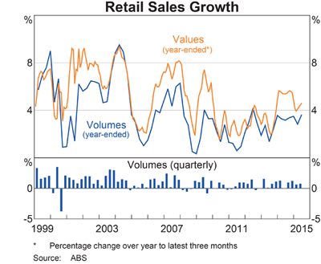
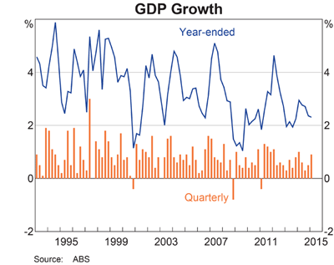

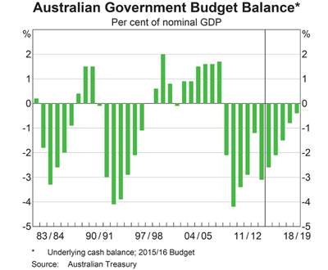
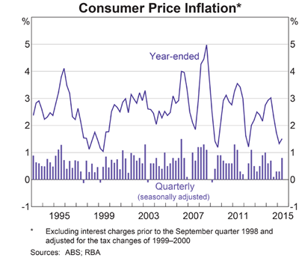

- Use a fishbone to analyse the position of Australia’s economy. Use an indicator on each bone of the ‘fish’
- Using the CPI, GDP and UE rate, deduce Australia’s position on the business cycle and justify your decision
- Using economic indicators (UE rate, GDP, CPI, HDI and Gini) create a Y-chart classifying the following countries as developed, developing or undeveloped

Algeria
Argentina
Australia
Belguim
Boznia and Herzegovina
Brazil
Cameroon
Chile
Columbia
Costa Rica
Cote d’Ivoire
Croatia
Ecuador
England
France
Germany
Ghana
Greece
Honduras
Iran
Italy
Japan
Korea Republic (South Korea)
Mexico
Netherlands
Nigeria
Portugal
Russia
Spain
Switzerland
Uruguay
USA

- Using a 2 circle VENN diagram analyse and compare the economies of Australia and a developing country from the list above

Evaluation: Judging the information
- In 2008, Australia went through the GFC. What did the Australian Government do to the economy during this time? Use a PMI to evaluate the decisions the government made to keep the economy going.
- Compare and contrast the Government response in the GFC to the Government response to COVID-19. Which do you think was managed better? Give at least 5 reasons in your response (1/2 page)
- Evaluate the claim that Australia is the best country in the world to live in (1/2 page)
- To what extent do you agree with the following statement:
- To keep Australia growing, more money needs to be injected into the economy. (1 page)
  - Use a judgement/reasons/response model to plan this response
Creating
- Creativity Questivities
  - What would happen if undeveloped and developing countries became developed in the next 50 years? What would life be like?
  - Would you rather live in a developing or undeveloped country? Explain your decision.
  - How would you feel if you were an undeveloped country?
  - In your opinion, what is the most reliable economic indicator?
  - Why do some countries experience economic prosperity and others do not?
  - How is economic performance like a football game?
  - Active question – Make a list of questions the president of Nigeria might ask Scott Morrison about economic management
- Design a poster clearly demonstrating the issues of inequality raised by the Lorenz curve

Reflection

- Complete the following reflection stem questions:
- Looking back
- I enjoyed learning this because…
- One thing I didn’t expect was…
- Before this I did not know that…
- Doing this made me wonder about…
- Looking forward
- This has inspired me to look into…
- I need to understand this because…
- I want to find out why ________ happens so that I can…

Extension Activity

RAFT Task – Select from the following list to create your own task completing the sentence below.

Role –
Audience
Format
Topic –

You are a __________________, presenting to a group of ______________________ by way of a __________________ your understanding of _______________________________________________

Investigative task. Find at least 10 examples of how the concepts of economics we did are found in the bible

Learning Intentions – to what extent do you know them? What do you still need to work on?
- I will learn how money flows through our economy and how it affects the UE rate, CPI and GDP
- I will learn how to identify and read and analyse indicators of economic performance
- I will learn how governments can solve economic problems
- I will learn how to evaluate the effectiveness of economic policy
- I will understand that GDP, HDI and TQL indexes can be used to show development and inequality
- I will learn how the Lorenz curve and gini index can show the unequal distribution of income around the world

