KEEP THIS BUSINESS AFLOAT FOR 2025

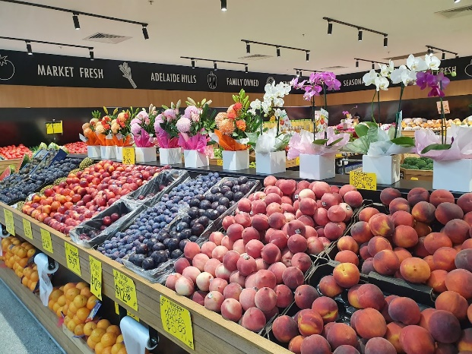
Scenario
You are a small fruit shop owner that operates in the Adelaide Central Markets. You sell all kids of fruit and vegetables as well as gift baskets. You employ 2 full time staff and 3 part-time staff (one of which is a sibling).
You have found that in the last 12 months your costs have gone up dramatically and you are finding it difficult to keep your business going. How are you going to survive the year?
Keep in mind that inflation is currently at 4% nationally.

Revenue | 2022 | 2023 | 2024 (projected) | % change 2023-24
Sales of fruit & vegetables | 520,000 | 550,000 | 570,000 | +3.6%
Sales gift baskets | 58,000 | 45,000 | 50,000 | 11.1%
Total Revenue | 578,000 | 595,000 | 620,000 | 4.2%
Cost
Rent | 18,000 | 20,000 | 22,000 | +10%
Wages | 200,000 | 200,000 | 204,000 | +2%
Electricity | 27,000 | 30,000 | 35,000 | +17%
Insurance | 13,000 | 15,000 | 20,000 | +20%
Stock costs | 290,000 | 300,000 | 350,000 | +17%
Total Costs | 548,000 | 565,000 | 631,000 | +13.2%
Profit (loss) | 30,000 | 30,000 | (-11,000)

As a group, analyse what is happening in this business and propose some ways that the business might be able to keep going into 2025.

As you do this, answer the questions on the following page as a group:
Why might there be pressure on wages to increase?

Why do you think the business has only increased wages by 2% when inflation is at 4.1%

Demonstrate what you think has happened to supply for each item in the spreadsheet above and give reasons (factors) for why you think this has happened
You will need to do a little research as a group to justify your answer

Why do you think demand might be decreasing, but you’re still increasing the amount of money you’re getting in?

What are some areas that your business might be able to reduce costs?

If you were to cut labour costs (wages), what impact do you think this will have on the business?
What will be the effect on the businesses costs?
What will be the impact on the morale of employees?
What kind of unemployment might this fall under?
Is there an alternative way to keep all your employees but still reduce costs?

What are some ways that the business might be able to increase revenue?

Overall, what is your group recommendation to this business to keep it going into 2025. Pitch this idea as a group to the class. (max 1 minute)

REFLECTION QUESTIONS ON COLLABORATION

Throughout this task, how did you

Communicate your ideas with your group personally? Give an example

How did you get and/or give feedback? Give an example of how you did this.

How did you make sure everyone in your group was understanding the answers? Were there any occasions where it wasn’t quite clear? Explain.

How did your group make sure everyone was in agreement?

Overall, how effective was your collaboration? Highlight where you think your group fell and give a reason for why you say this.

Superb | Communicates ideas, information, and feedback effectively, facilitating understanding and alignment among team members to work collectively toward a solution.
Great | Consistently communicates ideas and feedback clearly and listens actively to work collectively toward a solution
Good | Communicates ideas adequately but may occasionally struggle to ensure understanding.
meh | Struggles with clear communication, leading to misunderstandings within the team.
Oh boy…! | Fails to communicate effectively, hindering collaboration efforts.

