Blender: Controls
Tab  Switch editing mode |  |  |  |  | E  Extrude |  | R  Rotate  Ctrl-R  Loop cut |  | T  Tools |  |  | Y  Lock to Y axis |  |  |  |  | O  Proportional editing |  | Ctrl-P  Set parent |  |  |  | 7  View top | 8  Orbit up
 | A  Select all/none |  | S  Scale  Alt-S  (texture window)  Save Image |  |  | Shift-D  Duplicate |  | F  Make edge/face  Brush size (texturing) |  | G  Move |  |  | H  Hide selected  Shift-H  Hide unselected  Alt-H  Unhide all |  |  |  |  |  |  |  |  |  | 4  Orbit left | 5  Persp/ortho | 6  Orbit right
 |  | Z  Lock to Z axis |  | X  Lock to X axis |  | C  Paint select |  |  |  |  | B  Box select |  |  | N  Properties |  | Alt-M  Merge vertices |  | ,  Pivot bounding box centre |  | .  Pivot 3D cursor |  |  | 1  View front | 2  Orbit down | 3  View right
Ctrl  Lasso select |  |  |  |  |  |  |  |  |  |  |  |  |  |  |  |  |  |  |  |  |  |  |  |  | .  Centre view

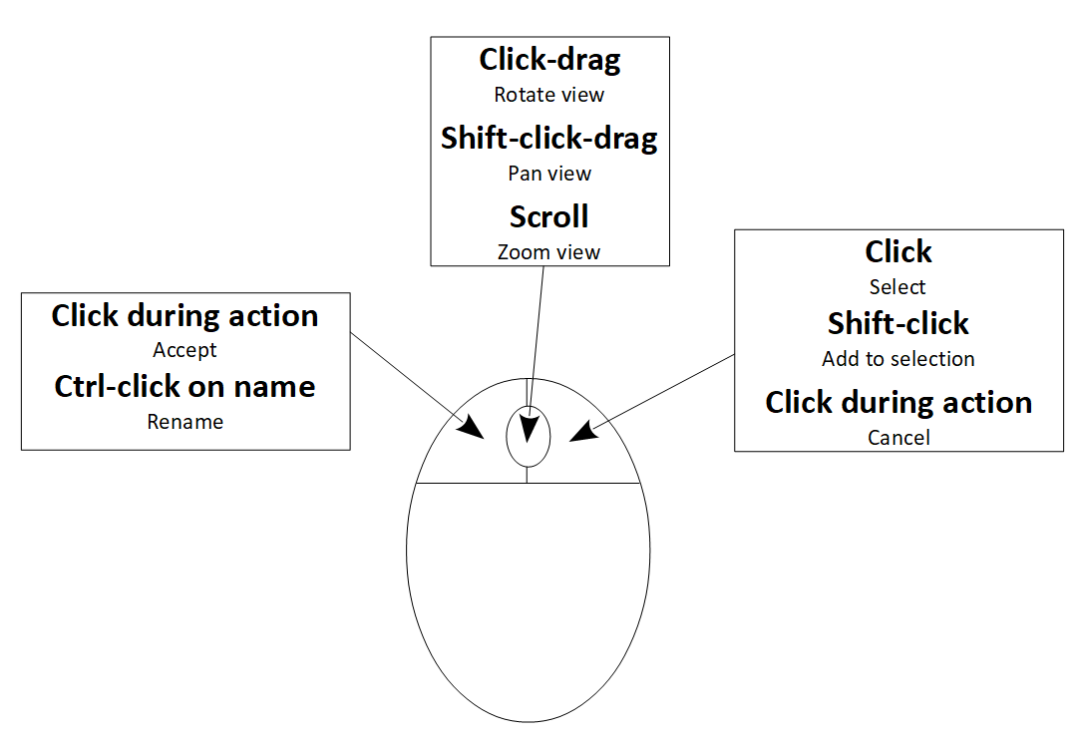
Blender: Texturing
Setting up your mesh for texturing (video version here: https://www.youtube.com/watch?v=WjS_zNQNVlw):
- Change into Edit mode (press Tab or select it from the drop-down menu at top left)
- Make sure everything in the mesh is selected (press A until everything is orange)
- Press U, click Smart UV Project, then click OK
- Change window layout (at top of screen) to Texture Paint, make sure you are in the tab
- Press the + button on the right of the screen (next to No Textures) and choose Base Color then OK
- Click Material Base Color that has now appeared next to the + you just clicked
- Make sure you save your texture often while painting (top left menu Image > Save)
Other things to remember:
- If your brush is only painting on some of the mesh, make sure Normal is set to 90 in the model view Tools panel (in the middle of the screen, you might need to scroll it down).
- Keyboard shortcuts only work when the last window you clicked in matches that action
  - Example: You can use Alt-S to save your texture image quickly but only if the last window you clicked in was the image view (the left window in Texture Paint layout)
You can also set the brush to paint only on certain faces by pressing this button at top of right window:
If you do, use Edit Mode to choose which faces are selected.

Blender: Animating
Setting up
- Change window layout to Animation
- Turn on automatic keyframes ( white circle button down the bottom of the screen)
Rigging (creating a skeleton)
To use bone animation, first you need to add bones to your mesh:
- Go into Object Mode
- In the menu at the top of the screen, Add > Armature
- Go into Edit Mode
- Position, rotate and extrude bones as necessary to fit your mesh
- Click into the Object Data Properties tab (this button , on the right of the screen)
- Find the Viewport Display section and change Display As to Envelope
- Move and scale the envelopes to set which parts follow which bone (Alt-S to scale just an end)
- Go into Object Mode, select the mesh object, and click into the Modifiers tab (this button: )
- Click Add Modifier, choose Armature, set the Object field to Armature, tick Bone Envelopes
- Select the armature object
Animating
- Go into Pose Mode
- Click the frame in the animation timeline you want to set
- Rotate/move the bones however you like
All bone animating needs to be done in Pose mode (Edit mode is used to change the bone positions across all frames).

