Key Unlock
  - Godot 4 Tutorial

Create the scene
- Create a new project (or even just a new scene in your current Godot project)
- Choose 2D Scene
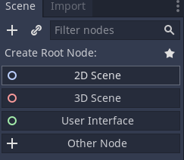
- Put the room, key, chest_open and chest_closed files into the project.
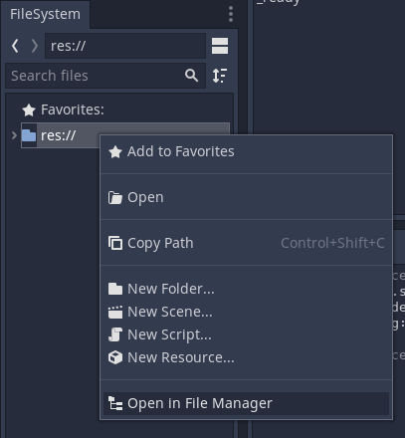
- Attach a new script to the Node2D node and save it.
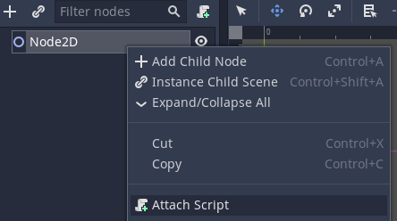

Create the background
- Click on 2D at the top of the window to return to the viewport.
- Drag the room file into the viewport so that it covers the game area
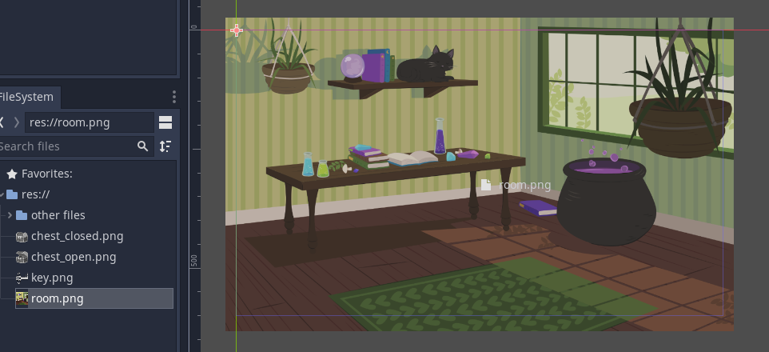
- Lock the background into place by clicking the padlock icon
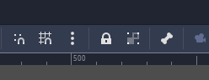

Create the chests
- Add an AnimatedSprite2D child node to the Node2D node
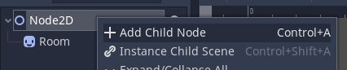
- Rename it to WhiteChest
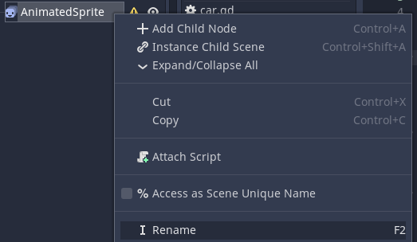
- In the Inspector, expand the Animation section and set Sprite Frames to New SpriteFrames
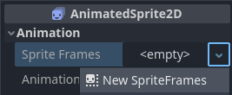
- Click SpriteFrames to open the animation editor
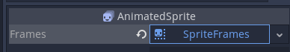
- Click the default animation to rename it to closed
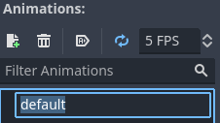
- Drag the chest_closed file into the Animation Frames area
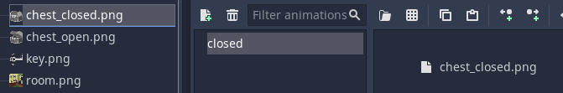
- Click the button to add a new animation
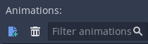
- Double-click New Anim to rename it to open
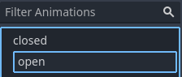
- Drag the chest_open file into the Animation Frames area
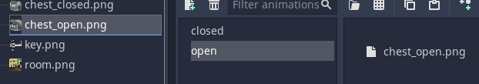
- In the Inspector, make sure Animation is set to closed

- Duplicate the WhiteChest node, then rename it to YellowChest
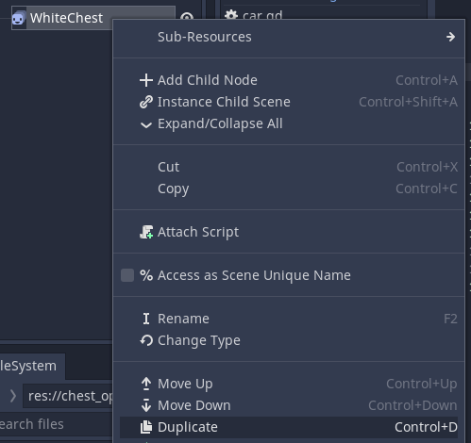
- In the Inspector, expand Visibility and change Modulate to yellow
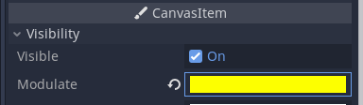
- Move the chests so they look like they are on the floor of the room
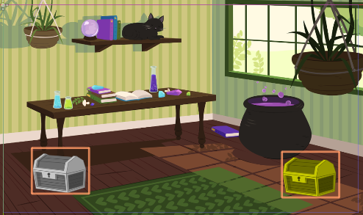

Create the keys
- Add a TextureButton child to the Node2D node
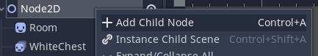
- Rename it to WhiteKey
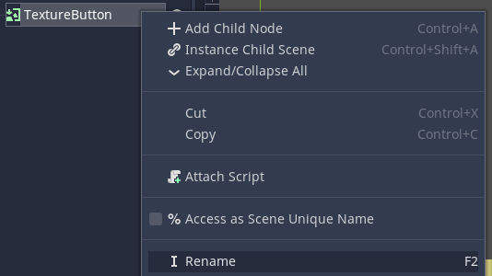
- In the Inspector, expand Textures and load the key as the Normal texture.
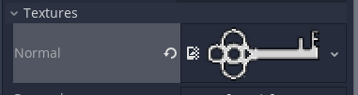
- Move the white key so it is above a hanging plant
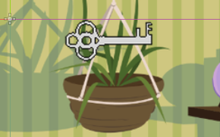
- Repeat steps 1-4 to create another key but this time call it YellowKey
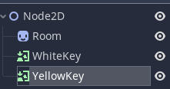
- In the Inspector, expand Visibility and set Modulate to yellow.
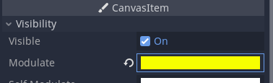
- Move the yellow key so it is above the cauldron
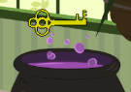

- Switch to the Node tab
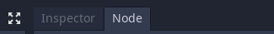
- Connect the pressed signal
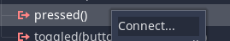
- Select WhiteKey
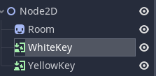
- Connect the pressed signal
- Change the _on_yellow_key_pressed and _on_white_key_pressed code to this:
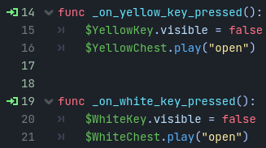
- Play the scene to make sure it works (you should be able to unlock chests by clicking keys)

Hide the keys
- Click the eye icons next to the key nodes to hide the keys
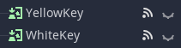
- Click on 2D at the top of the window to return to the viewport.
- Add a TextureButton child node to the Node2D node.
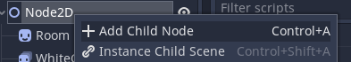
- Rename it to FindWhiteKey
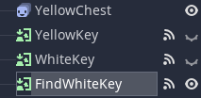
- Move and resize the rectangle to cover the pot of the plant
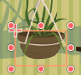
- Connect the pressed signal
- Repeat steps 2-6 but this time name it FindYellowKey and cover the cauldron
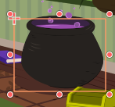
- Change the _on_find_white_key_pressed and _on_find_yellow_key_pressed to this:
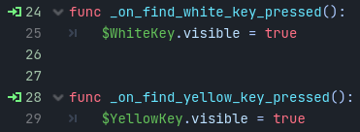
- The game is finished!

