Octopus Star Collect Game
  - Godot 4 Tutorial

Create the scene
- Create a new project (or even just a new scene in your current Godot project)
- Choose 2D Scene
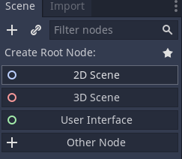
- Put the octopus file and the star file into the project folder.
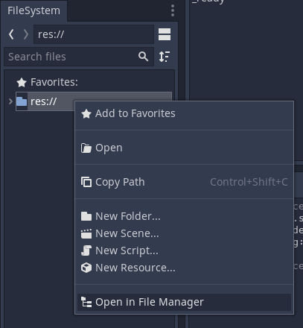

Create the octopus
- Drag the octopus file into the viewport.
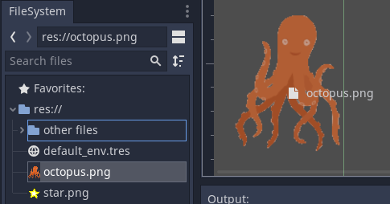
- Add an Area2D child to the Octopus node.
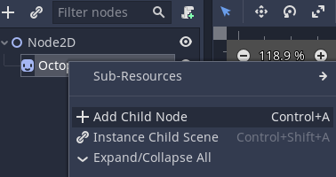
- Add a CollisionPolygon2D to the Area2D node.
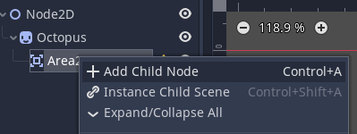
- Create points using the + tool.
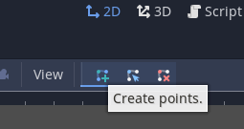

Make octopus move with arrow keys
- Attach a script to the Octopus node
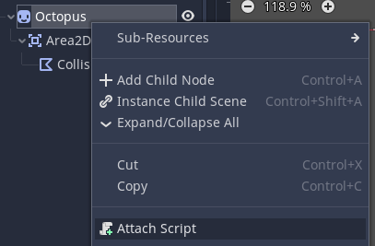
- Delete all the script code and put this:
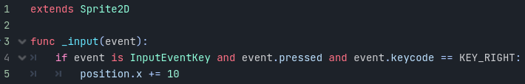
- Run the scene and try pressing the right arrow key to move the octopus.
- Once you’ve closed the running game, add the code for the other arrow keys:
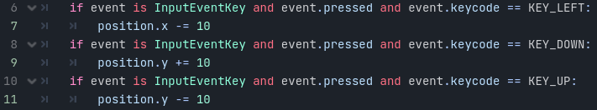

Create the star
- Click on 2D at the top of the window to return to the viewport.
- Drag the star file into the viewport.
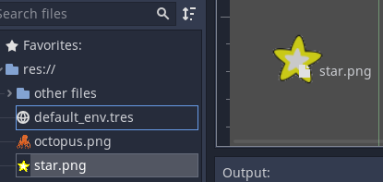
- Add an Area2D child to the Star node.
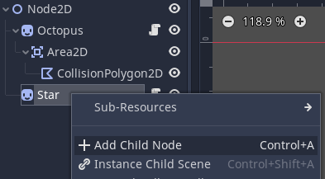
- Add a CollisionShape2D child to the Area2D node you just added.
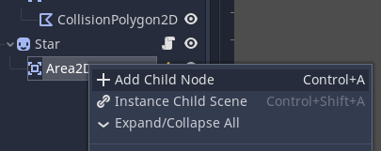
- Choose a circle from the shapes list in the Inspector
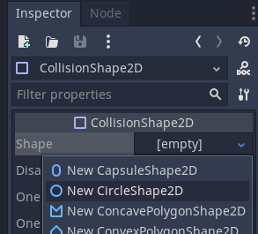

Make the star move when you collect it
- Attach a script to the Star node
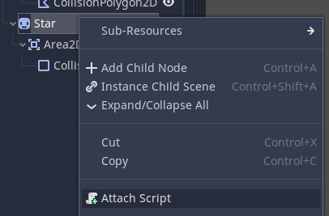
- Delete all the code and set the code to this:
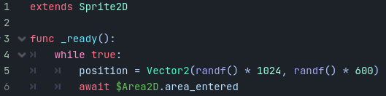
- Run the scene to make sure it’s all working properly.

Make a score count
- Once you’ve closed the running game, add a Label child node to the Node2D node.
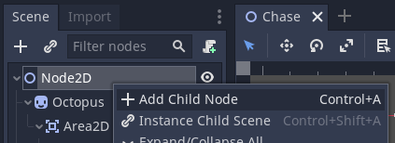
- Select the Area2D node for the star
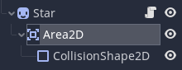
- Click the Node tab (next to the Inspector)
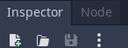
- Connect the area_entered signal to the Octopus node
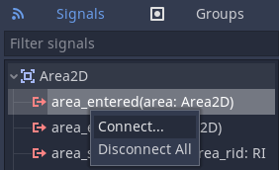
- Write this code into the script:
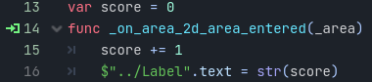
- The game is finished!

