Platform Jump Game
  - Godot 4 Tutorial

Create the scene
- Create a new scene.
- Choose 2D Scene, then save the scene.
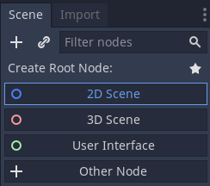
- Put the jumper, platform and cracked files into the project folder.
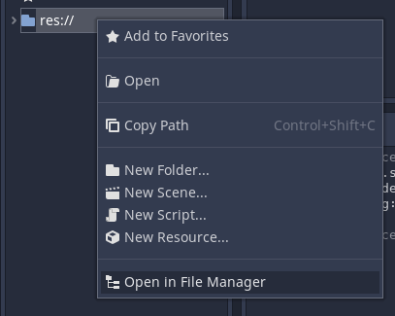
- Rename the Node2D to PlatformJump.
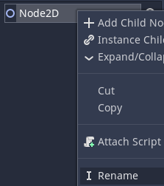

Add a platform
- Add a StaticBody2D child to the PlatformJump node.
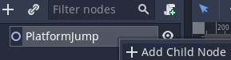
- Rename the StaticBody2D to Platform and move it into the lower centre of the game area.
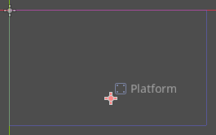
- Drag platform.png into the viewport so that it is centred on the + symbol.
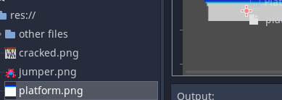
- Make the Platform2 node a child of Platform by dragging it:
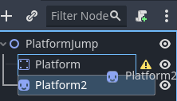
- Add a CollisionShape2D child to the node.
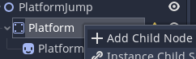
- In the Inspector, choose Rectangle for the Shape and tick One Way Collision.
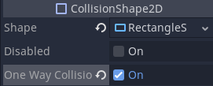
- Use the resizing handles to make the shape match the platform picture.
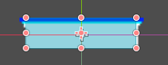

Add the jumper
- Add a CharacterBody2D child to the PlatformJump node.
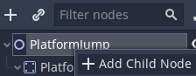
- Rename the CharacterBody2D node to Jumper and move it just above the platform.
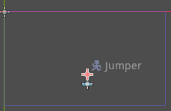
- Drag jumper.png into the viewport so that it is centred on the + symbol.
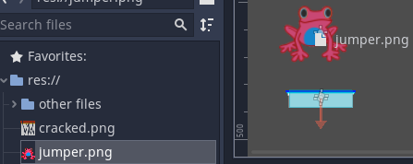
- Make the Jumper2 node a child of Jumper by dragging it:
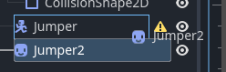
- Add a CollisionShape2D to the node.
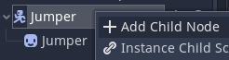
- In the Inspector, choose Rectangle for the Shape.
- Use the resizing handles to make the shape match the frog picture.
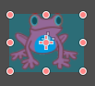

Make the frog bounce
- Attach a script to the node.
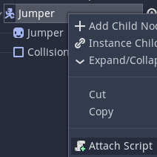
- Delete all the code and replace it with this:
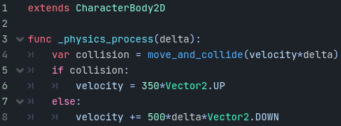
- Run the scene to make sure it’s all working properly.

Control the frog with left and right arrow keys
- Add this code to script:
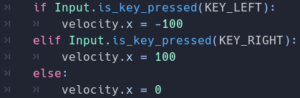
- Run the scene to make sure it’s all working properly.

Add a cracked platform
- Duplicate the node.
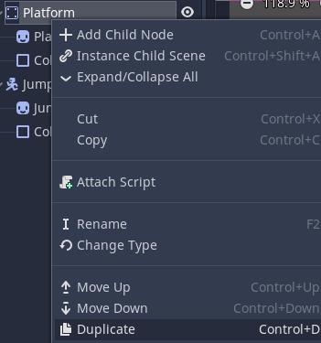
- Rename the node to Cracked and change its type to RigidBody2D.
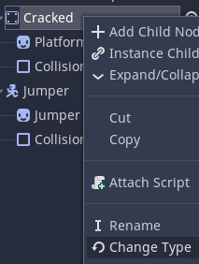
- Make sure the Cracked node is selected. In the Inspector, check Freeze so it is On.
- Switch back to 2D view using the button at the top of the screen.
- Use the move tool to move the Cracked platform away from the other platform.
- Select the child of Cracked node. In the Inspector, load cracked.png to Texture.
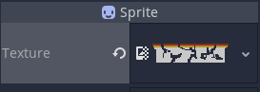

Make the cracked platform crumble when touched
- Change this code…
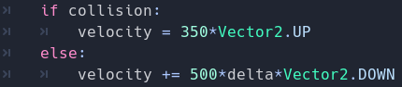
…to this:
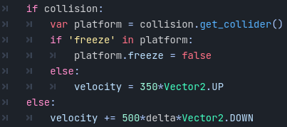
- Run the scene to make sure it’s all working properly.

Fill the game area with platforms
- Attach a script to the PlatformJump node.
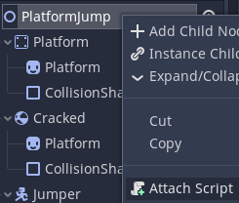
- Delete all the code and replace it with this:
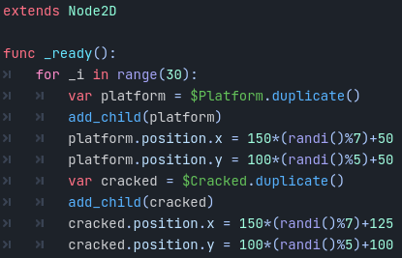
- The game is finished!

