Pong Game
  - Godot 4 Tutorial

Create the scene
- Create a new project (or even just a new scene in your current Godot project)
- Choose 2D Scene
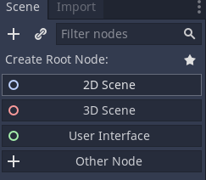
- Put the ball and paddle files into the project folder.
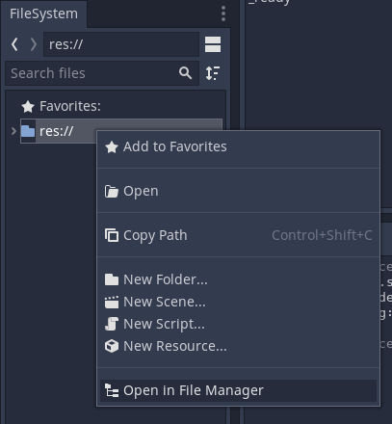

Create the ball
- Drag the ball file into the viewport.
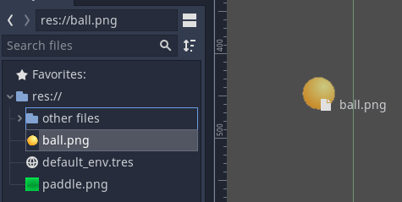
- Attach a new script to the Ball node
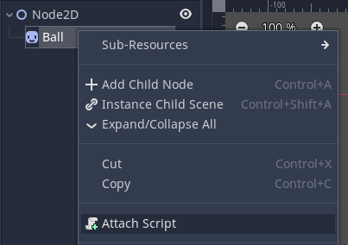
- Delete all the code and set the code to this:
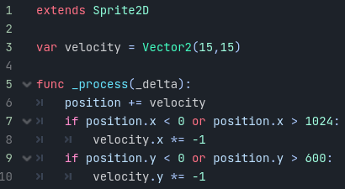
- Play the scene to make sure it works

Create the paddle
- Click on 2D at the top of the screen to go back to the viewport
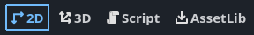
- Click on the Node2D node to select it
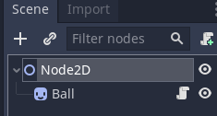

- Drag the paddle image into the viewport
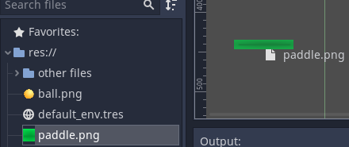
- Add an Area2D child to the Paddle node.
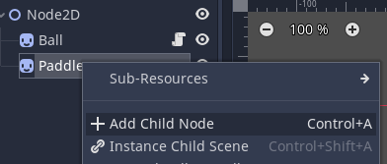
- Add a CollisionShape2D child to the Area2D node.
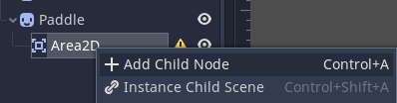
- Choose the rectangle shape
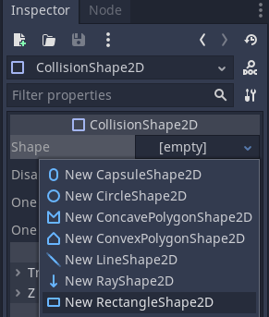
- Resize the shape to approximately match the paddle
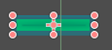
- Attach a new script to the Paddle node
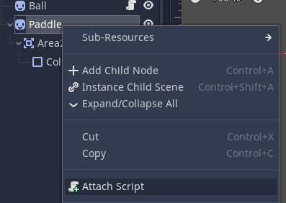
- Delete the code that appears and set the code to this:
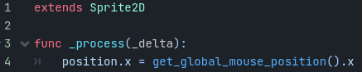

Make the ball bounce off the paddle
- Click on 2D at the top of the screen to go back to the viewport
- Add an Area2D child to the Ball node
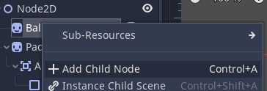
- Add a CollisionShape2D node to Area2D you just added.
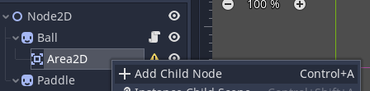

- Choose the circle shape
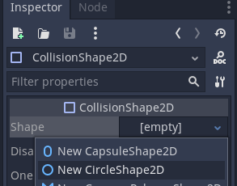
- Resize the circle to approximately match the ball
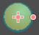
- Click the script icon next to the Ball node to open the ball script
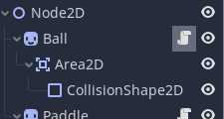
- Add this code below the existing code:
- The game is finished!

