Trumpet Ball Bounce
  - Godot 4 Tutorial

Create the scene
- Create a new project (or even just a new scene in your current Godot project)
- Choose 2D Scene
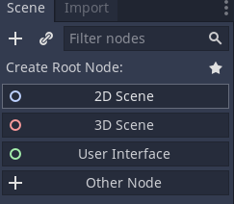
- Put the ball, gem and trumpet files into the project.
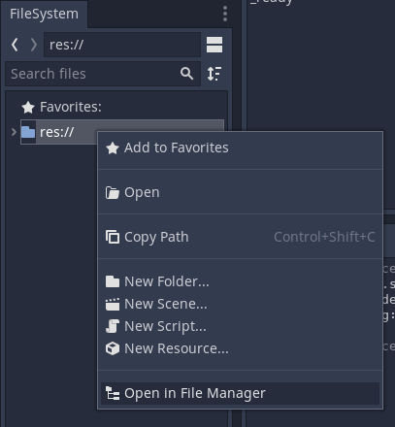
- Attach a new script to the Node2D node
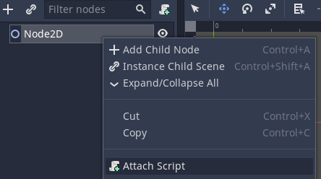
- Click on 2D at the top of the window to return to the viewport.

Create the gems
- Add a StaticBody2D child to the Node2D node.
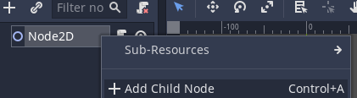
- Rename StaticBody2D to Gem.
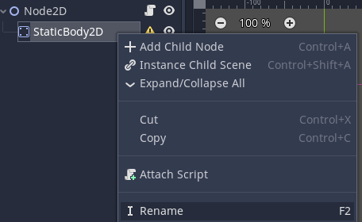
- Move the + symbol into the centre of the viewport.
- From the Node tab, click Groups, then add the gems group.
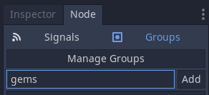
- Drag the gem file into the viewport. Make sure it is centred on the + symbol.
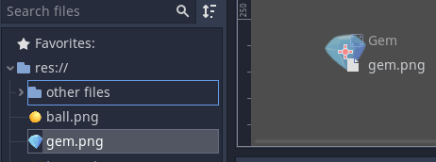

- Drag the node onto the node to make it a child. Rename it to Gem.
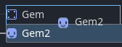
- Add a CollisionShape2D child to the node.
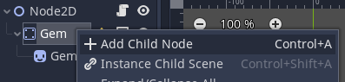
- From the Inspector tab, set the shape to a New CircleShape2D.
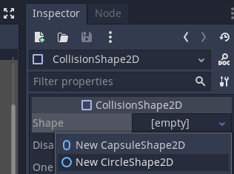
- Resize the collision shape to match the gem by dragging the red circle.
- Go to script view by clicking Script at the top of the screen
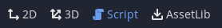
- Delete all the code in the Node2D script and set the code to this:
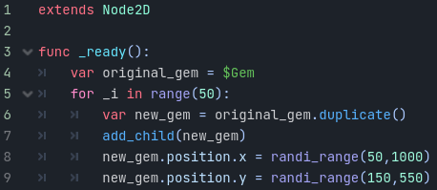
- Play the scene to make sure it works (there should be lots of gems)

Create the ball
- Add a RigidBody2D child to the Node2D node.
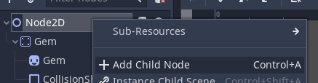
- Click on 2D at the top of the window to return to the viewport.
- Move the + so it is above the gem in the viewport.
- In the Inspector, set Max Contacts Reported to 1, and Contact Monitor to On.
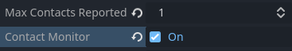
- Create a new PhysicsMaterial and click on it to open it.
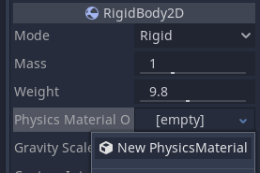
- Set Bounce to 0.7
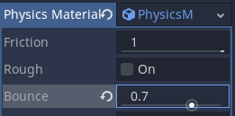
- Rename the Rigidbody2D node to Ball.
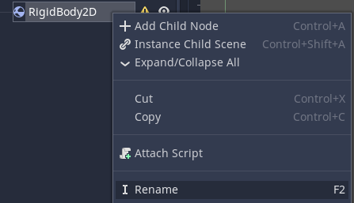
- Drag the ball image into the viewport. Make sure it is centred on the + symbol.
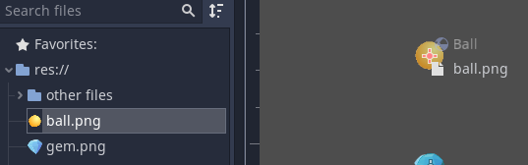
- Drag the node onto the node to make it a child. Rename it to Ball.
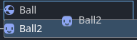
- Add a CollisionShape2D child to the node.
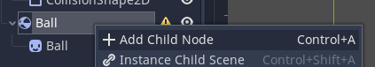
- Choose the circle shape
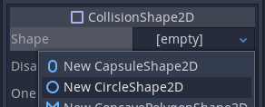
- Resize the collision shape to match the ball.
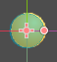
- Select the node:

- From the Node tab, click Signals.
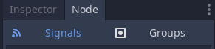
- Connect the body_entered signal to the Node2D script.
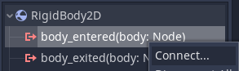
- Change the _on_ball_body_entered code to this:
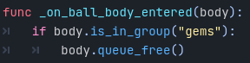
- Play the scene to make sure it works (the ball should bounce off gems and destroy them)

Create the trumpet
- Click on 2D at the top of the window to return to the viewport.
- Drag the trumpet image into the viewport. Place it at the top of the viewport.
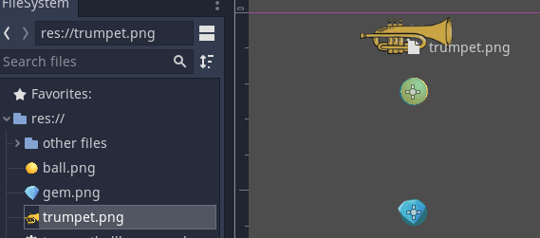

Make the trumpet launch the ball
- Change to script view and add this code:
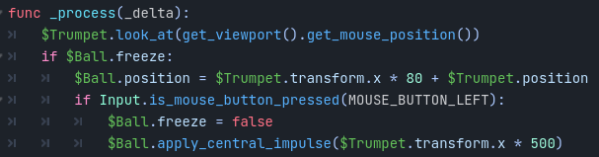
- Select the node.

- Switch to the Inspector tab.
- Change Freeze to On
- Play the scene to make sure it works (click the left mouse button to launch)

Reset the ball when it goes out of view
- Add a VisibleOnScreenNotifier2D child to the node.
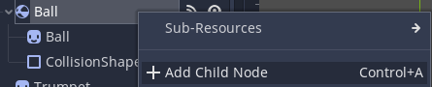
- From the Node tab, click Signals.
- Connect the screen_exited signal to the Node2D script.
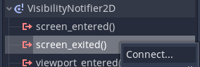
- Change the _on_visible_on_screen_notifier_2d_screen_exited code to this:
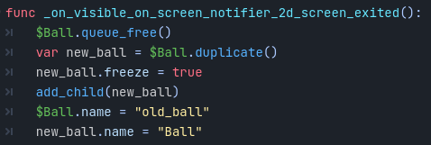
- The game is finished!

Bonus step
If you add the wall file to your project, you can put two walls in the game – one on the left and one on the right. Give each one a StaticBody2D to keep your ball from flying off the sides of the screen!

