Block Stack Game
  - Godot 4 Tutorial

Create the scene
- Create a new scene.
- Choose 2D Scene, the save the scene.
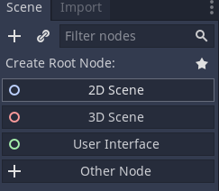
- Put the block file into the project folder.
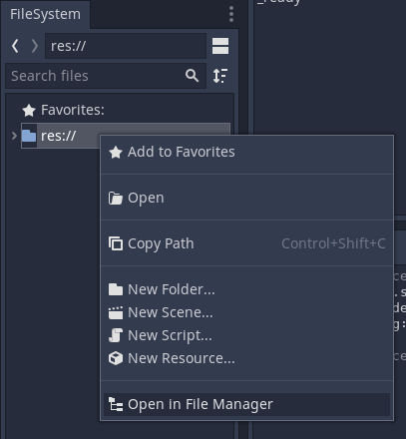

Create the block
- Drag the block file into the viewport, then select the 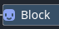 node.
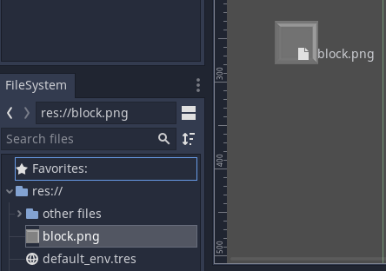
- From the Node tab, click Groups, then add the block to the blocks group.
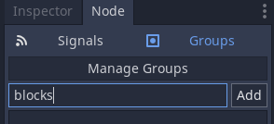
- Attach a script to the Block node.
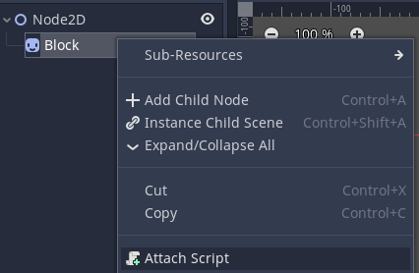
- Delete all the script code and put this:
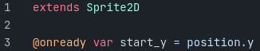

Control the block with a timer
- Add a Timer child to the Block node.
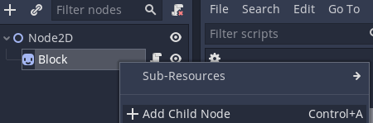
- In the Inspector, set Autostart to On.
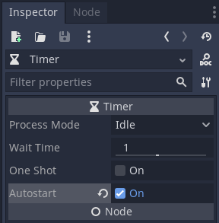
- Go to the Signals section of the Node tab (next to the inspector).
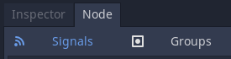
- Connect the timeout signal to the Block script
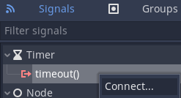

- Write this code into the script:
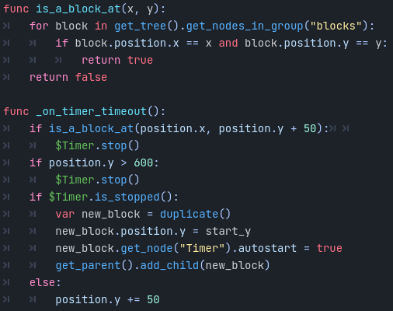
- Run the scene to make sure it’s all working properly (blocks should fall one at a time).

Move the block with the arrow keys
- Add this code to the script:
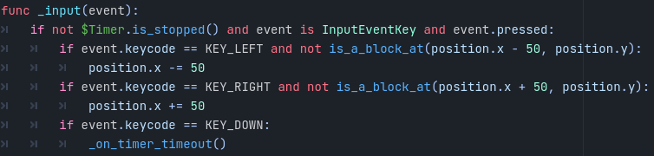
- The game is finished!

