Cake Decorate Game
  - Godot 4 Tutorial

Create the scene
- Create a new project (or even just a new scene in your current Godot project)
- Choose 2D Scene
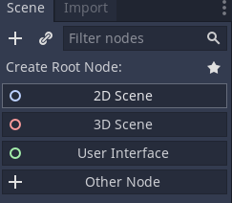
- Put the cake file and the candle file into the project folder.
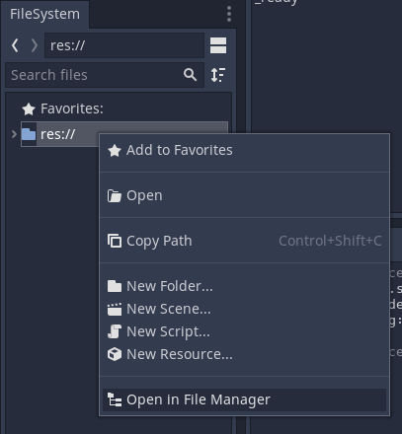

Create the cake
Drag the cake file into the viewport.
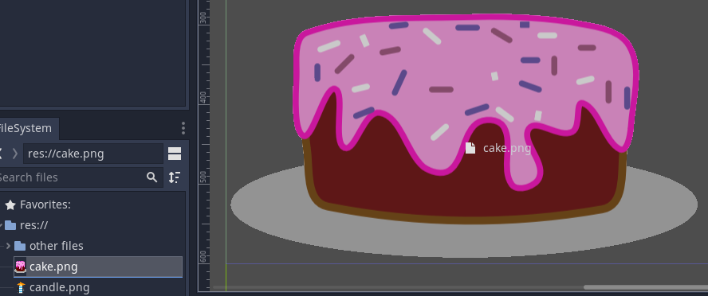

Add the candle
- Drag the candle into the viewport (not on the cake)
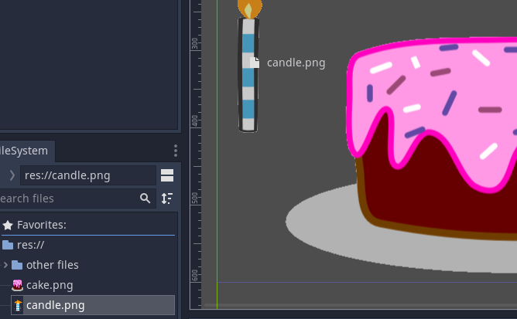
- Add an Area2D child to the Candle node.
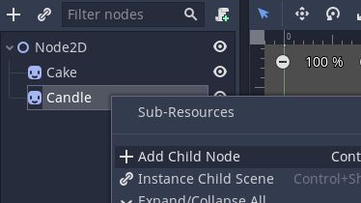
- Add a CollisionPolygon2D child to the Area2D node.
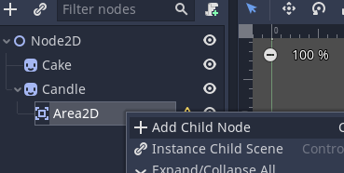
- Create points using the + tool.
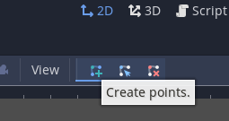
- Add a Label child to the Candle node.
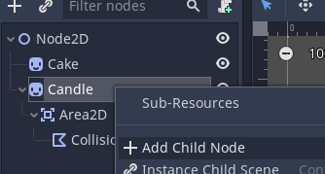

Make the candle able to be clicked
- Attach a script to the Candle node. Save it as Decoration.gd
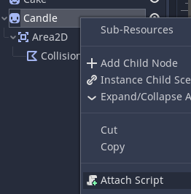
- Select the Area2D node.
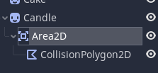
- Go to the Signals section of the Node tab (next to the inspector).
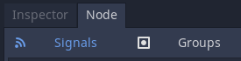
- Connect the input_event signal to the Area2D script
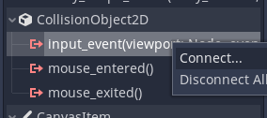

Add the code to make more candles
- Delete all the script code and put this:
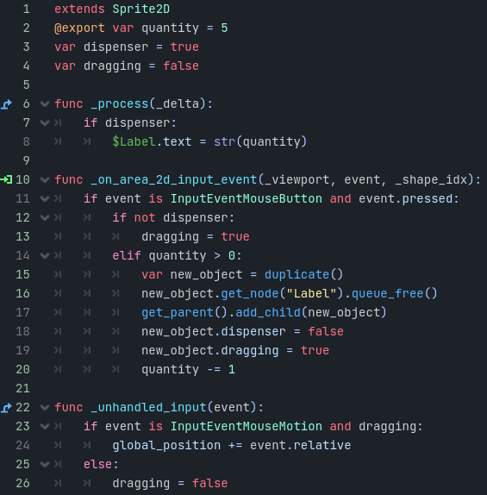
- Run the scene and try clicking and dragging candles onto the cake.
- Try adding another cake decoration by following the candle steps for a different picture. When you get to the part where you attach a script, load the Decoration.gd script so you don’t have to enter all the code again!

