Drift Car Game
  - Godot 4 Tutorial

Create the scene
- Create a new scene.
- Choose 3D Scene, then save the scene.
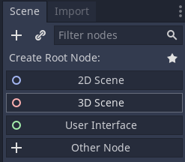
- Put the car file and the track file into the project folder.
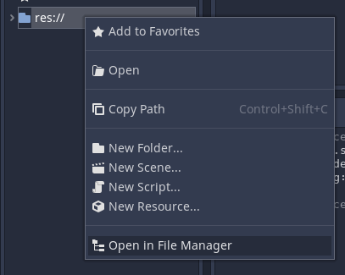

Set up the camera
- Add a Camera child to the Node3D node.
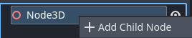
- In the Inspector, open the Transform section.
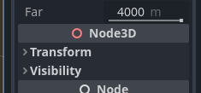

- Set Rotation y to -45
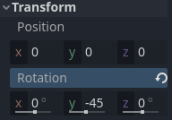

Set up the track
- Add a Sprite3D child to the Node3D node.
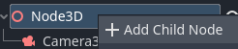
- In the Inspector, load track.png as the Texture.
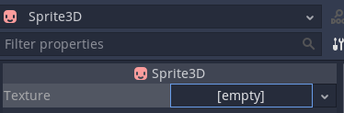
- In the Inspector, open the Transform section.
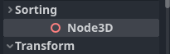
- Set Translation y to -0.2, Rotation Degrees x to 90, Scale x to 10, and Scale y to 10.
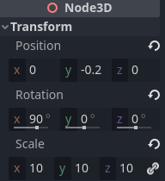
- In the Inspector, open the Flags section.
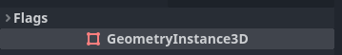
- Set Texture Filter to Nearest
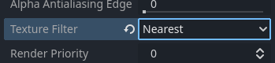

Set up a light
- Add a DirectionalLight3D child to the Node3D node.

- In the Inspector, open the Transform section and set Rotation x to -45 and Rotation y to -45.
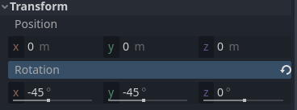

Set up the car
- Drag car.glb onto the Node3D node.
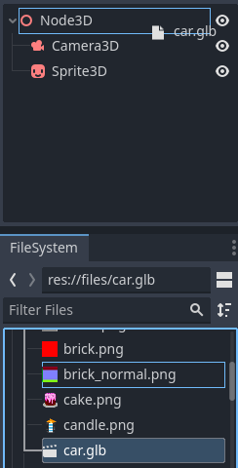
- Attach a script to the car node.
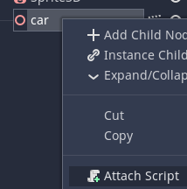
- Delete all the code and replace it with this:
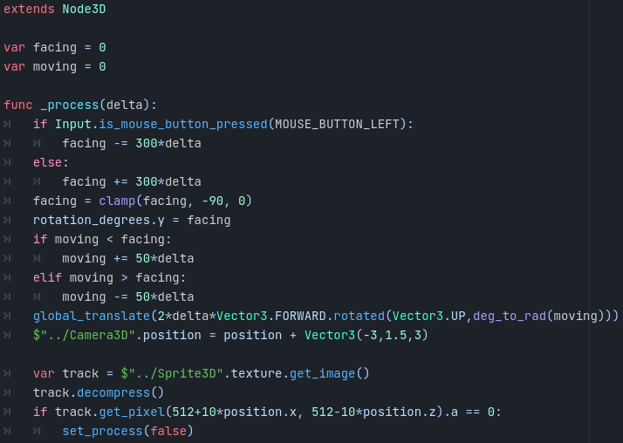
- Run the scene to make sure it’s all working properly.

Make the car stop if it goes off the track
- Under the other code, add this code to the script:
- The game is finished!

