Introduction to Godot

Learning Intentions
- To be able to create and save a new scene in Godot.
- To be able to attach a script and enter code correctly.
- To be able to run a scene and check the output.
- To be able to add a child node and position it in the scene.
- To be able to connect a signal to a script.

Setup
How to create a project that will contain all of your scenes:
- Open the Student Drive and go into the Programs folder:

- Copy the file onto your desktop:

- Close the Programs folder and run Godot from your desktop. Click Cancel in the popup.

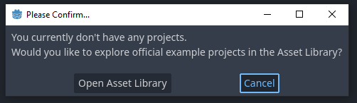

- Click , then click 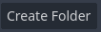, then click 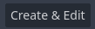

- You have finished creating a project!

Exercise 1: Print
- Since you have just created a new project, you are looking at an empty scene.
Click 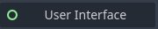 to give the scene a User Interface root node.

- Press Ctrl and S together to save the scene. Call it Exercise1.tscn
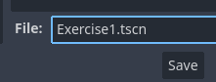

- Attach a new script to the Control node by clicking the button.
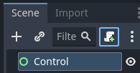

- Click Create to finish creating the new script.
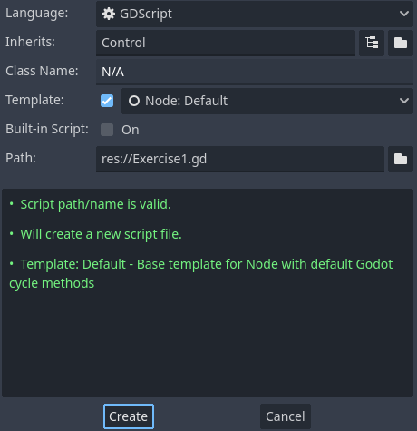

- Under func _ready():, delete the word pass and change the code to this:
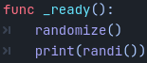
The is a tab space (use the Tab key on the left of the keyboard, not the spacebar).

- Run the scene (top right), a random number will appear in the Output box at the bottom of Godot (ignore/close the grey window that appears, that’s only for games with images).
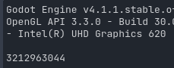

Exercise 2: Variables
- Click the + next to 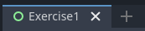 to create a new scene.
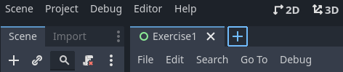

- Click to give the scene a User Interface root node.

- Press Ctrl and S together to save the scene. Call it Exercise2.tscn
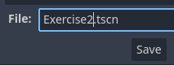

- Attach a new script to the Control node by clicking the button, then click Create.

- Near the top of the code, under extends Control, add the following two lines:
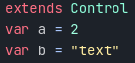

- Under func _ready():, delete the word pass and instead enter this line:
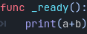

- Run the scene , an error should say this message:
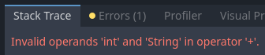
This is because you can’t add a number (int) to a word (string).

- Try making a and b both numbers or both strings by changing the code at the top of the script, and run the scene again. The result should appear in the Output box.

Exercise 3: Signals
- Create a new scene, choose , and save the scene as Exercise3.tscn

- Switch to 2D view using the button at the top of the window:
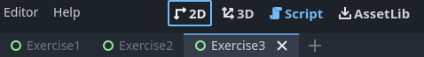

- Click the padlock at the top of the viewport to lock the Control node.
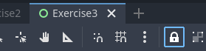

- Attach a new script to the Control node, save it as Exercise3.gd.

- Click the + on the left of side of the window to add a new node.
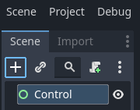

- Search for TextEdit and click Create. Then use the orange handles to move and resize it.
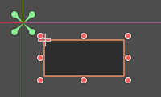

- Open the Node tab in the right top corner of the window:
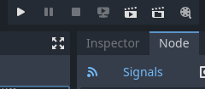

- Right-click text_changed() and choose Connect, then click Connect.
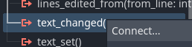

- At the bottom of the code that appears, delete the word pass and instead enter this code:
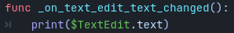

- Run the scene , click in the dark grey area and then type something. Text should appear in the Output box.

Exercise 4: Conditionals
- Create a new scene, choose User Interface root node, and save it as Exercise4.tscn.

- In 2D view, click the padlock (at the top of the Viewport) to lock the Control node.
- Attach a new script to the Control node, save it as Exercise4.gd.

- Add a TextEdit node as a child of Control, then position and resize it.
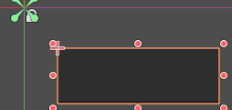

- Right-click on the Control node and choose + Add Child Node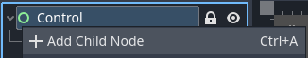

- Search for Label and click Create, then resize and position it above the textedit object:
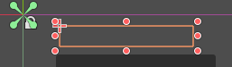

- In the Inspector on the right of the screen, set text to What kind of animal is a chameleon?
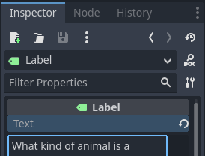

- Add a Button node as a child of Control, and position it under the textedit object.
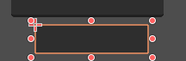

- Open the Node tab on the right top of the screen and connect the pressed() signal.
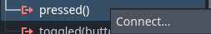

- At the bottom of the code that appears, delete the word pass and instead enter this code:
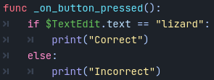

- Run the scene , type in the dark grey area and click the button, look in the Output box to see the result.

Reflection: Do I know how to…
- create and save a new scene in Godot?
- attach a script and enter code correctly?
- run a scene and check the output?
- add a child node and position it in the scene?
- connect a signal to a script?

Challenge: Make a “Guess the number” game
Make a game where the computer secretly chooses a number and the player tries to guess it. If the player guesses too high, the programs should print “Too high!” and if the player guesses too low the program should print “Too low!” If the player guesses the number, print “Correct!”
Hints:
- Create the random number by putting this line in the code:

- In your “if” check, you can’t compare words with numbers so you’ll need to convert the words to numbers using “int” like this:

