Nutrients and their benefits
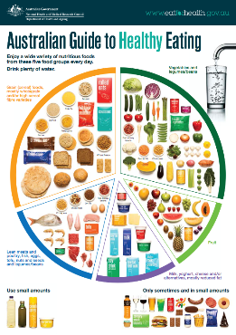
The key to healthy eating is to enjoy a variety of nutritious foods from each of the 5 food groups.

The Australian Guide to Healthy Eating displays the 5 food groups on a plate, in the proportion that you should be eating them throughout your day. If you eat a variety of foods from each of these groups, your body will receive all the nutrients and vitamins it needs to function.

Nutrients build and repair tissues, give heat and energy, and regulate body processes.
- Nutrients needed in large quantities are called macronutrients.
- Micronutrients are required in only small quantities.

Using your knowledge and research skills complete the table below.
For each nutrient given, list the functions of this nutrient and good food sources.

Nutrient | Function of the nutrient in the body | Good food sources  (use pictures to help)
Protein | The body uses protein to repair tissue.
Carbohydrate

Fat

Vitamin A

Vitamin C

Vitamin D

Calcium

Fluoride

Iron

Sodium

Zinc

Water

Fibre

