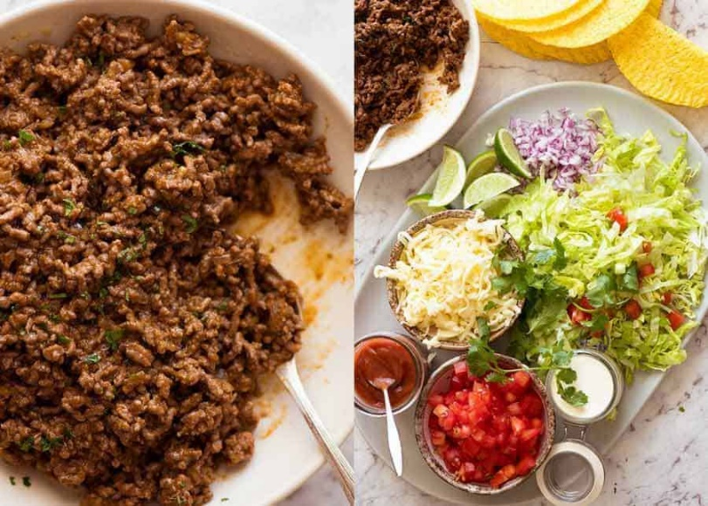
Beef TACO’s

INGREDIENTS
4 taco shells
BEEF TACOS:
1/2 Tablespoon oil
1 garlic cloves, minced
1/2 onion, finely chopped
250 g beef mine
1 Tablespoon tomato paste
35ml water

HOMEMADE TACO SEASONING:
1/2 teaspoon EACH garlic powder, onion powder, dried oregano
1 teaspoon EACH cumin powder, paprika
1/8 teaspoon cayenne pepper (adjust spiciness to taste, can skip)
1/2 teaspoon salt
1/8 teaspoon black pepper

TOPPINGS:
50g Shredded cheese
2 leaves shredded iceberg lettuce
¼ red onion, chopped
¾ Tomato, diced
¼ cup sour cream

GAUCAMOLE:
1 ripe avocado (100g)
1/8 red onion, finely diced
¼ tomato, diced
4 coriander, leaves picked, finely chopped
¼ lime, juiced

sweet chilli sauce (to serve)

METHOD:

1. Preheat oven to 180C

BEEF FILLING:
2. Heat oil in a large frying pan over high heat. Add garlic and onion and cook 2 minutes until golden.
3. Add beef and cook for 2 minutes, breaking it up as you go, until it changes from red to light brown.
4. Add Taco Seasonings and cook for 2 minutes until beef is cooked through.
5. Add tomato paste and water. Cook for 1 minute or until water is evaporated and you're left with a juicy not watery beef filling.

BAKE (OPTIONAL):
6. Place taco shells in a baking tray. Fill with taco meat, top with cheese.
7. Bake 5 to 7 minutes until cheese is melted by which time the shells with be crispy.

GAUCAMOLE:
8. Roughly mash avocado with a fork.
7. Mix in tomato, onion, coriander and lime juice. Season with salt.

SERVE:
9. Serve tacos hot, straight out of the oven. Lay out toppings and guacamole and sweet chilli sauce and assemble.

