Pork and Vegetable Gyoza
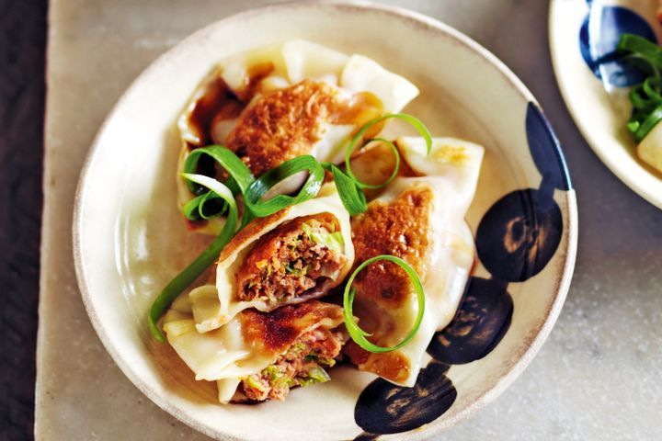
Ingredients (makes 30)
250g pork mince
3/4 cup thinly sliced Chinese cabbage (wombok)
1/2 small carrot, finely grated
1 green onion, thinly sliced
2 tsp ginger
1 garlic clove, crushed
2 teaspoons soy sauce
1 teaspoon hoisin sauce
1/4 teaspoon sesame oil
275g packet gow gee wrappers
1 tablespoon vegetable oil
Thinly sliced green onion, to serve
Dipping sauce
1 1/2 tablespoons soy sauce
1 tablespoon rice wine vinegar
1/4 teaspoon sesame oil
1/2 teaspoon caster sugar

Method
- Combine mince, wombok, carrot, onion, ginger, garlic, soy sauce, hoisin sauce and sesame oil in a bowl.
- Place wrappers on work surface. Place 2 rounded teaspoons mince mixture on 1 half of wrappers. Brush edges with cold water. Fold over to enclose filling. Pleat edges together to seal.
- Heat half the vegetable oil in a large, non-stick frying pan over medium-high heat.
- Arrange half the dumplings in pan. Cook for 1 minute each side or until lightly browned. Add 1/2 cup cold water. Cover pan with lid. Cook for 4 to 5 minutes or until gyoza are just tender. Remove from heat. Stand for 1 minute in pan.
- Carefully transfer to a plate. Cover with foil to keep warm.
- Repeat steps 3-5 with remaining oil and gyoza.
- Meanwhile, make dipping sauce Combine soy sauce, vinegar, sesame oil, sugar and 1 tablespoon cold water in a small bowl.
- Serve gyoza with dipping sauce and sliced green onions.

