Ice cream Popsicles
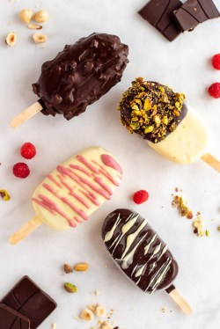
Ingredients
Fruit coulis
120 g fresh or frozen fruit of choice
(raspberries, strawberries, blueberries, blackberries)
1 tbsp caster sugar
1 tbsp lemon juice
Ice cream
120 g whipping or double cream
60 g sweetened condensed milk
60 g evaporated milk
1/4 tsp pure vanilla paste
Chocolate Coating
200g dark or milk chocolate (dark, milk or white)

Method:
- Place the ice cream mould on a tray that fits into your freezer.
Fruit coulis:
- In a small saucepan, add the fruit and sugar. Bring to a simmer over medium-high heat. The mixture will begin to boil, turn it down to medium heat. Continue to simmer for about 5 minutes, stirring the mixture often.
- Once the fruit has broken down and softened, turn off the heat – this will take a few minutes longer if using frozen fruits. Transfer the mixture to a blender or food processor and pulse until it reaches a smooth sauce consistency.
- Strain the mixture through a strainer into a pouring jug and add 2-3 tablespoons of filling to the bottom of each mould and then place in the freezer for 30 minutes.

Ice cream:
- In a mixing bowl, whisk the cream until soft peaks form. Then add the condensed milk, evaporated milk and vanilla paste. Whisk until smooth and creamy.
- Remove the mould from the freezer and insert the wooden lolly sticks. Fill the moulds with the ice cream mix and transfer to the freezer for 3-4 hours, until completely set.
Coating:

- Once frozen, carefully remove the ice-creams from their moulds and place them back into the freezer on a tray lined with baking paper until ready to coat.
- Melt the chocolate in a heat-resistant bowl over a small pan of simmering water (double boiler). Pour the melted chocolate in to a tall glass/bowl and dip each ice cream in it. At this stage they can be decorated with crushed biscuits, freeze dried fruit or drizzled with melted chocolate.
- Put the ice creams back on the tray to set in the freezer for 10 minutes before serving or store in an airtight container for up to 3 months.

