 |  | 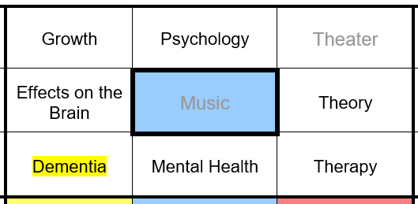
Plus | Minus |  | Interesting
This topic is something I’m really interested in, and I believe is relevant today with more research being placed into it than ever before. Therefore understanding how music effects the brain, could be highly beneficial to myself and others around me making my findings useful. | research into music’s effects on a child’s brain has been research quite highly in the last few years unfortunately it’s effect on dementia patients has not been research as heavily so information will be hard to find and therefore difficult to see if the information is reliable. |  | Music’s effect on the brain is a newly researched topic that hasn’t been researched into heavily in relation to dementia patients. This means the research I am undertaking is uncommon and the information found will be interesting and new to me.
Why my topic is worth researching:
My topic is worth researching because daily dementia patients become more a more depressed and if music could help lift their mood and allow them to remember things from their past and possibly healing them.

Initial Question: How does music improve the quality of life for dementia patients?

1. To what extent does music therapy improve a dementia patients mental health?
This question needs to be made more specific with mental health being a very broad topic which was seen through a small amount of research of this question.

2. To what extent does music therapy improve the behaviour, emotion, and cognition of a dementia patient?
This question was made more specific though “dementia patient” covers a large variety of diseases so it should be narrowed down.

3. To what extent does music therapy improve the behaviour, emotion, and cognition of a person with Alzheimer's disease? I changed the end of the question from dementia patient to person with Alzheimer’s disease because it makes the search more specific as to what disease and will narrow down the results found. The three aspects though are to many to research so they should be narrowed down to one.

4. To what extent does music therapy improve the cognition a person with Alzheimer’s disease?
This question was made more specific focusing on just cognition and not behaviour and emotion as I would not have enough pages or time.

Final question
To what extent does music therapy improve the cognition of a person with Alzheimer’s disease?

Why my final question is worth researching
My final question is worth researching because it will help me understand and evaluate how music therapy affects the way Alzheimer’s patients cognize information.

Ethical Consideration:
My question and the means to which I’ll conduct my research will be ethical not forcing anyone to participate in surveys or interviews and if they participate their personal information will be blanked out or not asked for. I will also not conduct any personal experiments as that would be unethical towards the Alzheimer’s patients.

sgfhdfghfdghfdghfhgfdghh

