Topic and question refinement:
How can ‘fashion’ be therapeutic to those who are self-conscious about their body image?
Determining a topic: I was able to narrow down the topics I’ve been interested in and would like to research into. Starting with 4 topics, (Animals, Fashion, Environment and Scoliosis) including why that topic would be a good or bad choice to use. I chose fashion in the end.
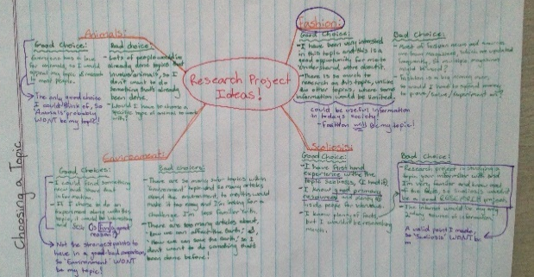
What is Fashion: Noun; a popular or latest style of clothing, footwear, accessories, makeup, hair, decoration, behaviours and body, (Dictionary.com, 2019).

Plus: I’m more commonly aware of what fashion is, but I don’t know much in-depth information about it. This research process will help me investigate and find out more about the topic. Fashion resources are all around the world, (magazines, websites, articles, social medias, documentaries, news reports and books), making it easier for me to find an abundance of resources. Lately, I’ve been interested in fashion and have wanted to research more into it and research project was a great opportunity.
Minus: The fashion industry is forever changing, so I need to know what is constantly happening in fashion. I’d also need to update information constantly in my research.
Interesting: Fashion isn’t only about clothing, footwear, makeup, accessories, hairstyles, it’s also about different lifestyles and the body.
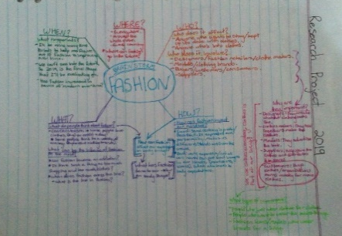
Refining topic for question development: I then created a mind-map and outlined the topic fashion to understand what’s involved within the industry. I asked questions using, who, what, when, where and how. The question, ‘who is involved?’ showed me there are more people within the fashion industry than expected.
After creating a brainstorm mind-map, I filled in a lotus diagram using the areas of fashion that show importance, (Target audience, designers, brands, designs, trends, styles, body images and therapy).
Refining topic question: By looking at the brief details the lotus diagram gave me, I was able to form some questions for my topic:
- How does/can/has fashion affected the mind over time?
- This was the first question that I developed and using, does/can/has, the question could go three different pathways.
- This question is easily answered with, ‘If your comfortable with what you wear for a period of time, then you’ll feel good about yourself.’ (Quora, 2019).
- How has fashion affected the mindset of teens?
- When this question was researched, all that came up was negative feedback from communities saying teens form bad influences from the modern society of fashion. What I’m looking for is something positive, (Tornado News, 2019).
- Is fashion the problem for negative teen mindsets on their body shape?
- This question was developed from the previous questions results, but I focused the topic on teens body image.
- Ikon London Magazine, 2019 states it’s more of the designers themselves than the fashion industry itself. So, ‘fashion’ itself isn’t the problem.
- Can fashion be therapeutic and good for your health over time?
- This question is more of a ‘yes’ or ‘no’ question. Even with plenty of research, this question will still lead to a ‘yes’ or ‘no’ answer. I am looking for a question that provides me with more of an in-depth answer, than just a ‘yes’ or ‘no’, to an in-depth question and this question includes only brief topics and isn’t that much in-depth.
- “Fashion Psychology is the integration and utilization of the science of psychology and the industry of fashion to create manageable therapeutic tools that ultimately assist in the development of desired results in both clients' perceptions of self, their behaviors, and moods as well as targeted objectives within the business model.” (Emergence of fashion psychology, 2019).
- How can ‘fashion’ be therapeutic to those with anorexia?
- This question specifically focuses on people with anorexia. Searching for this specific subject showed me that if you mention any question with the word, ‘anorexia’, fashion is pushed away, and anorexia is the main subject which isn’t what I’m studying.
- When fashion is recognised in the question, articles put negative views on the fashion industry, (Eating Disorder Hope, 2019).
- How can ‘fashion’ be therapeutic to those who are self-conscious about their body image?
- This question appealed to me the most because it’s more in-depth than the previous questions and talks about all body images and not just anorexia.
- This question will show how fashion can be good for those who might be self-conscious about their body image and how fashion can help them with their body image. This question will prove that you can use the thing that has affected you for the worse and use it for something good. (tandfonline, 2019).
Plus: This question would be best to use because it includes how fashion is therapeutic and talks about modern problems like how self-consciousness affects the body image, which needs to be faced in society. This question doesn’t specifically talk about one type of body image, it’s referring it to all body images, so it has a wider range of information to research.
Minus: This question hasn’t specifically talked about what parts of fashion can be therapeutic, it only mentioned the whole topic of fashion and hasn’t narrowed that part down.
Interesting: This question doesn’t directly focus on a particular person but at a group of people. it doesn’t have to focus on people who are self-conscious about their body image but could also focus on people who are just self-conscious or are suffering from body image expectations.
Capabilities I am using:
Intercultural understanding capability: Fashion is used around the whole world, so fashion brands will have to know about different cultures and what is considered culture appropriation.
By using this capability, I will be able to understand how fashion can affect the cultural and religious side of our society. I will also develop different understandings on different cultures and religions through the fashion industry and how they are affected. This capability might also teach me the respect I will need to understand different cultures and religions.
This capability will also teach me the negatives within my topic of fashion. I will be understanding the different challenges in a culture or religion and finding the differences between negotiating, interpreting and mediating through fashion.
Critical and creative thinking capability: Fashion is always making a statement, with creative styles, designs and colours.
This capability is separated into two sup-capabilities; critical thinking and creative thinking. Critical thinking is all about the logic, facts and assessing different ideas. Creative thinking is all about exploring, experiencing and experimenting creative processes and practises.
By using the critical thinking capability, I will be able to learn how the fashion industry is forever learning, how they apply new skills, how they organise things. I will research these things through critical evaluating of information.
By using the creative thinking capability, I will be able to use different thinking techniques to identify reasons for different choices, strategies and actions taken. I will also be learning how features fit specific functions. For example; swimming wear, formal wear, pyjamas, etc.
Sources I am using:
Since fashion is a modern topic, having up to date sources will be necessary for reliable information. So, I will only be using sources from the past 10 years for more modern information about fashion therapy and body images.
- Websites:
I will be using different websites because most things can be found on the internet in different articles, website pages or news feeds.
I will be using websites for a source of information because fashion is a modern subject and one of the main sources of modern knowledge is on the internet. Websites are a secondary and primary source because you aren’t getting the information straight form the source and some sites, like blogs, you do.
Not all websites will be reliable because anyone can have their own opinion and edit on the internet, so I need to be careful who and where I get my information from.
Can websites be precise and accurate with their information? If I found information that needed to be backed up, I would find other websites that say the same thing, so I would have more than one website, making the information more precise and accurate.
- Magazines/books:
I will be using magazines and books as a source because some fashion topics are found in magazines, posted by newspapers or have information written in books about certain aspects on fashion. Magazines and books are mostly a secondary source but sometimes they do include primary sources, like interviews, dairy entries and first-hand articles. When would I use magazines or books? When I need an opinion, advice, specific facts or experiences about certain topics from specific people.
Magazines can be a reliable source if I get the information from the brands, like Vogue, who know what they are talking about and is written by professionals.

- Interviews:
I will be using interviews as a source of information because they’re a great primary source to get information first hand from. I will be using interviews for the purpose of getting different people’s opinion on my subject of fashion therapy.
Who would I be interviewing? I will be interviewing people with lots of experience with fashion or fashion therapy, (professionals), effects of body images, (organisations like headspace), or even someone who knows all the above. I will also be interviewing friends that feel self-conscience about their body image.
Interviews are very reliable sources for opinions but when it comes to finding out different facts about topics, I will need to reach out to a professional who knows what they are talking about for reliable information. I’ll be sending interviews to people 4/03/19 and will use the information I receive back until the 13/05/19. These are some question I will be asking in the interviews:
- Do you believe that ‘fashion’ can be therapeutic and why?
- How has fashion been influenced by people over time?
- How have people been influenced by fashion and does it have a positive or negative affect?
- Why do you think people are self-conscious about their body image?
- Do you think fashion has a role to play with people being self-conscious about their body image?
- Can we use fashion, (shopping, designing, etc) to positively influence those who are self-conscious about their body image?
- How can fashion be therapeutic to those who are self-conscious about their body image?
- Other sources:
Websites, books/magazines and interviews are the main source types that I will be using but some other sources that I may analyse are; pamphlets, (they have a summary of heaps of information) interviews not conducted by myself, (the questions would be more in-depth and the interviewer would probably be more professional) and experimentation, (where I will be documenting different franchises and conducting my own conclusion about fashion therapy).
Ethical Considerations: Some ethical considerations that I need to consider would be that with my question, I mention a topic like, body image, which is a sensitive topic to some people. So, I need to make sure that when I mention body image, I refer to it in a sensible manner. I will need to check that any questions I ask in the interviews are not too personal or immoral. I will have these questions checked before I use them in the interviews so, I will need to have back-up questions in-case I can’t use the original questions and this problem occurs.
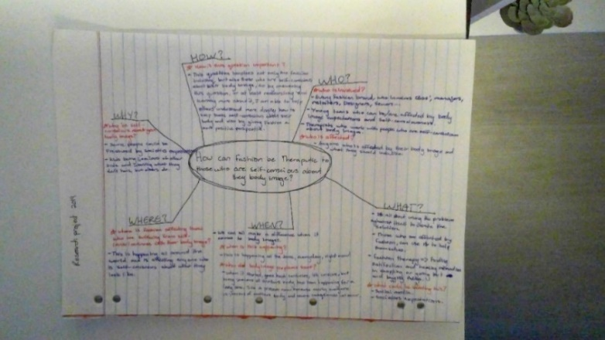
Further planning: Before getting into the research I created a mind-map with my question as the centre and the questions who, what, when, where, why and how as the sub-questions. By answering these I am able to know where I should start off with my research.
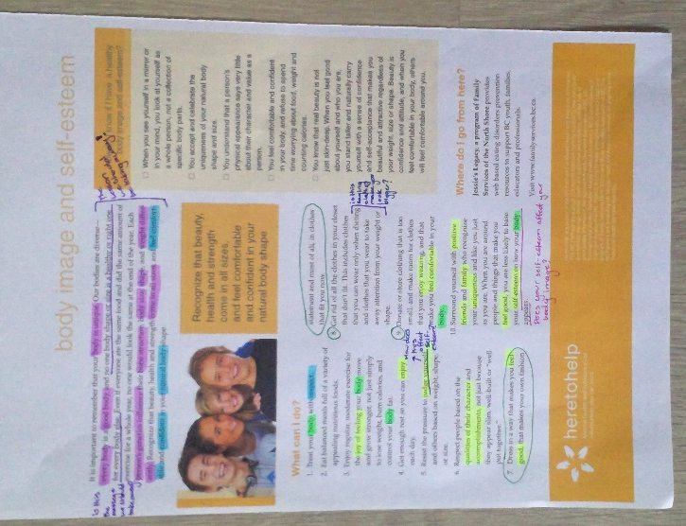
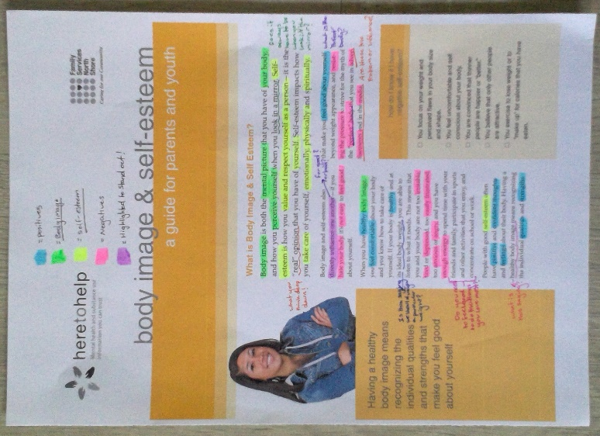
Relevance:
This pamphlet about body image and self-esteem was used to start off my research so that I could get a deeper understanding of what body image is all about and how your self-esteem effects what you think of your body.
Key Findings:
- Body image is what you look like on the outside.
- Self-esteem is what you think on the inside about yourself.
- Self-esteem effects what you think about your body image. For example, if you have a negative/low self-esteem, you will think less of your body and won’t feel happy in it.
- Steps 7, 8 and 9 are about what you can do with fashion to make you feel happier about what you wear and feel comfortable in.
- By wearing clothes that you enjoy wearing and looking at, it boosts your self-esteem towards your body image and what suits your body.
- Everyone is unique; thus, their clothing and body image is unique.
Reliability and Validity:
Reliability: This source being a pamphlet, means that there were people who gathered information and summarised it by putting the key points into a pamphlet. This means there was information analysed, annotated, read through and questions asked, proving that this information was gathered from other sources like, people with experiences, websites and other article/booklets. This means the pamphlet is backed up with other sources.
Even though the information was gathered by an organisation, there wasn’t one author who wrote this, so the information could’ve come from anyone in particular, which shows that this pamphlet is not as reliable is it could be.
Validity: This pamphlet was written by an organisation that specialises in body image and self-esteem. It’s not a government run program, so it focuses on this specific topic, which makes it more reliable because the ‘Here to Help’ community focus’ on people who need help, for example, need help with body image and self-esteem.
This source was easier to find/access then those of a government written articles. This source was found online but can be found in receptions of health clinics and articles in libraries to provide information.
Effectiveness: How does this source effect my question?
This source does not cover all of my question. It mainly focusses on the self-consciousness toward your body image. On the second page it mentions a few points about clothing and fashion choices. The source doesn’t mention fashion therapy but can be related to what I am researching and studying from my question.
I can use the points about clothing to help with my research, by answering this question, “How can these points relate to fashion therapy?” The answer is if you’re comfortable and feel good in the clothes you wear, that will help with a positive self-conscience towards your body image.
Skill Development:
While annotating this pamphlet, I have learned to ask many questions and ended up forming this question, “Does your self-esteem effect your body image?” By asking many questions, I was able to research deeper into the topic. I did this by annotating the pamphlet and wrote down any questions that came into my head. This pamphlet concluded that your attitude towards how you look DOES affect your appearance. A good self-esteem towards your body can make you feel and look good towards yourself.

Capabilities:
Critical thinking capability: By evaluating the information from this pamphlet, I have learned new knowledge and skills about body image and self-esteem and how to apply the new knowledge I have learnt in 10 points.
What Next?
This pamphlet mainly focused on body image and self-esteem, (only half of what my main topic question is about), so I think the next stage would be to research into the topic of ‘fashion therapy’. This will help with the other half of my main topic question by focusing on the therapeutic side of fashion.
After researching fashion therapy, I will be combining the sources information together to form a more in-depth conclusion.
Development and Analysis of Research:
Pamphlet:
Heretohelp.bc.ca. (2019). Body image and self-esteem. https://www.heretohelp.bc.ca/sites/default/files/body-image-and-self-esteem-a-guide-for-parents-and-youth.pdf Accessed 25 March 2019.
I have interviewed a range of people for my research project like, professional organisations, (Headspace, HereToHelp and Jessies Legacy), I have also interviewed some friends and family who I know are self-conscience about their body image and what they wear.
It was difficult to find a professional in fashion so that is why I have analysed an interview conducted by a fashion magazine, Harpers Bazaar, who interviewed Karl Lagerfeld, who is a fashion expert.
This was a formal email/letter to headspace, but I got no reply because of the time and date that I sent the email. I sent it 2 days too late and she wasn’t allowed to answer, even though she was interested in the topic of fashion therapy.
I received back an answered interview questions from HereToHelp, but it was my second preference of choice.

Why Headspace would’ve been better than HereToHelp?
Headspace is mainly focusing on younger people with problems, so that’s why I emailed them because the audience I am trying to answer my topic question to would help younger people like teens more. But HereToHelp is still good because it mainly focuses on self-esteem and body image which is what I am mainly focusing on.

Above I have included what I have sent to people whom I am interviewing and sending my interview questions to.
This is a letter of introduction and it explains the purpose of the interview, what it is for and who I am.
[Dear (name/organisation).
Hello, my name is Amber, and I am doing a research project about fashion therapy and being self-conscious towards your body image.
I am researching this topic to answer my question, 'how can fashion be therapeutic to those who are self-conscience about their body image?' I am also researching this to help others who are less confident with their body image and also to help myself.
I came across one of your articles about 'body image and self-esteem' and found it to be very positive and uplifting and was wondering if you could spare some time to answer some questions I have conducted about fashion therapy and body images?
Thank you, Amber McColl.]

Interviews:
Planning:
The following questions are the final questions I will be asking in my interviews, with reasons why I chose these questions:
- Do you believe that ‘fashion’ can be therapeutic and why?
- This question is a good question because it clarifies what the person I am interviewing believes that fashion is or is not therapeutic and a reason why they think that.
- I have put this question first because once I have gotten the answers back I can see who agrees with my opinion that fashion can be therapeutic. Even if the answers come back and the person I am interviewing does not agree with me, their opinion will still help me to answer my topic question.

- How has fashion been influenced by people over time?
- This question was developed from one of my capabilities that I am using, the critical thinking capability, “Recognising how knowledge changes over time and its’ influence by people.”
- This question is important because it acknowledges the connection between fashion and people/time.

- How have people been influenced by fashion and does it have a positive or negative affect?
- This question is like question 2 but instead of fashion being influenced by people it is how people have been influenced by fashion. It is good to have a question that says the opposite so that the person I will be interviewing will have more in-depth answers when I combine the two questions and their answers.
- By asking, “does it have a positive or negative affect” will give the person I am interviewing an opinion on fashion.

- Why do you think people are self-conscious about their body image?
- I have divided my interview questions into sections that relate back to my topic question. The first three interview questions mainly focus about fashion therapy and the next three interview questions mainly focus on body images.
- This question is mainly a general knowledge questions and I am again asking for the person I am interviewing’s opinion.

- Do you think fashion has a role to play with people being self-conscious about their body image?
- I have used this question because many people ‘blame’ fashion and modals for body-image problems, (as well as the social media influence on teens), so this question gives me the perspective of what sides people are on when it comes to this specific topic.
- Being self-conscience about your body image is a very sensitive subject so I had to take into consideration some ethical considerations into account.

- Can we use fashion, (shopping, designing, etc) to positively influence those who are self-conscious about their body image?
- The last two questions are more in-depth and the answers to these two questions are what I think to be most important because they focus on what my topic is all about. They both include all the main things, (fashion therapy, influence and body images) and these things also make the questions very important.
- This question focuses on what we can do help those who are self-conscience about their body image and how to make them feel better and happier with themselves. It also suggests how we can use fashion to help those who are self-conscience about their body image.

- How can fashion be therapeutic to those who are self-conscious about their body image?
- I have used my topic question as my last interview question because this topic I chosen can not only be answered with my research, the answers I will receive back will help me answer my topic question and get better knowledge on the question.
- This question is a good to ask because I have specially developed this question with thorough planning and research.
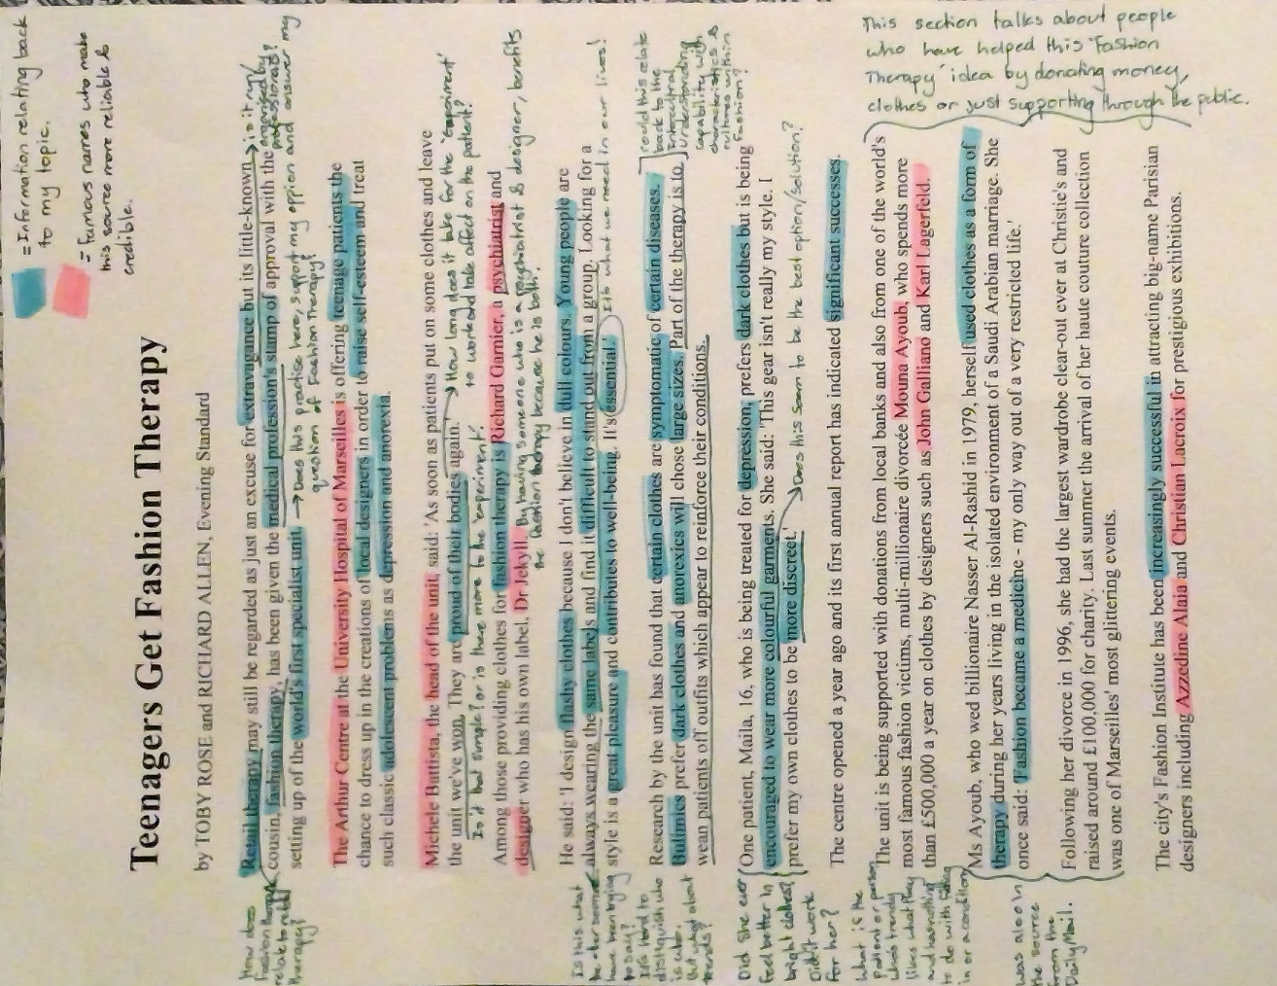
Key Findings:
- Their Fashion Therapy program isn’t an experiment but an institute and organisation. An experiment is to prove whether or not something works but their program is something that the organisers know will work and they have patients that have contributed to the program, with positive results.
- This article mainly focuses on fashion affecting health problems more than self-esteem, but these problems, such as depression, can affect your self-esteem, which affects body-image.
- The professionals in this article have a different definition to fashion therapy than what I do. Their definition is instead of a therapist, you have fashion to fix what you have. My definition is fashion being therapeutic to those who want to change what they feel.
Usefulness and Limitations:
This article was useful because it supported my opinion on fashion therapy and answered most of my questions from my first previous sources I have evaluated, especially the questions about positivity towards yourself and how you feel about your body.
Some limitations are that it talked more about self-esteem, self-consciousness and health conditions more than the fashion side of fashion therapy. it was useful with the facts and information it gave but it limits to how fashion can be therapeutic. It also doesn’t mention how fashion can affect your feelings.
Capabilities:
Intercultural Understanding Capability:
I have this annotated in the article on the side, but paragraph six mentions there being characteristics and cultures within the fashion industry. They say that certain clothes are symptomatic for certain diseases, like with how Bulimics prefer to wear darker clothes and people with Anorexia chose larger sized clothes.
Critical Thinking Capability:
I have been able to pose questions and have answered questions from previous sources and to clarify information by making connections throughout other sources and using them to backup information.
Reliability:
Reliability: This source may not be as reliable as some of my other sources because the magazine that wrote this article does not specialise in fashion, self-esteem or body image. It is a general news magazine. But the magazine is written by professionals who do specialise in what they write about and they have studied and learnt the information stated.
Skills Developed:
As well as answering questions from previous sources, I was able to ask more questions on this source. As these sources have gotten me to answer more questions, the new questions I have asked are more in-depth and require more thinking.
This source quotes two people, one being someone who works within the company and the other is a patient. Having a source with that quotes people on each side of the program has taught me that it is important to keep into account different perspectives and how they express their opinions.
Impact on the Audience:
This source reveals the answers to an experiment that was conducted about fashion therapy, so when someone reads this article, they will feel more positive towards the results, because they know it has worked. The audience will also take into account what the experiment consisted of and try it for themselves so that they can also be happier in what they wear.
Where to from here?
After making the many connections between this source and some of the first few sources I used, I will be using another source about fashion therapy and I will try to make more connections between my sources and answer more questions using that new source. The more connections and answers I find, the more in-depth the topic question will be.
Relevance:
This is an article from a magazine, Daily Mail, and it is relevant to what I am researching and my topic questions because it focuses on my target audience, which is young people, teenagers and young adults.
- Mail Online, (2019), Teenagers get fashion therapy | Daily Mail Online, https://www.dailymail.co.uk/health/article-11932/Teenagers-fashion-therapy.html, Accessed 29 January 2019.

Key findings and questions:
Effectiveness: How does this interview effect my question?
Conducting an interview is a very effective way to get answers because if you choose the questions to ask properly, they will be answered properly, and the feedback will be useful.
An interview can be sent to anyone and anyone can answer them, so the limitations on whose answers you want are endless.
Interview:
Anonymous 1. How can ‘fashion’ be therapeutic to those who are self-conscious about their body image? Interviewed by Amber McColl, (10th March 2019).

Relevance:
This is an interview using my interview questions, answered by someone who went through a time where they were self-conscious about what they looked like and went on a diet. This interview is to get an opinion from someone elses perspective.
Skill Development:
The interview shown above was not the only interview I conducted but it was one of the more informative ones. Since there were more than one person/organisation to send my interview to, I had to set and plan goals over a period of time, which was the 4/03/19 to the 13/05/19, so that I would be able to collect the information I need.
The interview shown above is personal to the person I was interviewing so I have understood their personal right to be anonymous. By keeping their name and who they are is a responsible decision I have made.
While annotating the answers from my interview I was able to build links between the answers and to make connections with other interviewed answers to my questions from other people. I was also able to ask questions while annotating the interview and expressing my opinion while also being able to take different perspectives into account.
As this is an interview that I have conducted myself, unlike the interview I evaluated from Harper’s Bazaar, that makes this interview a primary source.
Reliability and Validity:
Reliability: This source being an interview, makes it a primary source, so the information given in the answers is more reliable because it has come straight from the person I was interviewing. The person I was interviewing had some experience with being self-conscious towards their body image and had low self-esteem, so the information I have gathered from them is very reliable from their personal experience. This is a sensitive topic, so being honest makes the information more valid.
Usefulness and Limitations:
The interview questions were structured to provide information relevant to my topic question.
Some limitations from this interview was the person I was interviewing did not go that much in-depth than what I would have liked, but their answers have proven useful because of their personal experience with body image.
Capabilities:
Critical thinking capability: From creating and conducting this interview I have learned to think logically, ethically and have been able to reflect on the things I have learned. After the questions were answered, I learned to access and organise the answered questions into useful information. I have also learned how to evaluate the information I have gathered by annotating the answers from the interview.
I have also learned how the knowledge of the younger generation have changed over time and is influenced by people.
Creative thinking capability: I have learned to reflect, adjust and explain the person I interviewed answers to my questions through their thinking. I have also learned how to identify reasons for why the person who answered my questions chose how they answered my questions. I have done this by making connections through the information.
Ethical Considerations:
The person who I interviewed was considerate of their language and did not swear and was as polite as they could be because they knew I was going to use their answers in a school research project. While answering these questions, the person that was interviewed did not get offended and was not rude back.
I think the person I interviewed message was in their answer to question 7, “Be happy with what you look like… Being around the right influences.”
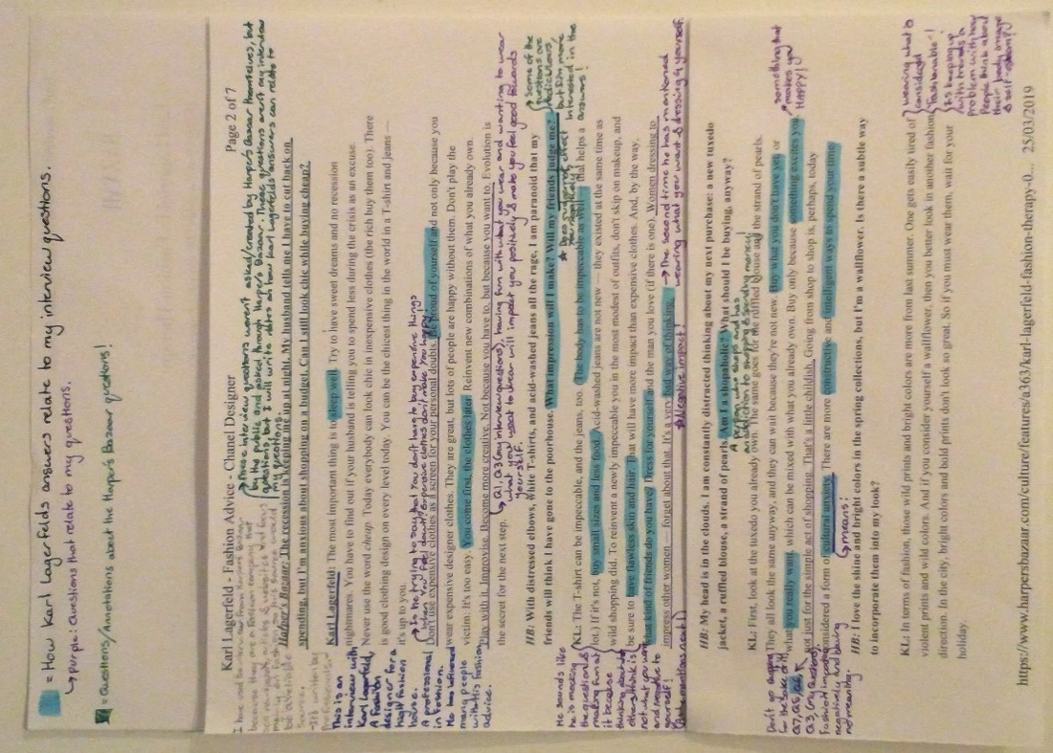
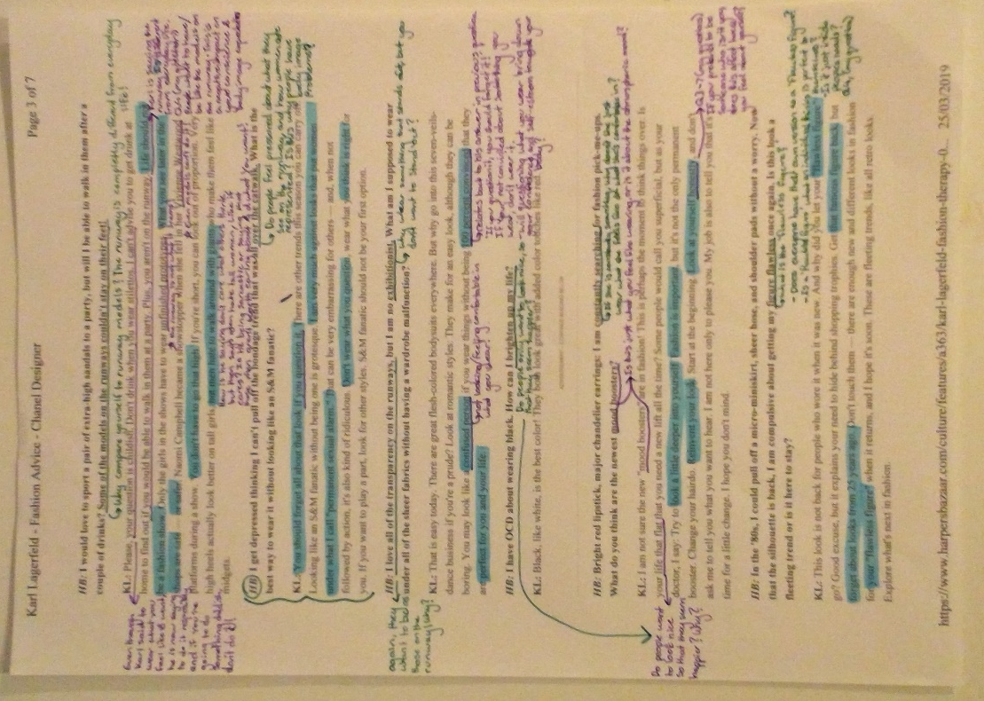
Skills Developed:
While annotating this interview, I have learned to make connections with other people’s work and my own. I have also learnt to ask questions and taking different perspectives into account and how it might affect the audience. Also, by reading Karl’s answers I have realised that the type of language used, increases awareness and suitability for a chosen audience in a specific context and for different purposes.
Ethical Considerations:
In an interview, the person being interviewed may not have a filter with their words and thoughts, they might swear, be racist/sexist or not know what is considered rude or impolite. Some people may get offended by one of the interviewer’s questions and be offensive back not knowing that people listening/reading the interview may also get offended.
In this interview, Karl doesn’t swear and speaks his opinions truthfully. In some areas he does seem impolite. His message was to wear what you want to wear and what feels like you but, in some replies, he seems like he’s judging a few things.
Key Findings:
- Don’t worry about what other people are wearing, only worry about what clothes make you feel like yourself.
- Don’t worry about people judging you and that you should feel confident with what you wear.
- You don’t have to keep up with the trends to look good.
- People who are suffering from self-esteem towards their body image are blaming it on modals because they, themselves, don’t have the same body shape and don’t look as good in the same clothes the modals wear.
- Most of the questions asked by Harper’s Bazaar and the answers given by Karl Lagerfeld related back to my interview questions and all of my questions have been answered by Karl in a way.
Relevance:
This is an interview conducted by a fashion magazine, Harper’s Bazaar, with Karl Lagerfeld, a well-known fashion designer. This interview mainly focuses on the fashion aspect of my question.
Capabilities:
Intercultural understanding capability: From reading the answers Karl gave in this interview, I have been able to identify the different ways of thinking and traditions in fashion within different cultures. This interview mainly mentions the American/European side of fashion culture, which is a trendy, stylish, chic, western wear.
Impact on the Audience:
Karl Lagerfeld is a fashion designer icon and has been an influencer to many people, so when someone reads this interview, they will know that he is serious about what he says and will feel positive towards the answers/advice he gives.
Reliability:
Reliability: This interview was conducted by a magazine, Harper’s Bazaar, which specialises in fashion. This magazine is very reliable because my topic focuses on fashion, so this was a great source to use. This is also a great source to use because the people who write for the magazine and answer magazines interviews are professionals when it comes to fashion and they know what they are talking about because of their experience.

Harper's BAZAAR. (2019). Karl Lagerfeld's Fashion Therapy. https://www.harpersbazaar.com/culture/features/a363/karl-lagerfeld-fashion-therapy-0309/# Accessed 3 March 2019.

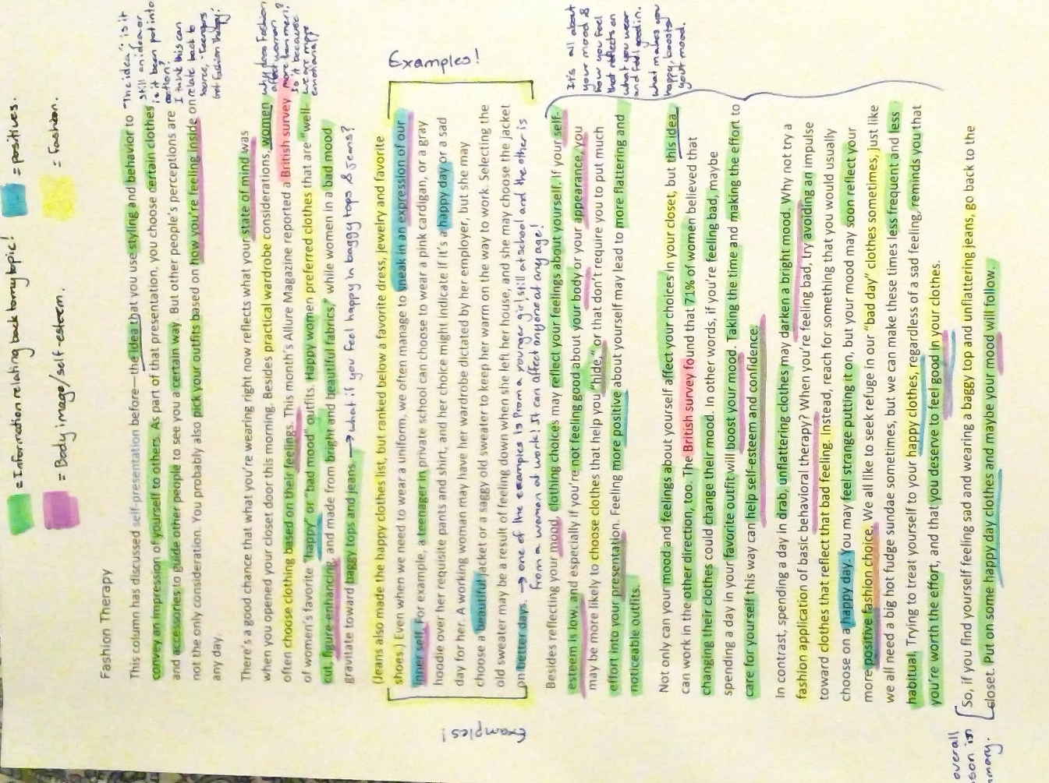
Skills Developed:
I have been able to analyse information from a range of sources, (websites, interviews, videos and magazine), I have been able to translate information from one source to another for a better understanding of the information.
Using more than one type of source helps justify the information and backs up the facts so that the information will be more reliable and useful.
While annotating this source I asked the question, “What if you feel happy wearing baggy tops and jeans?” By asking this question, I have developed empathy towards the people I see that wear these clothes. That even if those people do not feel sad, they still feel happy in what they are wearing and what clothes make me sad, can make another person feel happy.
Impact on Research:
This source was one of the best sources I have come across because it has covered most of the questions I have asked and has provided the most information that I can use to answer my topic question, ‘How can ‘fashion’ be therapeutic to those who are self-conscious about their body image?’
This source is also a great summary of what I have been researching and has equal discussions on both fashion and self-esteem towards your body image. It also has extra information and talks about moods and feelings and how they affect what you wear and vice versa.
Capabilities:
Critical Thinking Capability: From reading and analysing this source I have learnt to think critically by making connections with other sources, also to think logically by answering previous questions from other sources.
While annotating this source by highlighting it, I have learnt to look for answers within the text to answer questions, to ask more questions for a better un-depth understanding and also looking for relevant information about my topic.
I have also been able to recognise how knowledge of fashion therapy and how people see themselves and their body have changed over time and how it is influenced by people and how people have influenced it back.
Creative Thinking Capability: The three paragraphs I have grouped together, near the end of the article, have taught me that when I mention an idea, I should explain it with understandable thinking and to give reasons for the explanations I give.
I have learnt, using a new strategy, when I change colour highlighter, I go through the article again and reread the article. I don’t highlight everything at once.
Kay Findings:
- The last sentence of this website is also the lesson from the article, which is ‘Putting on some happy day clothes and maybe your mood will follow.’
- Clothing choices may reflect your feelings about yourself.
- You can use clothes to ‘hide’ what you feel about yourself. By doing this, you are lowering your self-esteem which is very unhealthy for not just the mind but the physical body as well.
- If you are feeling sad/down, you should wear what you would consider your happy clothes to brighten your mood. If you wear clothes that make you sad, your mood will darken. It is like reverse phycology, but with your brain.
- Wearing what you feel like is unique to yourself will boost your self-esteem and to other people you will look unique and happy by wearing an expression of your inner self.
- Not only does fashion effect your mood but your mood can affect your fashion. ‘Feeling more positive about yourself may lead to more flattering and noticeable outfits.’
Relevance:
This website about fashion therapy is one of the last sources I will be using. This source has concluded many questions I have asked in previous source analysis and have also concluded what I need to know about fashion therapy and how it has answered my topic questions.
- YouBeauty. (2019). Fashion Therapy - YouBeauty.com. https://www.youbeauty.com/life/fashion-therapy/, Accessed 19 April 2019.

Capabilities I have used throughout my folio:
Critical and creative thinking capability:
I have learned and applied the new skills and I knowledge that I have gathered to help me throughout my folio.
I have also accessed, organised, used and evaluated information from a wide range of sources.
I have posed many questions, not only with the sources I have analysed but also with the new information I have gathered.
I have developed knowledge and understanding of a range of research processes, from looking up ‘fashion therapy’ on the google search bar to browsing through a library for books about self-esteem.
I can recognise how knowledge can change over time and how it is influenced by people and vice ve rsa.
I have been able to reflect and explain the people who wrote the sources thinking and am able to identify the reasons behind some of the choices and actions that they have taken.
The literacy capability:
By conducting interviews and sending emails I have been able to communicate with a range of people in a variety of contexts from emails to in person casual conversations.
I have asked many questions and expressed not only my opinions but those of others, even if they do not agree with my opinions. I have also taken different perspectives into account, like those who conduct the experiments and those who participate in them.
The ethical understanding capability:
With researching a sensitive subject such as body image and self-esteem, I had to take into consideration the ethical principles of others and I have had to accept, appreciate and reflect people’s personal rights.
The personal and social capability:
As I have chosen a sensitive subject I have had to not only consider other peoples personal rights but also had to think about myself and what impact this has had on me by developing a sense of personal identity throughout the folio.
I have developed empathy for people who suffer from self-esteem towards their body image and what/how they feel about fashion and what they wear. I have had to understand others and learn information from their perspective and their opinions.
All throughout this research project I have had to review and constantly plan personal goals with not only due dates but also the researching and the background work that was put into this folio.
While also reviewing and planning, I have had to make responsible decisions based on evidence I have collected from the sources I have analysed and evaluated.
As this is a research project, I have had to analyse and evaluate many sources, even if I have not included some sources into my folio, I have built and created links between sources and have answered questions from one source with another source’s information. Together my sources have helped me finalise the answer to my topic question.

Bibliography:
Websites:
- 10 Types of Fashion Styles, Which One is You? | Style We Blog, (2019), 10 Types of Fashion Styles, Which One is You? | Style We Blog. https://blog.stylewe.com/10-types-of-fashion-styles/, Accessed 29 January 2019.
- www.dictionary.com, (2019) Fashion | Define Fashion at Dictionary.com, https://www.dictionary.com/browse/fashion, Accessed 13 February 2019.
- Mail Online, (2019), Teenagers get fashion therapy | Daily Mail Online, https://www.dailymail.co.uk/health/article-11932/Teenagers-fashion-therapy.html, Accessed 29 January 2019.
- International Student, (2019), Why Fashion is a Hot Study Topic | Study Fashion in the US, https://www.internationalstudent.com/study-fashion/why-fashion-is-a-hot-study-topic/, Accessed 30 January 2019.
- How does fashion affect your thoughts and behaviors throughout the day? – Quora, (2019), How does fashion affect your thoughts and behaviors throughout the day? https://www.quora.com/How-does-fashion-affect-your-thoughts-and-behaviors-throughout-the-day, Accessed 06 February 2019.
- HF Tornado News, 2019, The Negative effects the fashion industry has on youth — Tornado News, (2019), https://hftornadonews.org/fashion-and-style-1/2018/3/16/the-negative-effects-the-fashion-industry-has-on-youth, Accessed 07 February 2019.
- Emergence of Fashion Psychology | CareersinPsychology.org. (2019), Emergence of Fashion Psychology | CareersinPsychology.org. https://careersinpsychology.org/the-emergence-of-fashion-psychology/, Accessed 13 February 2019.
- Eating Disorder Hope, (2019), The Fashion Industry & Body Image; Transcending the Acquisition of Thinness, https://www.eatingdisorderhope.com/information/the-fashion-industry-transcending-the-acquisition-of-thinness, Accessed 13 February 2019.
- Fashionista, (2019), Let's Make the Fashion Industry a Better Place for Those Struggling With Eating Disorders – Fashionista, https://fashionista.com/2018/09/fashion-industry-eating-disorders-support-sensitivity, Accessed 13 February 2019.
- Taylor &Francis Online, (2019), Significance of body image among UK female fashion consumers, tandfonline, (2019), https://www.tandfonline.com/doi/full/10.1080/17543260701867697?src=recsys&, Accessed 13 February 2019.
- En.wikipedia.org. (2019). Karl Lagerfeld. https://en.wikipedia.org/wiki/Karl_Lagerfeld, Accessed 2 April 2019.
- YouBeauty. (2019). Fashion Therapy - YouBeauty.com. https://www.youbeauty.com/life/fashion-therapy/, Accessed 19 April 2019.
Interviews:
- Harper's BAZAAR. (2019). Karl Lagerfeld's Fashion Therapy. https://www.harpersbazaar.com/culture/features/a363/karl-lagerfeld-fashion-therapy-0309/# Accessed 3 March 2019.
- Anonymous 1, How can ‘fashion’ be therapeutic to those who are self-conscious about their body image? Interviewed by Amber McColl, (10th March 2019).
- Anonymous 2, How can ‘fashion’ be therapeutic to those who are self-conscience about their body image? Interviewed by Amber McColl, (12th March 2019).
- Anonymous 3, How can ‘fashion’ be therapeutic to those who are self-conscience about their body image? Interviewed by Amber McColl, (12th March 2019).
- Anonymous 4, How can ‘fashion’ be therapeutic to those who are self-conscience about their body image? Interviewed by Amber McColl, (12th March 2019).
Magazines/books/pamphlets:
- Heretohelp.bc.ca. (2019). Body image and self-esteem. https://www.heretohelp.bc.ca/sites/default/files/body-image-and-self-esteem-a-guide-for-parents-and-youth.pdf, Accessed 10 April 2019.
- Clark, L. (2019). Your own harshest critic? Here’s how to break up with that judgy voice. Vogue. https://www.vogue.com.au/beauty/wellbeing/your-own-harshest-critic-heres-how-to-break-up-with-that-judgy-voice/news-story/f02aa98e06bf1c7fde507009ca264b9a, Accessed 12 Apr. 2019.
YouTube Videos:
- Vimeo (2018). Fashion Therapy. [video] https://vimeo.com/user83635436, Accessed 11 April 2019.
- Vimeo (2019). Fashion Therapy. [video] https://vimeo.com/285328559, Accessed 11 April 2019.

