Analysing and Interpreting Qualitative Data

Data Analysis: An attempt by the researcher to summarize collected data.

- As you collect data ask:
  - What have I learned to help me answer my question
  - Why did the interviewees answer as they did?
  - What else do I want to know?
  - What new ideas have emerged?
- Next, categorise and code data, grouping it into themes:
  - Identify themes:
    - Ideas that are repeated
  - Reduce data to a manageable form by coding info by themes. Suggested methods:
    - Attach category labels to blocks of text
    - Write notes on note cards and sort into themes.
    - Cut and paste blocks of text onto index cards.
    - Then you can group cards that have similar labels together
    - And revisit piles of cards to see if clusters still hold together.

Data Interpretation: making sense of the data

- Answer these questions
  - What do these categories and patterns mean in answering my question?
  - What are the most important themes in the data?
  - Why are they important?
  - What can be learned from these themes?
  - So what is the final answer to my question?

Choosing and Interpreting Graphs (Quantitative Data)
Chart type | When to use it | Interpreting it | Example
Pie | Splitting a population into non-numerical categories | The slices show the relative size of each category compared to the whole lot | Hours worked per week  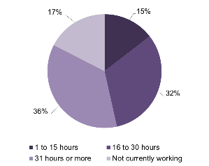
Histogram | Counting a population into numerical ranges of equal size | Higher frequency (count) means more fall in that range | Age of respondents in years  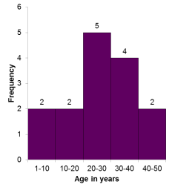
Clustered column | Comparing counts from different sample sets | Look at each category separately to compare height (frequency) results | Age of respondents by gender  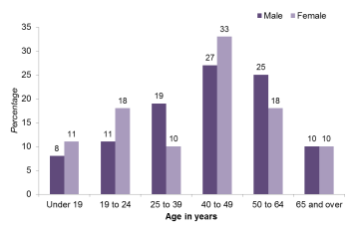
Line | Collecting data over a period of time | The rise and fall shows changes or trends | Temperature over one week  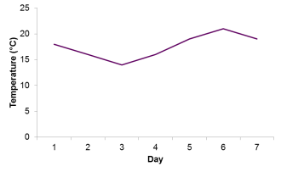
Scatter | Finding a relationship between two quantities | Draw a line of best fit through the scatter to find the pattern | 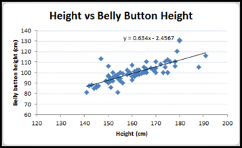

Important Note: If you can quantify your qualitative data (i.e. numbers of people who had similar responses) you can also use graphs of various types to represent and help interpret this qualitative data in a visual way.

