How to Find Journal Articles

# Using the state library website (you will need to apply for a card)

Go to <https://www.catalog.slsa.sa.gov.au/search/y>

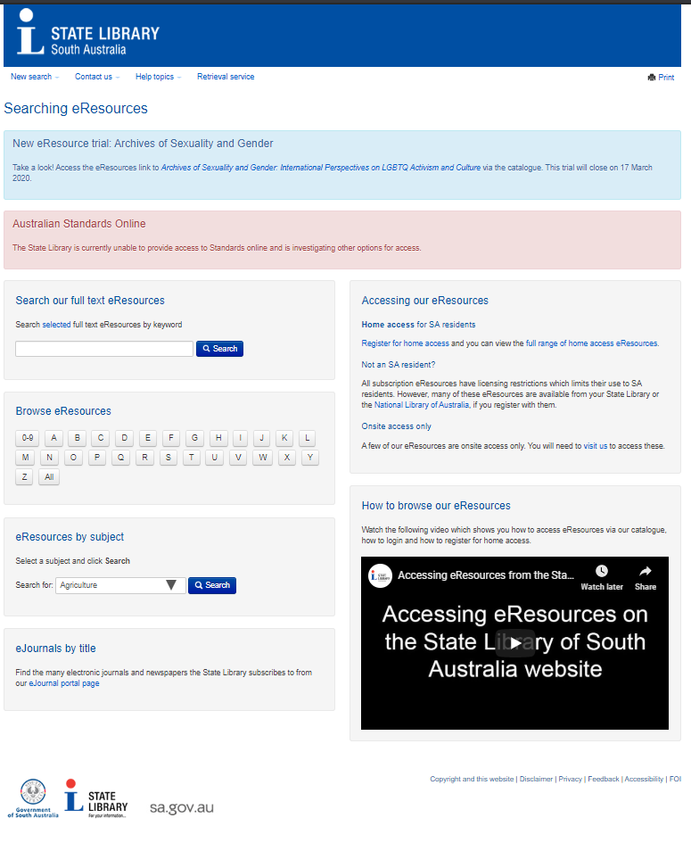

v

This box is the one we want to use. You can select by topic. E.g If you are looking at the effect of stretching on reducing injury you would select “Health and Biological Science”.

We will use the “Multi-subject eResoruce” option.

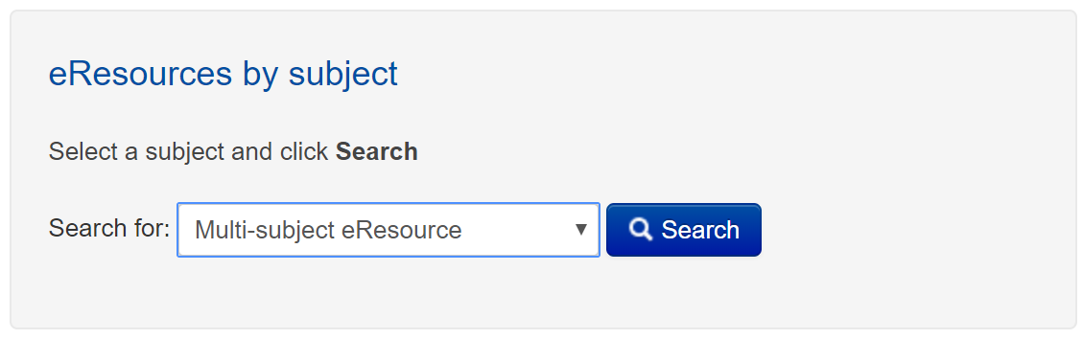

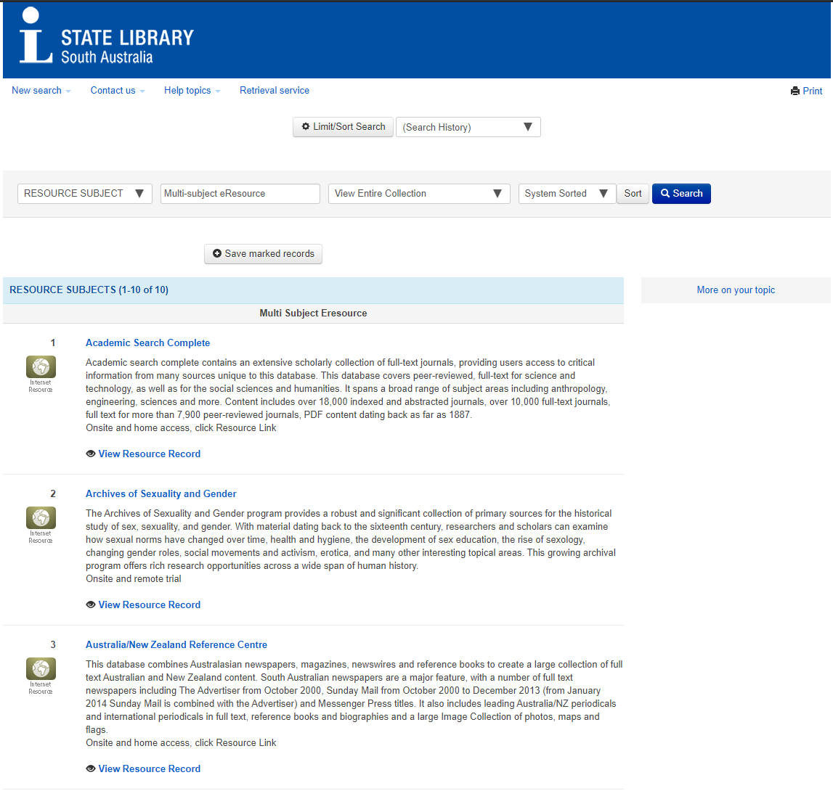

Select a database that you want to search. Which one you choose will depend on your topic. Below is a list of my suggestions:

**Academic Search Complete** – International database of journal articles with many different topics.

**Ebsco Databases** - International database of journal articles with many different topics.

**Informit** – Focused on Australian journals so good if your question has a local focus.

**eBook Central** – As the name suggests this is a database of eBooks rather than journal articles.

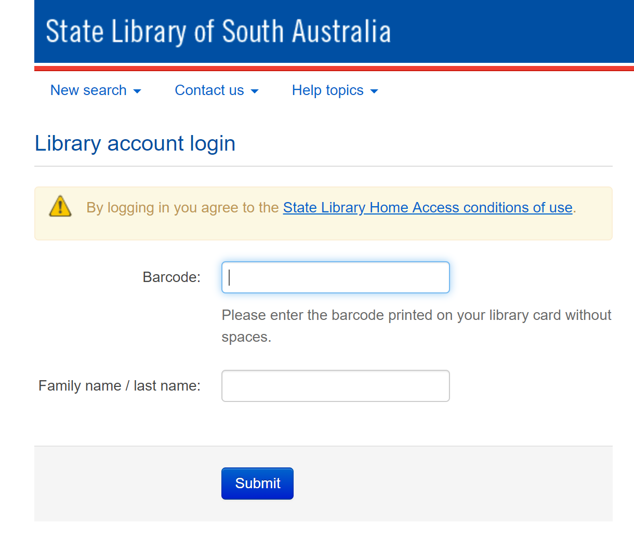

Once you have selected a database, for this example I have chosen *Academic search complete,* you will need to log in with your library card barcode number.

When you’re logged in you will see the screen below. You can just type in keywords and start searching

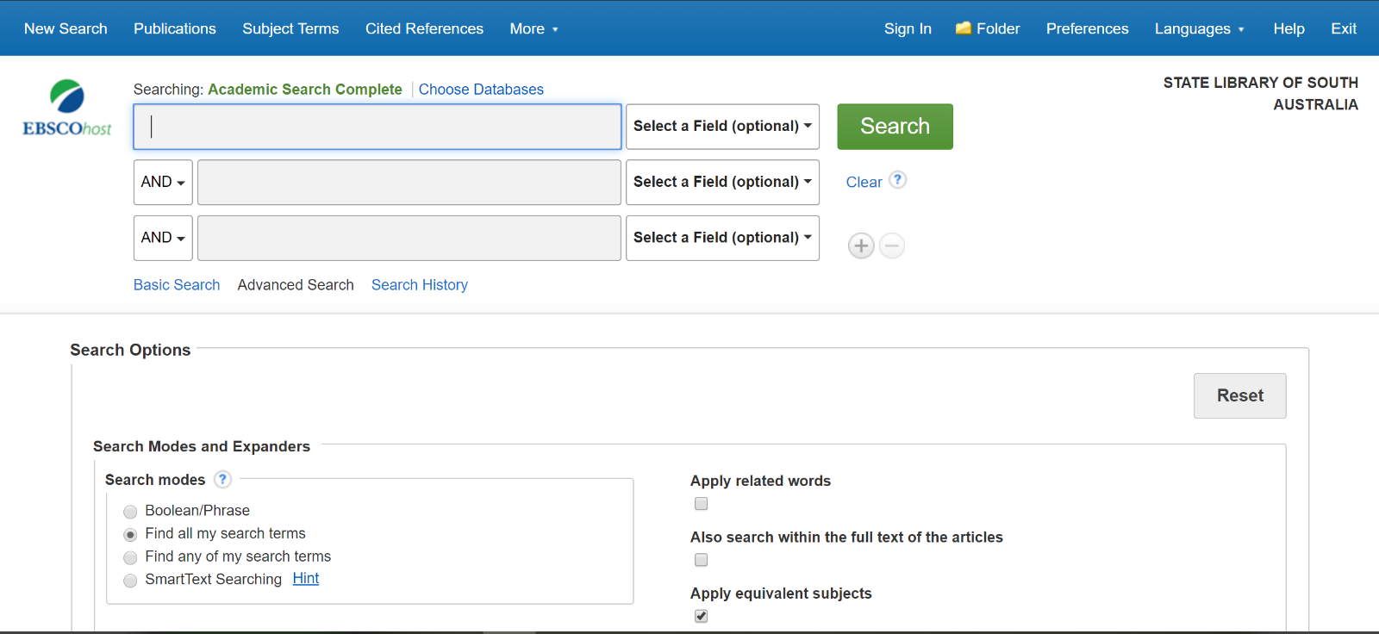

You can also limit your search so that you find the most relevant sources.

**Full text/PDF Full Text** – Will only search for articles that are available in full, removing results that only include the abstract of the article.

**Scholarly (peer reviewed) Journals** – This limits the search to the most reliable sources. Peer reviewed means the articles are checked by people in the same field of study before they can be published.

**Published date** – This is helpful to find the most recent sources.

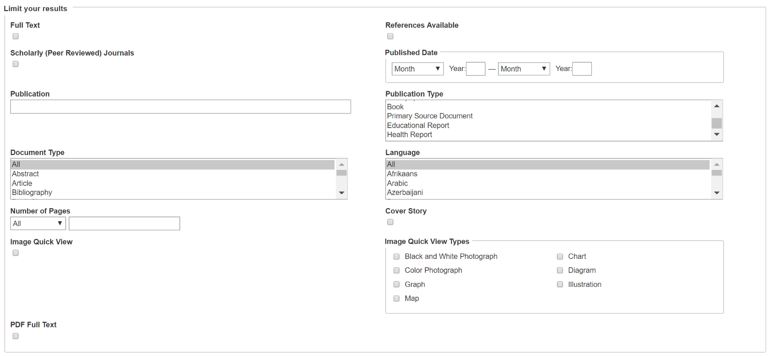

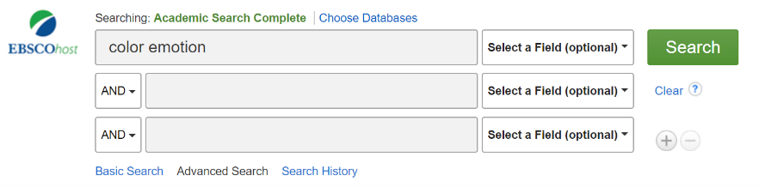

I’m going to do a search with key words “color” and “emotion”. I have chosen to use the American spelling to find sources that I would otherwise miss.

I have also limited my search to full text, peer reviewed journals published after 2015.

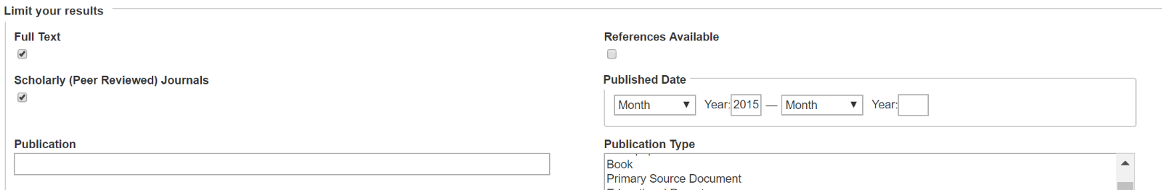

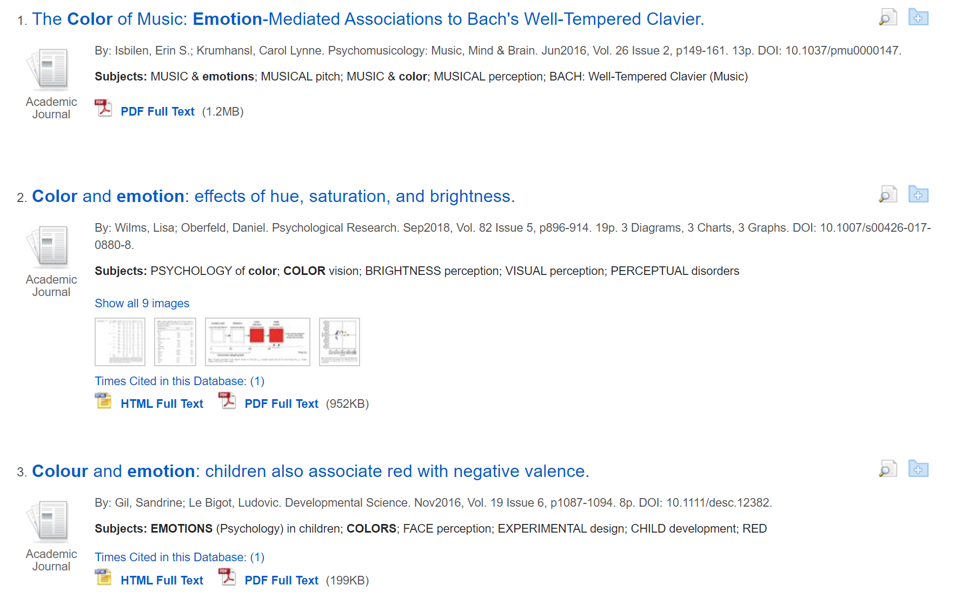

Click on *PDF Full Text,* this will to take you straight to the complete source as a pdf so you can save it to your device or print it.

Or, you can click the title of the result

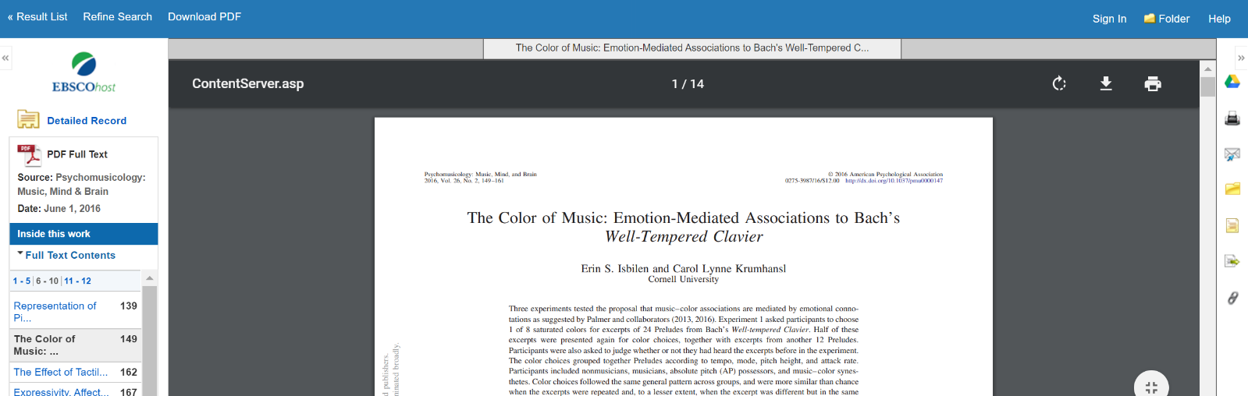

If you selected *PDF Full Text,* you will see a result like the one below. Click the down arrow with a line to download and save the PDF

# Using Google Scholar

Go to google scholar: <https://scholar.google.com/>

Type in your search term.

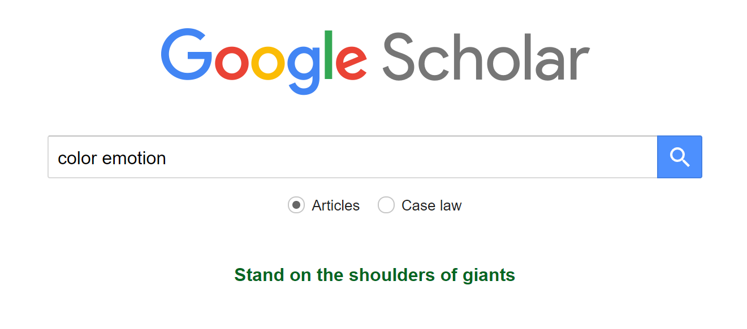

Some articles will already have a full text PDF available.

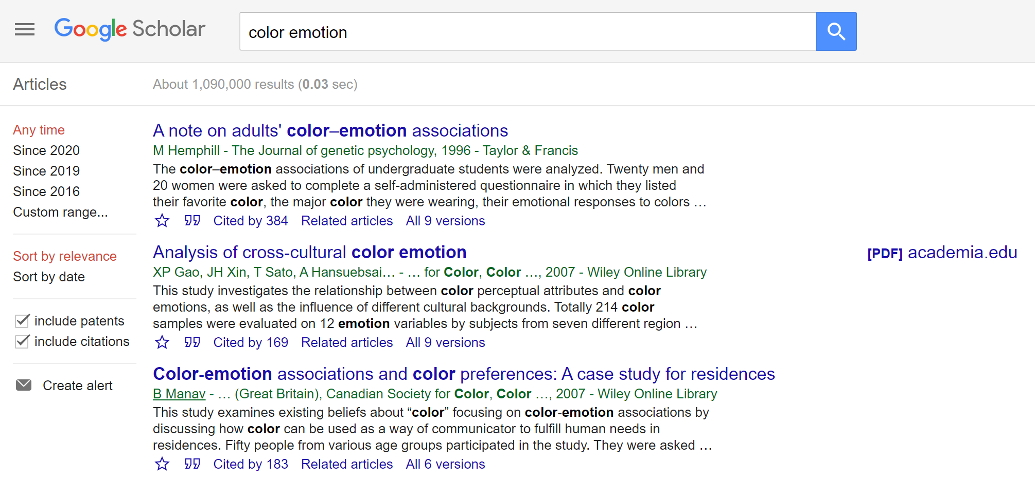

For those that don’t, copy the exact title of the article. Paste the title into a normal google search. Put quotation marks around the title. Then type in filetype:pdf. An example is shown below. [Note: You must leave a gap between the title and filetype:pdf. There can be no gaps in filetype:pdf or it won’t work.]

This method only works around 80% of the time, so expect some articles to be unavailable.

