Some Useful Sources
theconversation.com/au
Articles are relatively easy to read but are written by university academics. You can also click on the Author’s name and it will give you a full biography of that person which makes it easier to write your analysis. Another bonus is that it is an Australian based site so there is a lot of information that relevant to our specific context.

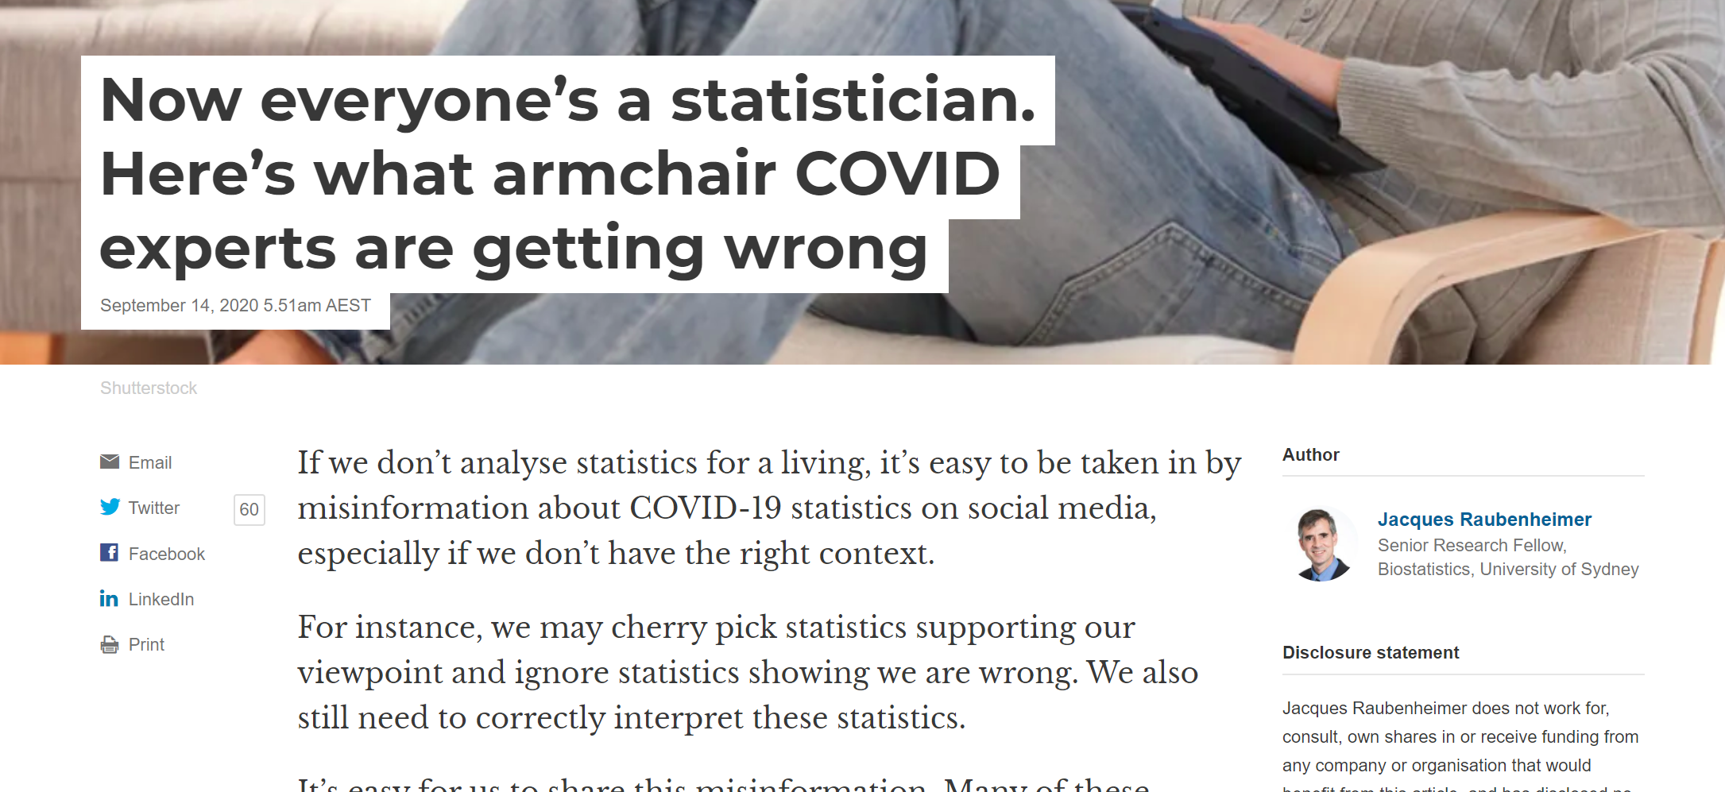
Author Info
www.sciencedaily.com
Similar to the conversation this site takes in depth science topics then writes them up in a more easily digestible form. The advantage of this site is that it tells you the name of the primary source (usually a journal article) that it is based on. If you like the information you can use that reference to find a copy of the journal article using the “find journal articles” document (or talk to unc. Jared for help). This is an international source so will not have a local Australian focus.
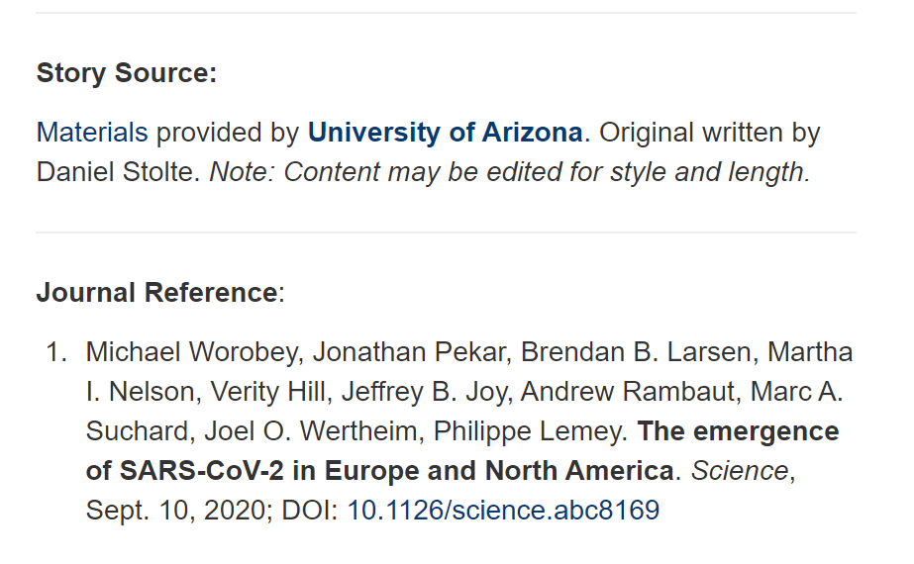
Journal Info
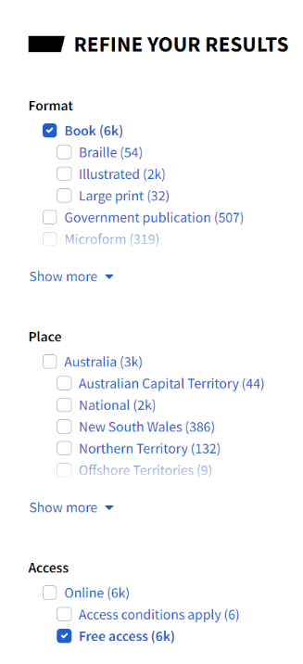
trove.nla.gov.au
This is the website of the National Library of Australia. It is best for looking for historical sources specifically from Australia. They have many newspapers, magazines and books that freely available online.
When you do a search make sure these boxes are ticked to find things that you can actually access

www.ncbi.nlm.nih.gov
This site is mostly useful for medical topics as it is the U.S National Library of Medicine. You can find many full text journal articles and book chapters on very specific medical topics. This isn’t a place to start researching as the writing is highly technical and full of jargon. Use this site towards the middle or end of the research process to find answers to specific gaps in your knowledge.
On the right-hand side of each articles are some handy options:
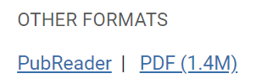 | The PDF button allows you to down load the article as a pdf which can make it easier to print or store in a folder.
 | This button will create a full reference for the journal article that you can copy/paste. You will need to edit it so it is the right format.
 | Clicking this button will bring up a list of articles that are similar to the one you are on. If you find a good one have a look.
 | This button will show any other journal articles that used the one you are currently on in their research. This may lead you to relevant research for your question.

