The Outcome (Answer to Question with Proof)
Maximum 1000 words – This part can be other media or appropriate to context, not just an essay
- In most cases, the Outcome requires you to have synthesised your research by putting the individual findings into groups or themes.
- Findings are the major ideas from your research which, for most outcomes, can be summarised down into themes that answer or help answer the question. Findings will include new ideas you come up with, created from putting together info.
- It is expected that you back up all statements you make with evidence – this means referring to specific parts of your research.
- It should also include a conclusion of what the answer to your question is.
Easiest structure generally:
- Intro
- Each paragraph will generally address a group of findings and will include evidence for why you say this from your research
- The conclusion will sum up the answer to the question

In the example below you can see that topic of for each paragraph is highlighted in yellow. The supporting findings for each topic are then highlighted in green. These findings are then explained in the section highlighted in blue.
You should be familiar with the PEEL paragraph structure which is similar. Instead of giving all your evidence and then all your explanation you alternate between evidence and explanation.

Performance Standards at A Level

Knowledge and Understanding
- KU2 Thorough knowledge and understanding of relevant research approaches for a variety of purposes.
Development
- D1 Thorough development of, experimentation with, and application of specific research skills

Example Outcome at the year 11 Level
What are some important uses of water and what properties of water make it eminently suitable for these usages?
Water, a common liquid, has unique properties that make it ideal for many uses (Johansen, 2010). It can be used for domestic procedures such as washing clothes, dishes and bodies (Gruffy & Nant, 2001). It can also be used or help in specific chemical reactions such as production of materials (DatScienceShow, 2015). A further use of water is to give life to most organisms on earth, which require water to support their biological processes (WaterUses contributors, 2016). The interesting factor is that all of these seemingly modest uses rely on complex chemistry to enable them.
The initial theme of my research and an important aspect of water to understand when exploring its usefulness is that it possesses unique properties. According to Aristu Sahu, a physicist I interviewed, water is the “only common substance which is found naturally in solid, liquid and gas forms” (Sahu, 2016). Water is unusual in that it expands when it freezes, which means that ice floats on water (WaterFacts, 2016). Water is also able to resist freezing more than most substances (Perrine & Schneitz, 2014; DatScienceShow, 2015). Combining these findings together, it could be suggested that water’s unique properties are a result of how it responds to being heated or cooled. This explains why in many of the uses of water it could not be replaced with another substance, because other chemicals might react differently when placed in hot or cold conditions.
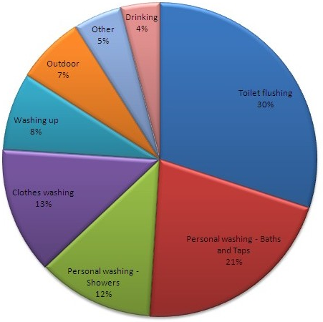
The unique ability of water to work in conjunction with detergent for washing a wide variety of substances was a further proof of its exceptional qualities. My own findings from a survey (see figure 1) included a wide variety of modern domestic washing practices that use water, including the washing of clothes, dishes and bodies (Gorgon, 2016; Sharburn, 2009). As well as such mundane uses of water, one of my findings was that wood pulp can also be washed this way (woodwashers.org, 2014). This was supported by Pogar (1994) who states: “many procedures that we might not normally think about as being washing, such as removing unwanted oils from wood, benefit from the application of soapy water”. An academic journal, Surfactants, stated that water and soap have been used for thousands of years for cleaning fabrics such as wool (Sharburn, 2009). Combining ideas from these findings, it has been possible to extrapolate that water is a very non-reactive substance as many different substances can be washed effectively in practically the same manner. Thus, one property of water that makes it highly suitable for washing is its chemical neutrality while another is its ability to exhibit enhanced cleaning action when combined with detergents.
Fig 1: Results of my survey on domestic water uses.
The use of water for chemical reactions was another evidence of water’s unique properties. Water is incredibly common in chemical processes, though often just as a substance to hold the chemicals rather than being used up itself; zinc metal production is an example of this (Cecchi, 2004). As well, water can be used to carry heat to or from chemical reactions in order to control them or use the energy for power sources (Batterton et al., 1999). A science TV show, DatScienceShow, revealed that there are many reactions which use vast amounts of water, such as producing or recycling paper (DatScienceShow, 2015). These findings collectively show that water is crucial to many chemical processes, even when seemingly not directly involved, its useful property here being its ability to hold and transfer chemicals and energy.
A final theme investigated was water’s importance in the life support of just about any organism on earth, relying on its property of preferring a liquid form. Water is able to contain nutrients in dissolved form, such as salt and minerals (Nasser, 2013). Also, water, commonly being found in liquid form, is important for transportation of nutrients, including through the roots of plants (WaterUses contributors, 2016). Another finding, attained from a documentary on the subject, was that most organisms are more than half water, and have various “strategies for collecting and storing water in order to survive” (The Secret Life of Water, 2008; Johansen, 2010). The importance of Earth’s water cycle, where water evaporates from the ocean and forms rain again and again without failing, was also discovered (Milone, 1988). Looking at all these findings as a whole, it is clear to me that life depends on water being in liquid form. Liquid water allows transportation of vital nutrients by rain outside of organisms and delivery through the organisms by flowing inside them.
In conclusion water is uniquely suited for its many uses because of the way it responds to temperature changes, that one of the most important uses of water is in washing, that water performs a crucial role in helping and controlling chemical reactions and that it is a critical component of life on Earth due to its ability to carry salts and minerals.
1000 words
Reference List
Primary Sources
Sahu, A 2016, Interviewed by Stanley Gorgon, Adelaide, 30 August
Gorgon, S 2016, Survey on Water 10-16th Sept 2016
Books and Journals
Batterton, F, Freidrich, K, Jerman, Y & Nongul, N 1999, To What Extent Can Water Be Used to Improve the Efficiency of Chemical Reactions?, New Grinswald Academy of Science
Gruffy, BN & Nant, RG 2001, Clean Chemistry, 1st edn, McGraw Hill, Sydney
Johansen, S 2010, Wonderful Water, 2nd edn. Dorling Kindersly, USA
Milone, P 1988, Earth’s Natural Cycles, 6th edn, Harrison, Melbourne, pp. 50-54
Pogar, B 1994, ‘Liquid Gold’, WASH, 14 March p19
Sharburn, G 2009, ‘Soap in Hellenistic Greece’, Surfactants, vol. 22, no. 4, pp. 10-11
Visual Texts
DatScienceShow 2015, H2O, Australian Broadcasting Corporation, Sydney, 9 July
The Secret Life of Water, 2008, Directed by Norm Zindra [DVD], UK: BBC
Websites
Cecchi, C 2004, Producing Zinc, http://bbn.news.com.au/producing-zinc-20040918.html, accessed 19 Sept 2014
Nasser, W 2013, Solubility of Common Salts, http://noguphys.co.uk/archive/2013-04-15/solubility-of-common-salts.pdf, accessed 18 Sept 2014
Perrine, L & Schneitz, T 2014, Thought of the Day, http://perriandsz.blogspot.com/2012/12/thought-of-the-day.html, accessed 15 Sept 2014
WaterFacts 2016, Why is Water so Weird?, http://wateranswers.org/a.php?qid=368677, accessed 11 Sept 2014
WaterUses contributors 2016, Xylem, http://waterwiki.org/wiki/Xylem, accessed 7 Sept 2014
Woodwashers.org 2014, ‘About Us’, http://woodwashers.org/about.htm, accessed 20 Sept 2014
Analysing and Interpreting Qualitative Data

If you conducted primary research such as a survey or experiment you may need to analyse the data before it is useable in the outcome.

Data Analysis: An attempt by the researcher to summarise collected data.

- As you collect data ask:
  - What have I learned to help me answer my question
  - Why did the interviewees answer as they did?
  - What else do I want to know?
  - What new ideas have emerged?

- Next, categorise and code data, grouping it into themes if possible (most cases):
  - Identify themes:
    - Ideas that are repeated
  - Reduce data to a manageable form by coding info by themes. Suggested methods:
    - Colour code by theme
    - Attach category labels to blocks of text
    - Write notes on note cards and sort into themes.
    - Cut and paste blocks of text onto index cards.
    - Then you can group cards that have similar labels together
    - And revisit piles of cards to see if clusters still hold together.

Data Interpretation: making sense of the data

- Answer these questions
  - What do these categories and patterns mean in answering my question?
  - What are the most important themes in the data?
  - Why are they important?
  - What can be learned from these themes?
  - So what is the final answer to my question?

Choosing and Interpreting Graphs (Quantitative Data)
Chart type | When to use it | Interpreting it | Example
Pie | Splitting a population into non-numerical categories | The slices show the relative size of each category compared to the whole lot | Hours worked per week  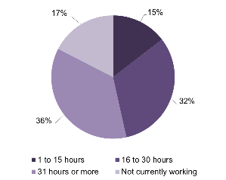
Histogram | Counting a population into numerical ranges of equal size | Higher frequency (count) means more fall in that range | Age of respondents in years  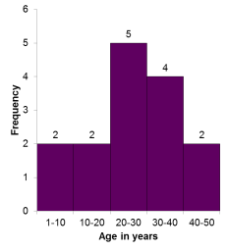
Clustered column | Comparing counts from different sample sets | Look at each category separately to compare height (frequency) results | Age of respondents by gender  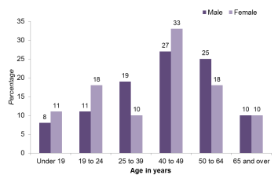
Line | Collecting data over a period of time | The rise and fall shows changes or trends | Temperature over one week  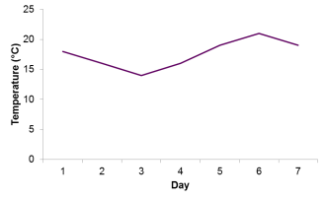
Scatter | Finding a relationship between two quantities | Draw a line of best fit through the scatter to find the pattern | 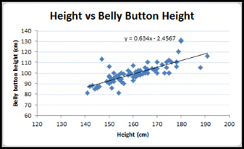

Important Note: If you can quantify your qualitative data (i.e. numbers of people who had similar responses) you can also use graphs of various types to represent and help interpret this qualitative data in a visual way.

