Exploring Identities and Futures - Assessment Type 1: Exploring me and who I want to be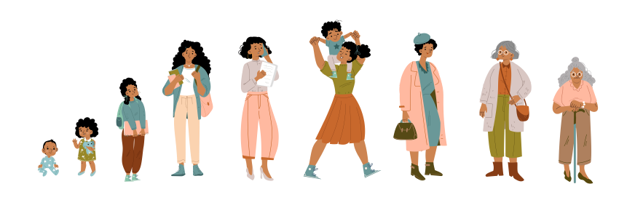
Part 1 - Who am I now?
In this first section of the assignment you are to explore who you are as a person in the present. This may include your past as this has a large effect on who you are now.
The exploration can be in any format you like. Some ideas are listed below and we will look at some examples in class
Timeline: A timeline covering your past, present and future with images and annotations
Vision board: A document of images with captions covering your past, present and future.
Folio: This could be a collection of smaller documents such as pieces of writing, art, photographs, videos.
Blog/Website: Use a tool like wix or weebly etc. to create a website to display your learning.
Other: This will need to be negotiated with your teacher.
Part 2 - Who do I want to be?
Part 2 can be integrated into part 1 or a completely new separate section. You can use the same list in part 1 for ideas on how to present this section.
This section aims to look forward at who you want to be in the future. You could explore: career aspirations, your spiritual life, hobbies/passions that you would like to develop, fitness and sport aspirations, artistic/musical/cultural development and more. These things may be related to what you have already explored in part 1 or they might be new things that you have never done before.
Part 3 - How do my connections shape who I am and who I want to be?
Note: do not do this part until part 1 and 2 are complete.
You are to share your work for part 1 and 2 with two people from your network/community. Do they agree with the findings of your work so far? Do they think that your judgement of who you are now is accurate? Do they agree that your aspirations are worthy and achievable?
One of the people you contact can be a person your age (e.g a classmate) but the other person must be an older person (e.g parent, uncle/aunty, grandparent, boss, teacher etc.)
This can be presented in any format but some suggestions are:
Recorded video/vocal interview: Record yourself discussing what you have done with your two chosen people (they can be done separately)
Email/forms/survey monkey: Write a series of questions and send them to your chosen people and put the responses in a document with your own commentary/annotations.
Paragraph of reflections: You can write a reflection after the discussion and choose to only include quotes/paraphrases from your discussion with your chosen people.
Part 4 - How am I going on my journey of becoming who I want to be?
This final part is for you to reflect on everything you have covered in part 1-3. This can be presented in any format but some suggestions are:
Reflective paragraph: A written paragraph discussing your thoughts.
Video/voice recording: Record yourself discussing your thoughts.
Artwork with annotations: Create an image that represents your current progress with annotations explaining the meaning.
A note on word/page count: There is no word count or page limits in this assessment item. This is due to the open-ended nature of the whole subject. However, the work done needs to be at the level of a 10 credit stage 1 subject.

 | Exploring Identity and Connections  (Developing agency) |  | Planning and Implementing Action  (Applying self-efficacy and self-regulation) |  | Communicating Evidence of Learning  (Developing communication and reflective practice)
 | CEL2 Reflecting and response | EIC2 Exploring connections | PIA1 Planning & organising | PIA2 Implementing and refining plans | CEL1 Communicating evidence of learning | CEL2 Reflecting and response
A | Purposefully explores and evaluates relationships between current identities and future aspirations. | Purposefully explores and develops connections and uses insights to inform future decisions and aspirations. | Designs a plan with strategic intent, prioritising and effectively managing actions and resources. | Refines and improves outcomes through responsive action, proactively managing emerging opportunities and challenges. | Intentionally selects relevant mode and medium to concisely convey ideas, findings and learning development fit for purpose and audience. | Purposefully explores diverse perspectives and proactively considers and values feedback to inform and reflect on learning.
B | Explores and considers relationships between current identities and future aspirations. | Explores connections with others to develop relationships and make decisions about their future. | Establishes a comprehensive plan, organising and prioritising required actions and resources to proceed. | Effectively implements a plan of action, responding to opportunities and challenges that arise. | Effectively communicates learning progress, ideas and/or findings with consideration of purpose and audience. | Explores and responds to perspectives and relevant feedback from others to inform and reflect on learning.
C | Explores and describes current identities and future aspirations. | Describes connections, and links these to future choices and aspirations | Makes a plan and identifies the required actions and resources that follow. | Implements a plan of action, responding to challenges to solve problems. | Communicates learning progress, ideas and/or findings to an audience. | Responds to a perspective or relevant feedback in the learning process to make progress.
D | Identifies personal interests or qualities that contribute to a sense of identity. | Identifies a connection that communicates a personal interest, choice or sense of belonging | Follows steps or directions for a purpose. | Participates in activities and makes learning progress | Communicates and/or demonstrates ideas and learning. | Identifies a perspective other than their own that impacts learning.
E | Identifies personal preferences, interests or skills. | Expresses preferences and choices to others in the learning environment | Accepts a plan for action. | Makes choices that aid participation in learning activities. | Partially recounts or demonstrates an aspect of learning | Acknowledges others’ ideas or perspectives in a learning environment

For this assessment type, students provide evidence against the following assessment design criteria:
• Exploring identity and connections (EIC1, EIC2)
• Communicating evidence of learning (CEL1, CEL2).

